CRITERION 7 - FACILITIES
Below is a summary of the campus facilities available to faculty, staff, and students.

A. Offices, classrooms and laboratories
Campus space allocated to the Department of Materials and Metallurgical Engineering Department is shown in Table 7-1. The department has 3,178 ft² of office space, 825 ft² of student lounge/study space, 6,406 ft² of lab space used primarily for the BS Metallurgical Engineering degree program with the balance of the 13,127 ft² allocated for research associated mostly with graduate research although undergraduate students do have access to such laboratories as needed. The above space includes 2,663 ft² in the well-appointed steel building termed the foundry that houses specialized manufacturing-related and blacksmithing equipment available for use by undergraduate students. Additionally, the BS Metallurgical Engineering students also have access are often closely involved with the 2,300 ft² Arbegast Advanced Manufacturing Center in the Civil-Mechanical Building which houses friction stir welding, ultrasonic welding, laser additive manufacturing equipment, and related mechanical testing equipment. Dr. Widener is the director of that facility, which also has several thousand square feet of additional space housing cold spray equipment in the Black Hills Business Development Center on campus. BS Metallurgical Engineering students often are employed in the center and all students are able to access such equipment if needed. The program faculty share classrooms across campus but do have three classrooms totaling 2,559 ft² in the Mineral Industries Building. As the campus student population grows, moves to larger classrooms or multiple course sections are being employed. Currently, there is adequate classroom space available; although, there is fairly high demand in the mid-morning periods. The fist M denotes SDSM&T in the state system; MI is the Mineral Industries Building, MF is the Met Foundry.

The university’s Capital Equipment List cites 980 individual capital equipment items. Major equipment under the Materials and Metallurgical Engineering Department is shown in detail in Appendix C – Equipment. The entire list is not included in this report for brevity but is available on request.

The campus offers multimedia teaching classrooms, each with computer projection equipment that consists of a minimum of a 2.6 to 3.4 GHz quad-core processer with 4 to 8 GB desktop system and a ceiling-mounted projector. Each projector is capable of accepting signals from multiple devices via the input selection, which enables faculty members to take their tablet PCs directly to the classroom. Each classroom has wireless capabilities for student tablet PCs. All instructional buildings offer 1 Gigabit-per-second local area network access. The campus has 54 Megabit-per-second wireless service. This equipment is adequate to meet the needs of the department. There are also four distance-delivery classrooms that offer the same assets as the multimedia classroom but have integrated video conferencing and recording capabilities. Recorded classes are available via our website for distance classes. All classroom instructional computers run Windows 7. The software on or available to students is listed in Tables 7-2 and 7-32. All software is available to students even though it is often assigned to a department for management purposes as is the case with the software listed in Table 7-3.
Table 7-1 Space Allocation for Metallurgical Engineering
Building | Room # | Area, ft² | Capacity | Primary Use
MMI | 128C | 196 | 5 | Lab, 3D X-ray tomography
MMI | 130A | 412 | 4 | Lab, Magnetic Separation
MMI | 130 | 1,082 | 11 | Lab, Mineral Processing
MMI | 128B | 362 | 8 | Lab, Furnace
MMI | 111 | 130 | 1 | Lab, Grad Research
MMI | 113 | 186 | 6 | Lab, Surface Chemistry
MMI | 121 | 530 | 3 | Lab, Grad Research
MMI | 127 | 330 | 5 | Lab, Characterization
MMI | 102A | 212 | 3 | Lab, Grad Research
MMI | 103A | 251 | 3 | Lab, Corrosion
MMI | 124C | 115 | 2 | Lab, Grad Research
MMI | 127B | 56 | 1 | Utility
MF | 104 | 1,853 | 20 | Lab, Manufacturing
MF | 102A | 357 | 5 | Lab, Manufacturing
MF | 102C | 453 | 5 | Lab, Manufacturing
MMI | 125 | 620 | 13 | Lab, Mechanical Testing
MMI | 126 | 1,140 | 12 | Lab, Hydrometallurgy
MMI | 124 | 940 | 24 | Lab, Phys Met
MMI | 124B | 172 | 1 | Lab, Optical Imaging
MMI | 124D | 110 | 2 | Lab, Grad Research
MMI | 105 | 415 | 15 | Library & Conference
MMI | 221 | 515 | 15 | Lounge, MI Bldg Student
MMI | 124A | 84 | 1 | Material Storage
MMI | 101 | 143 | 1 | Office, Dr. Jasthi
MMI | 102 | 124 | 2 | Office, Grad students
MMI | 103 | 130 | 1 | Office, Dr. Safarzadeh
MMI | 104 | 130 | 1 | Office, Dr. Hong, Res Sci
MMI | 106 | 130 | 1 | Office, Dr. Crawford
MMI | 108 | 191 | 1 | Office, Dr. West
MMI | 110 | 130 | 1 | Office, Dr. Cross
MMI | 112 | 170 | 1 | Office, Dr. Kellar
MMI | 114 | 160 | 1 | Office, Dr. Howard
MMI | 115 | 258 | 1 | Office, Department
MMI | 123 | 387 | 6 | Office, Grad students
MMI | 127A | 153 | 3 | Office, Grad students
MMI | 128A | 475 | 10 | Office, Grad students
MMI | 127C | 56 | 1 | Utility

Undergraduate students taking more than 6 credit hours are required to be part of the Tablet PC Program on campus. Participating students receive a Tablet PC with full tablet functionality. Tablets are on a four-year replacement cycle, and tablets are repaired or replaced quickly and as needed through the help-desk center. This program has been in operation since 2006 and has proved very successful for SDSM&T.

B. Computing resources
SDSM&T uses multiple and redundant servers to handle various types of services, including email, web hosting, licensing, and personal file storage. Networked file storage is provided for students, faculty, departments, and other campus needs. Faculty/staff email is provided by a campus Exchange mail system, while student email is provided by Google mail. All services and data can be accessed both on and off campus through protected connections.

SDSM&T participates in the Microsoft MSDN Academic Alliance (MSDNAA) program through which students and faculty can download and use various Microsoft software products and online resources for academic and non-profit research purposes. Non-Microsoft software is also available depending on the student’s major and classes. The software listed in Table 7-2 is the basic software package that is loaded on all classroom computers (i.e., those at the podium for the instructor to use as well as any machines for students), all computers in the Surbeck Center Lab, and computers in the Library. These programs are also common to faculty and student computers so they get classified as “Base Image” software.

Table 7-2 Base Image software
Department/Type | Software
Base Image | MS Office
PPT Addin | Insert New Slide
Base Image | MS System Center
Media Players | Quick Time Player
Media Players | Windows Media Player
Media Players | VLC Media Player
Media Players | Windows Expression Encoder
Media Players | DVD Player Codec/Program
Internet Browsers | Internet Explorer
Browser Addin | IE Flash Player
Internet Browsers | Chrome
Internet Browsers | Firefox
Browser Addin | FF Flash Player
Browser Addin | Adobe Shockwave Player
Browser Addin | Java
Browser Addin | Microsoft.net 4.0 Framework
MISC | Skype
MISC | Adobe Reader
MISC | 7 Zip
The software listed in Table 7-2 is also loaded on all of the instructional classroom computers, the Surbeck Lab computers, and Library Lab computers. Creating software images for each building/department would be too time consuming for ITS, so all programs that might be needed are loaded on all general access computers.

Table 7-3 Specialized available software
Department/Type | Software
AES | Compass ESL
CBE | EES
CBE | Polymath
CBE | COMSOL
CBE | Aspen
CBE | Loop-Pro
CBE | MD Solid
CBE | Pipe flo
CBE | StatEase DX9
CABS | Logger Pro
CEE | Arc GIS
CEE | GeoStudio Slope
CEE | Rocscience
CEE | Mathcad
CEE | MatLab
ECE | IE3D
ECE | CST
ECE | ADS
ECE | SIMSCRIPT
ECE | MatLab
ECE | Pspice
GEOL | Arc GIS
IA (athletics) | Hudl Remote
LIB | EndNote
MCS | MAPLE
MCS | Visual Studio
MCS | Microsoft SQL Client
MCS | VIM
MCS | Mathcad
MCS | Xming
ME | Solidworks/VS 2005
ME | MatLab
ME | Mathcad
MET | Thermocalc+Dictra
MET | Mathcad
MET | ENVI/IDL
The following is a partial listing of applications available to Faculty/Students:
- Microsoft DreamSpark
  - Windows Operating Systems (7, 8.1, 10)
  - Access 2016
  - Project 2013, 2016
  - Visio 2013, 2016
  - Visual Studio 2015
  - SQL Server 2012, 2014
  - Windows Server 2012, 2012 R2
  - Expression Studio 4
  - XNA Game Studio 4
  - Exchange Server 2010
  - SharePoint Server 2010
- SolidWorks
- Maple ( instructor tips from Maple)
- MATLAB
- Aspen
- MathCad
- StatEase
- Minitab 17

In addition to the above universally available software, Metallurgical Engineering undergraduate and MES graduate students have available the following program-specific software:
- ThermoCalc®, Thermochemical computations
- Dictra® Diffusion computations
- WinWulff®, Stereographic rendering
- STABCAL Thermochemical calculations
- Avizo Fire 3-D Visualization

SDSM&T provides several computing clusters for parallel work. The Department of Math and Computer Science (MCS) operates a Non-Uniform Memory Access (NUMA) system with 32 cores which is exclusively for use within the department. MCS faculty members also have access to computing hours at Golden Energy Computing Organization (GECO). The GECO system has 2144 cores on 268 nodes (256 Clovertown E5355 nodes and 12 Xeon 7140M nodes) with a 17 teraflop sustained performance. Moreover, the physics department maintains the largest cluster on campus with 256 cores on 51 nodes. There are also several smaller homogenous clusters (32-64 cores) housed in different departments on the campus.

The campus LAN consists of a 10 GB fiber backbone to every campus building. This resource is dispersed within the buildings to ensure 1 GB desktop connections. Wireless is available in all buildings on campus with student laptops, and faculty/staff machines have wireless access to the internal network servers. An open wireless infrastructure that sits outside our internal network exists for personal devices to provide direct access to the Internet.

As a member institution, SDSM&T is connected to the National Research & Education infrastructure through several high bandwidth networks:
- The Northern Tier Network Consortium (NTNC) connecting Chicago IL with Alaska through the northern tier of states (IL, WI, ND, SD, NE, IA, MT, ID, WA and AK). Internet2 supports NTNC by providing various types of organizational service and assistance. As an Internet2 participant, SDSM&T is connected with Committee on Institutional Cooperation (CIC OmniPoP), an Internet2 connector in Chicago, and is able to establish an appropriate high-speed connection to a national or international aggregation point through the NTNC shown in Figure 7-1.

- The Great Plains Network (GPN), a consortium of universities in the Midwest, connecting SD, NE, IA, KS, MO, AR, and OK connected as shown in Figure 7-2.

- The SD Research, Education and Economic Development Network (REED) connecting six public universities and two university centers in South Dakota with multiple 10 GB/s links. We are investigating the move to 100 GB for the REED backbone to be done over the next few years possibly connecting to the North Dakota network shown in Figure 7-3.

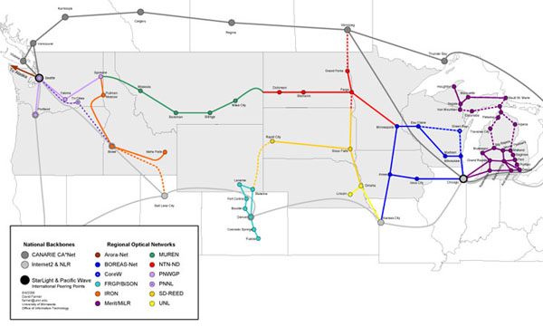

Figure 7-1 Northern Tier National backbone route across the northern U.S.

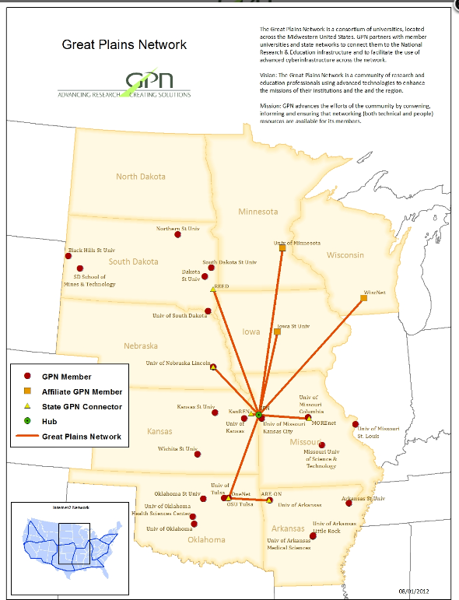

Figure 7-2 The Great Plains Network

Figure 7-3 SD Research, Education and Economic Development Network

C. Guidance
Students are given a tablet PC orientation when they arrive on campus and have training sessions throughout their academic careers. The Help Desk is also available to students for software and hardware training during normal working hours with some outside hours being provided during the week. There are also many webpages devoted to “How-To” queries to help students, faculty and staff with the more common issues/procedures. Instructional material as well as the South Dakota Board of Regents Acceptable Use Policies can be found at: http://www.sdsmt.edu/its.

D. Maintenance and upgrading of facilities
The department of Materials and Metallurgical Engineering shares with Department of Mining Engineering a full time technician who primarily addresses computer-related issues. The department hires students with high mechanical aptitude to assist in maintaining equipment. Additionally, the department hires on an as-needed basis our former technician to make equipment repairs that are beyond the capability of student hires. Balances and hardness testing equipment is recalibrated on a recurring basis by certified off-campus agents. New equipment is typically covered by warrantees or service contracts. Older equipment is maintained by the responsible faculty or in unusual circumstances by hiring a service agent.

The department of Materials and Metallurgical Engineering has also made a concerted effort in the last period to renovate and improve safety in the labs through research funding and industry foundation support. Recent examples include a complete renovation of the Mineral Processing Lab (MMI 130) and the Corrosion Lab (MMI 103A). The renovation of the Hydrometallurgy Lab (MMI 126) will begin in the spring of 2016.

All classroom instructional computers are replaced every three to four years. Student tablet PCs are replaced every four years. Incoming freshmen receive new tablets, and Windows 10. Software is maintained and upgraded regularly on tablet PCs. Should major operating system upgrades happen during the life of the machine, a new image is created with the new operating system, and students/faculty/staff can upgrade at their convenience.

SDSM&T offers certified service center so maintenance of computer/laptop hardware is done in-house. Turnaround times are greatly reduced with this method which creates a much more reliable Tablet Program on campus. A small percentage of machines are held in reserve so they can be immediately put into production in case a student or faculty/staff member has a catastrophic failure with a machine. Most of the time, even with a catastrophic failure, a student or faculty member can be out the door with a working machine in a matter of minutes as opposed to the weeks that replacement or repair would require were SDSM&T not a service center.

E. Library services
The Devereaux Library has nine full-time staff members, two librarians and seven support staff members. All are very responsive and provides excellent service. Additionally, approximately seven student workers are hired during the academic year to supplement the staffing of the library. This staff is adequate to serve the needs of the campus. Library Hours are as follows: Sunday 2:00 pm – 10:00 pm / Monday – Thursday 7:30 am – 10:00 pm / Friday 7:30 am – 5:00 pm / Saturday, closed. The physical presence and resources of the library are significantly supplemented by its online presences, access, and resources.

The library online (http://library.sdsmt.edu) is designed to guide students to search for information, find resources and keep in contact with the library. Most students start with the “Search for Resources Worldwide” search box (located next to the Devereaux Library banner) or the Subject Guides which sort the array of databases into departments/majors for ease of use. Each Subject Guide is divided into sections to assist in finding the right kind of information quickly. Alternatively, when an instructor has recommended or assigned a specific resource or database, a student can enter the information into “Search the Devereaux Library Website” and, thereby, locate the resource directly. The main page is designed to offer ready access to social media links; the library catalog; an individual student’s library-related records; interlibrary loan; and an interface for submitting comments, questions, and suggestions.

Historical practice for the library has been to allocate yearly resources to each academic program and to rely on academic department library liaisons for new, one-time acquisitions. Budget cuts and lack of resources has led to the suspension of this practice since 2014. The library director continues to consult with the academic departments and seeks to ensure that collections, subscriptions, and services meet needs.

A summary of journal resources and databases (both digital / paper) is as follows:
- Journals:
  - Paper Titles, 101 (24 of which include online access)
  - Electronic Titles, 347
- Databases
  - Full-Text, 2 (Applied Science & Technology and ProQuest SciTech)
  - Index only, 2 (Engineering Village 2 Compendex and MLA (Modern Languages Association)
- Ebook collections, 2 (Knovel and ProQuest Academic Complete, i.e.,’Ebrary’)
- Databases supported by the Board of Regents
  - Full-Text, 2 (Dissertations & Theses and IOP Science Journals)
  - Index only, 2 (Chemical Abstracts Service SciFinder Scholar and Thomson Reuters Web of Science)

The library has been moving aggressively toward an all-electronic model for journals over the last four years. Currently the titles retained in paper are popular reading (Time, Newsweek, Car and Driver, Rolling Stone, etc.), titles not available in electronic format, or titles prohibitively expensive to acquire in electronic format. Titles featured in the “downtime / popular reading” relaxation area are all maintained in paper.

Interlibrary Loan services are available to anyone with a valid campus ID. Faculty/Staff and Graduate Students are required to pay a minimal fee to off-set costs. Undergraduates are not charged. The Devereaux Library belongs to MINITEX, a network based at the University of Minnesota. MINITEX provides access to materials throughout the region (e.g., South Dakota, Minnesota, North Dakota, Wisconsin, etc.), Michigan’s Federal Depository libraries, the University of Illinois, and the Copyright Clearance Center. Most interlibrary loan traffic goes through OCLC, which has expanded into a worldwide conglomerate of libraries. The Untied State Patent and Trademark Office website http://www.upsto.gov is relied on for access to patent and trademark information.

Library resources of particular value to the BS Metallurgical Engineering program are as follows:
- Standards, Annual book of ASTM standards. American Society for Testing and Materials Annual, Philadelphia, PA, USA, 2004.
- Burkin, A.R., Chemical hydrometallurgy: Theory and principles. Vol. 1. 2001: World Scientific.
- Chandler, H., Heat treater's guide: practices and procedures for irons and steels. 1994: ASM international.
- Chandler, H., Heat treater's guide: practices and procedures for nonferrous alloys. 1996: ASM international.
- Davis, J.R., ASM specialty handbook: stainless steels. 1994: ASM International.
- Davis, J.R. and J.R. Davis, Aluminum and aluminum alloys. 1993: ASM international.
- Foundation, A.S. and A.W. Cramb, The Making, Shaping and Treating of Steel: Casting Volume. 2003: AIST Steel Foundation.
- Fruehan, R.J., The Making, Shaping, and Treating of Steel: Ironmaking volume. Vol. 2. 1999: AIST Steel Foundation.
- Garrels, R.M. and C.L. Christ, Solutions. Minerals and Equilibria: Freeman, Cooper and Company, San Francisco, 1965.
- Handbook, A., Properties and selection: irons, steels, and high performance alloys. ASM international, 1990. 1: p. 140-194.
- Hansen, M., K. Anderko, and H. Salzberg, Constitution of binary alloys. Journal of the Electrochemical Society, 1958. 105(12): p. 260C-261C.
- Hansen, M., R.P. Elliott, and F.A. Shunk, Constitution of binary alloys. First-supplement. Vol. 2. 1965: McGraw-Hill.
- Hultgren et al., Selected values for the thermodynamic properties of the elements, ASM international, 1970.
- Hultgren et al., Selected values for the thermodynamic properties of binary alloys, ASM international, 1970.
- Francis A Shunk, Constitution of binary alloys. Second-supplement. Vol. 2. 1969: McGraw-Hill.
- Hultgren, R., et al., Selected values of the thermodynamic properties of binary alloys. 1973, DTIC Document.
- Kosmulski, M., Surface charging and points of zero charge. Vol. 145. 2009: CRC Press.
- Krauss, G., Steels: heat treatment and processing principles. ASM International, 1990, 1990: p. 497.
- Marsden, J. and I. House, The chemistry of gold extraction. 2006: SME.
- Osborn, E. and A. Muan, Phase diagrams for ceramists (All Volumes). The American Ceramic Society, Columbus, OH, USA, 1964. 219.
- Raymond, R., Out of the fiery furnace: the impact of metals on the history of mankind. 1986: Penn State Press.
- Scott, D.A., Metallography and Microstructure in Ancient and Historic Metals. 1992: Getty Publications.
- Scott, D.A., Ancient metals: microstructure and metallurgy. Vol. 1. 2011.
- Scott, D.A., Ancient Metals: Microstructure and Metallurgy: Iron and Steel. Vol. 4. 2011.
- Stout, R.D. and W.D.O. Doty, Weldability of steels. 1971: Welding Research Council.
- Stull, D.R. and H. Prophet, JANAF thermochemical tables. 1971, DTIC Document.
- Tylecote, R., A History of Metallurgy, Inst. Material, London, 1992.
- Vander Voort, G.F., Metallography, principles and practice. 1984: ASM International.
- Villars, P., A. Prince, and H. Okamoto, Handbook of ternary alloy phase diagrams. 1995: ASM Intl., (10 vol)
- Wakelin, D., The Making, Shaping and Treating of Steel, Iron Making. David H. Wakelin, Richard J. Fruehan//Latest technology, 1999. 2: p. 497-533.
- American Society of Metals: Hand Books (All Volumes)- ASM International.
- Welding Handbook Series; American Welding Society; vol 1-5, 8th edition, 1987,
- Elements of X-Ray Diffraction, B. D. Cullity and S. R. Stock; Prentice Hall; 3 edition, 2001.
- Welding Journal
- Heat Treating Progress (ASM)
- Metallurgical Transactions A & B
- Advanced Materials and Processes (ASM)
- Journal of Metals
- International Journal of Mineral Processing
- Hydrometallurgy Journal
- Minerals and Metallurgical Processing Handbook
- SME Mineral Processing Handbook, V. 1 and 2, 1986, N. Weiss, Editor, SME.

In addition to these resources, the department maintains a library of several hundred reference books in the department study /meeting room (MI 105) open to students when not in use for meetings. This resource includes a complete set of ASTM standards. The faculty also have extensive reference materials that are made available to students as needed.

F. Overall comments on facilities
The BS Metallurgical Engineering program works to maintain safe equipment and a safe working environment. The facilities, tools, and equipment that present hazards if used improperly are kept locked and made available to those who have the appropriate instruction for safe operation. Chemical supplies are periodically cataloged by the Chem Stores Office and reviewed for safety and need. A complete set of (Materials) Data Safety Sheets ((M)SDS) are available for all chemical or hazardous materials in the laboratories via an online database (MSDSonline) that can be accessed through the SDSM&T environmental health and safety webpage . The system automatically updates as new (M)SDS sheets become available. Laboratories using chemicals are equipped with eye wash stations and showers are available. All laboratories involving hot materials are equipped with googles, gloves, and gowns. Laboratories involving flying debris from crushing equipment or mechanical processing equipment are equipped with eye protection. Ear protection is provided for all blacksmithing and metalworking activity. Before every laboratory, the instructor reviews pertinent safety information with all students.

The program has made a concerted effort in the last period to renovate and improve safety in the labs through research funding and industry foundation support. Recent examples include a complete renovation of the Mineral Processing Lab (MMI 130) and the Corrosion Lab (MMI 103A). The renovation of the Hydrometallurgy Lab (MMI 126) will begin in the spring of 2016. In addition, the department has worked with the Mining and Geological Engineering programs and university foundation to begin raising funds to completely renovate the Mineral Industries building. These efforts have resulted in $1.5M in committed funds as of end of FY 15.

All mishaps, close calls, or potentially unsafe conditions are reported to the department head or the Campus Safety Officer (Jerilyn Roberts). The campus Safety Officer conducts regular audits of our laboratories and sends the department head and all faculty members in the department a list of findings. Conditions in need of attention are followed by the department head and the Campus Safety Officer until rectified. Table 7-6 shows the Feb 10, 2016 Environmental Health and Safety Audit for the Department of Materials and Metallurgical Engineering.

Table 7-6 Environmental Health and Safety Audit Feb 10, 2016

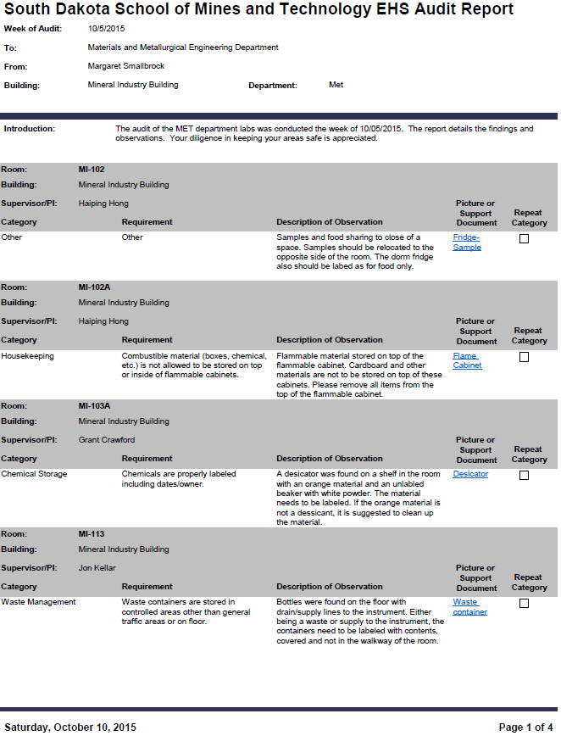
Table 7-6 Environmental Health and Safety Audit Feb 10, 2016 (Cont’d)
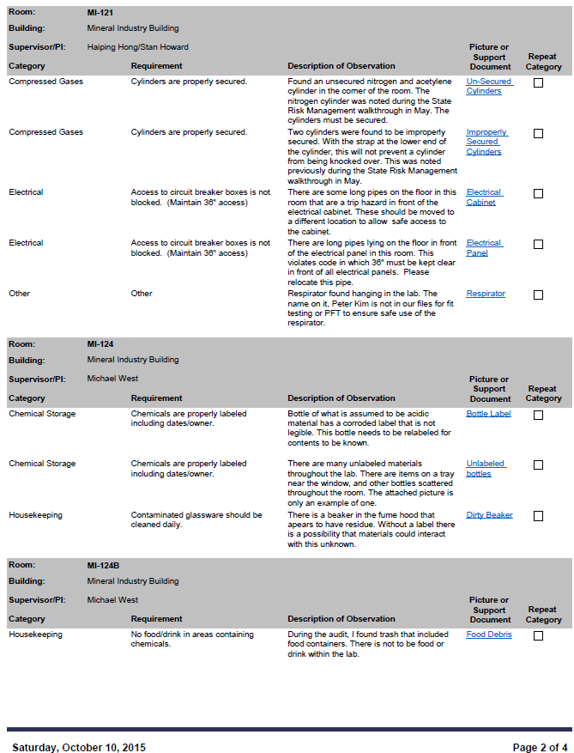

Table 7-6 Environmental Health and Safety Audit Feb 10, 2016 (Cont’d)
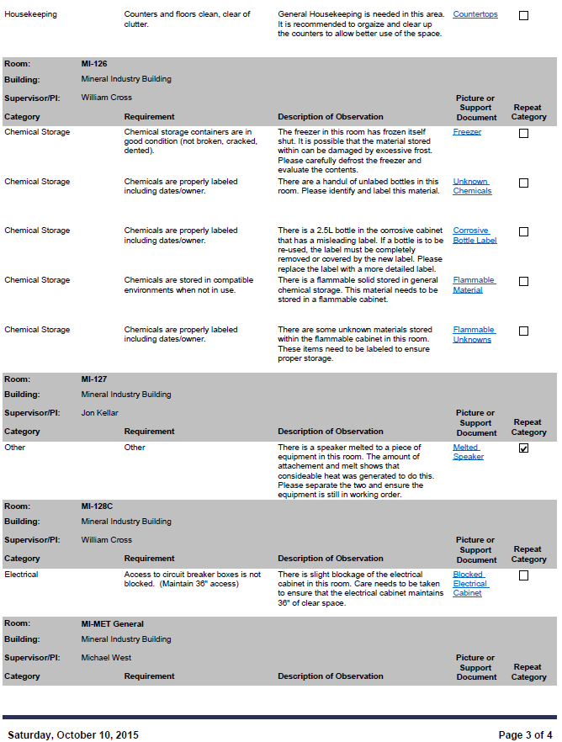

Table 7-6 Environmental Health and Safety Audit Feb 10, 2016 (Cont’d)

