CRITERION 6 - FACULTY

This criterion contains information on the program faculty qualifications, workload, size, professional development, authority and responsibility, and curriculum development and review policy.

- Faculty qualifications
A summary of faculty and expertise areas for members in the Department of Materials and Metallurgical Engineering is shown below.

- Dr Crawford, Arizona State University (mechanical metallurgy, physical metallurgy)
- Dr. Cross, University of Utah (aqueous extraction, surface chemistry)
- Dr. Howard, Colorado School of Mines (high temperature metallurgy, thermodynamics)
- Dr Jasthi, SDSM&T (physical metallurgy, corrosion engineering)
- Dr. Kellar, University of Utah (mineral processing)
- Dr. Safarzadeh, University of Utah (aqueous extraction, electrochemistry)
- Dr. Salem, University of Manchester, U.K. (polymers, polymer synthesis, composites)
- Dr. West, University of Tennessee, Knoxville (physical metallurgy, materials joining)
- Dr. Widener, Wichita State University (mechanical behavior, advanced processing)

Table 6-1 shows the program faculty qualifications. All program faculty members hold PhD degrees in metallurgical or materials engineering or a closely-related supportive field and graduated from quality institutions. All faculty members are active in the campus research effort. The program teaching faculty have developed a strong research portfolio with nearly $1.7M in FY 15 expenditures. This number does not include funding associated with the two research labs managed by Dr. Salem (CAPE Lab) and Dr. Widener (AMP Lab) which amounts to nearly $2.5M in external support. Major active resesarch highlights include three State of South Dakota centers in the areas of advanced metal alloy repair, advanced polymers, and security printing as well as DoD grants related to strategic metals as shown below. Faculty have leveraged this research funding to acquire new equipment that directly benefits students in the program. An excellent example is acquisition of the new 3-D X-ray MicroCT system.

- G. Crawford (PI), D. Anagnos, L. Groven, R. McTaggart, “Fundamental Research Towards a Printable Spacecraft”, SD NASA EPSCoR, funded, $50,000, 2014-2015.
- Hoppe (PI), S. Smith, D. Engebretson, G. Crawford et. al. “Biochemical Spatiotemporal NeTwork Resource (BioSNTR), SD EPSCoR, funded, $10,000,000, 2013-2018.
- W. Cross (PI), J. Kellar, D. Boyles, G. Crawford, “Novel Separation Technologies For Recovering Manganese From Process Streams”, Office of Naval Research, funded, $398,834, 3/12-4/15.
- W. Cross (PI), J. Kellar, S. Safarzadeh, D. Boyles, M. West, “Extraction and Recovery of Rare Earth Metals II”, Army Research Laboratory, funded, $325,000, 9/14-9/15.
- H. Hong (PI), “Next Generation of Nanocoolants, Nanogreases and Nano-lubricants”, Army Research Lab, funded, $197,000, 07/29/10 – 08/31/15.
- J. Kellar (PI), P.S. May, G. Crawford and B. Logue, “Center for Security Printing and Anti-Counterfeiting Technology,” SD Board of Regents, $900,000, funded, 12/13-6/16.
- J. Kellar (PI), W. Cross, S. Safarzadeh and M. West, “Strategic Minerals Extraction,” Army Research Laboratory, $999,998, funded, 11/13-5/15.
- D. Salem (PI), M. Robinson, W. Cross et. al, “Composite and Nanocomposite Advanced Manufacturing Center (CNAM), funded $2,000,000, State of South Dakota, 6/2013 – 5/2018,
- M. West (PI), W. Cross, “REU Site Back to the Future II”, NSF, funded, $300,000 3/2012-3/2015.
- Widener (PI), B. Jasthi (Co-PI)- Governor’s Research Center - Advanced Manufacturing Process Technology Transition and Training Center (AMPTEC), State of South Dakota, funded, $2,500,000, 07/01/13-06/30/18.
- Widener (PI), G. Crawford , M. West, B. Jasthi , M. Carter , T. Curtis, “Development of Advanced Materials Processing, Cold Spray, and Additive Manufacturing for DOD Applications”, Army Research Laboratory, funded, $300,000

It should also be highlighted that faculty have been successful to develop pedagogical grants in the last period that have directly benefited undergraduate student outcomes in the program. These include two ongoing NSF REU programs as well as an NSF S-STEM award.

- M. West (PI), J.Kellar, “REU Site Back to the Future”, NSF, funded, $300,000 3/2010-3/2012.
- M. West (PI), W. Cross, “REU Site Back to the Future II”, NSF, funded, $330,000 3/2012-3/2015.
- G. Crawford (PI), J. Kellar, “REU Site: Security Printing and Anti-Counterfeiting Technology”, NSF, funded, $453,000, 3/2012-3/2016.
- J. Kellar (PI), J. Karlin, S. Kellogg and D. Medlin, NSF, “S-STEM: Culture and Attitude---Innovative Partnerships for Success,” funded, $600,000, 9/09-8/15.

All faculty members are interested in student achievement and success and have two formal processes for monitoring the quality of their instruction: use of the IDEA end-of-course survey and monitoring of the benchmarks for instructional effectiveness, academic advising, and concern for the individual that are generated by use of the Student Satisfaction Survey (SSI) with all seniors. As a matter of regental policy, all courses are evaluated by students with the IDEA end-of-semester survey. Additional information on the use and features of this instrument is available at http://www.theideacenter.org.) Student evaluations are returned to the department head who reviews the evaluations and follows up with each faculty member. The results of all course surveys are stored digitally in the Office of the Provost. While the provost has free access to all faculty member files, the department head and the faculty member are the primary audience for end-of-course student evaluations. The monitoring and improvement of teaching quality is the purview and primary responsibility of the faculty members in the program in collaboration with the department head. Faculty members also have course management software available to them and access to Web Advisor and Colleague, which gives them access to student information needed for quality advisement. Academic departments are responsible for monitoring the holding and posting of office hours, ensuring that instructors are readily available for student inquiries, and monitoring the quality of academic advising within the program(s).

Table 6-1 Faculty qualifications: BS Metallurgical Engineering
Faculty Name | PhD Earned  Field and Year | Rank ¹ | Type of Academic Appointment²  T, TT, NTT | FT or PT³ | Years of Experience |  |  | Professional Registration/ Certification⁴ | Level of Activity⁵  H, M, or L
 |  |  |  |  | Govt./Ind. Practice | Teaching | This Institution |  | Professional Organizations | Professional Development | Consulting/summer work in industry
Crawford, Grant A. | Materials Science and Eng, 2008 | AST | TT | FT | 3.5 | 4.5 | 4.5 |  | M | M | M
Cross, William M. | Metallurgical Eng, 1999 | ASC | T | FT | 0 | 9 | 23 |  | M | M | L
Howard, Stanley M. | Metallurgical Eng, 1971 | EM & I | NTT | PT | 2 | 45 | 45 | PE | H | H | L
Jasthi, Bharat K. | Materials Eng and Sci, 2009 | AST | TT | FT | 2 | 3 | 7 |  | M | M | L
Kellar, Jon J. | Metallurgical Eng, 1991 | P | T | FT | 0 | 26 | 26 |  | H | L | L
Safarzadeh, M. Sadegh | Metallurgical Eng, 2013 | AST | TT | FT | 4.5 | 3 | 3 |  | M | M | L
Salem, David R. | Polymer and Fiber Physics, 1983 | P | T | FT | 32 | 9 | 6 | CPhys | M | M | L
West, Michael K. | Materials Science and Eng, 2006 | ASC | T | FT | 0 | 9 | 9 |  | M | M | L
Widener, Christian | Mechanical Eng, 2005 | ASC | T | FT | 6 | 6 | 5 |  | L | M | H
Instructions: Complete table for each member of the faculty in the program. Add additional rows or use additional sheets if necessary. Updated information is to be provided at the time of the visit.
1. Code: P = Professor, ASC = Associate Professor, AST = Assistant Professor, EM = Emeritus Professor, I = Instructor, A = Adjunct, O = Other
2. Code: TT = Tenure Track, T = Tenured, NTT = Non Tenure Track
3. At the institution
4. Code: PE = Professional Engineer, CPhys = Chartered Physicist
5. The level of activity, high, medium or low, should reflect an average over the year prior to the visit plus the two previous years.
Data shown in Table 1-8 generated by the use of the Student Satisfaction Survey (SSI) with all seniors is segmented by academic program and incorporated into the institutional-level performance metrics aligned with the strategic plan and tracked by the Executive Council. Levels of engagement and satisfaction with instruction at the sophomore level are monitored through use of the Second Year Student Assessment (SYSA) presented in Table 1-9.

B. Faculty workload

Table 6-2 summarizes the faculty workload and describes this information in terms of workload expectations for both 2014-15 and 2015-16. Workload expectations are set by the department head and agreed upon during the annual review cycle. Workload expectations are made to support the mission of the department and the university. The teaching faculty members in the department are expected to maintain a fairly equal balance between teaching and research and average approximately six credit hours a semester. New faculty members have been given a reduced teaching workload when possible during the review period to stimulate development of externally funded research programs.

- Faculty size

As shown in Table 6-1, the program has six full-time, tenure-track faculty (Michael West, Jon Kellar, William Cross, Grant Crawford, Bharat Jasthi, and Sadegh Safarzadeh), two shared appointment professors (Christian Widener of the Arbegast Advanced Materials Processing Center (AAMPC) and David Salem of the Composites and Polymer Engineering Laboratory (CAPE), and one senior lecture and professor emeritus (Stanley Howard). Additionally, Dr. Timothy M Brenza from the Department of Chemical and Biological Engineering teaches the program’s dual listed MET 433/CBE 433 Process Control course. The teaching faculty to student ratio for the program in Fall 2015 was 1/25.

The program faculty members are on first name basis with essentially all of our students by the time they reach their junior year. The department is known for its close and supportive relationship with its students. Students are welcomed into faculty offices to seek assistance with homework problems, curricular planning, scholarship applications, employment and interview procedures, or financial and personal problems. Students who are hospitalized are visited by a faculty to assess needs and provide assurance and support. Faculty offer special help sessions as needed for exam preparation and either post available office hours or have an open door policy. Friday Hammer In blacksmithing activity is often accompanied by grilled food, which draws faculty and students to this social event. The department annually holds several banquets and/or picnics sponsored by the local Materials Advantage Chapter. Through these activities and the constructive attitude of the faculty, the department continues its successful building of a close-knit student cohort supported by a caring, competent, professional faculty.

The program is managed by the program faculty in periodic curriculum planning sessions using input from the Advisory Board, reviews of other programs across the USA, and their experiences from implementing the prevailing program. Each program faculty member has adequate opportunity for making input and every change is discussed before submission to the University Curriculum Committee.

Dr. Cross is the program’s representative to the curriculum committee and also serves on the Faculty Senate. In recent years he has served as the Curriculum Committee’s representative to the Faculty Senate so presents all proposed curricular changes to the senate. This means that the BS Metallurgical Engineering Program has continuous and excellent communication with the process for making curricular changes. No change can be made without consent of the Faculty Senate and subsequent approval by the SD Board of Regents. Curricular changes are categorized in four levels with the first being minor modifications increasing to the most significant: new degree programs.

The administration has a long history of appreciating that the faculty has dominion over the curriculum within the broad boundaries established by legal, financial, facilities, and publically-expected norms (such as total credit hours for a degree). The faculty, administration, and the Regents have enjoyed a very constructive relationship for several decades. The Regents hold regular on-campus open forums for faculty and student input.

The Faculty Senate is comprised of a representative from each degree program or academic department. The senate has opted to impose no additional curricular requirements on engineering programs holding that the Regental General Education Requirements and those set by ABET are adequate minimums. The Provost is an ex-officio member of the senate and is always welcome to attend the senate meetings. The senate convenes General Faculty Meetings each semester at which time faculty are invited to discuss any topics of interest/concern. Without faculty senate approval no degree candidate may receive a degree from SDSM&T.

Table 6-2 Faculty workload summary: BS Metallurgical Engineering (2014-2015)
Faculty Member | PT  or FT¹ | Term and Year² - Classes Taught  (Course No./Credit Hrs.) | Program Activity Distribution³ |  |  | % of Time Devoted  to the Program⁴
 |  |  | Teaching | Research or Scholarship | Other
Crawford, Grant A. | FT | 14F – BME 601/(3), BME 790/(1), MET 464 (2)  15S – MET 450/550(3), BME 790/(1), MET 352/(2),  MET 465/(2) | 40 | 40 | 20 | 100
Cross, William M. | FT | 14F - MES 601/(4), MES 712/(3), Design Advisor  15S - MES 716/(3), MES 678L/(1), Design Advisor | 35 | 45 | 20 | 100
Howard, Stanley M. | PT | 14F - MET 320/(4), MATH 373/(3), MES 898/(2), Design Advisor  15S - MATH 373/(3), MES 898/(1&9), Design Advisor | 60 | 20 | 20 | 75
Jasthi, Bharat K. | FT | 14F - MET 231/(2), MET 430 & MET 430L/(3), Design Advisor  15S - MET 231/(2), MET 426/526/(3), Design Advisor | 60 | 20 | 20 | 100
Kellar, Jon J. | FT | 14F - MET 351/(2), MET 232/(3), Design Advisor  15S - MET 220/(3), MET 220L/(1), Design Advisor | 40 | 40 | 20 | 100
Safarzadeh, M. Sadegh | FT | 14F-MET 422/(4), MES 790/890(1), Design Advisor  15S-MET321/(4), Design Advisor | 40 | 40 | 20 | 100
Salem, David R. | FT | 14F – MET/CBE 489/589/(1) | 10 | 30 | 60 | 10
West, Michael K. | FT | 14F - MET 110/(1), MET 231/(3), Design Advisor  15S - MET 231/(3), MET 232/(3), Design Advisor | 30 | 20 | 50 | 100
Widener, Christian A. | FT | 14F - Design Advisor  15S - Design Advisor | 10 | 70 | 20 | 10
- FT = Full Time Faculty or PT = Part Time Faculty, at the institution
- For the academic year for which the Self-Study Report is being prepared.
- Program activity distribution should be in percent of effort in the program and should total 100%.
- Out of the total time employed at the institution.
Design Advisor – advised one of eight design groups in MET 351(2), MET 352(1), MET 464(2), MET 465(1)

Table 6-2 Faculty workload summary: BS Metallurgical Engineering (2015-2016)
Faculty Member | PT  or FT¹ | Term and Year² Classes Taught  (Course No./Credit Hrs.) | Program Activity Distribution³ |  |  | % of Time Devoted  to the Program⁴
 |  |  | Teaching | Research or Scholarship | Other
Crawford, Grant A. | FT | F15 - MET 330/(3), MET 330L/(1), MET 464/(2)  S16 - MET 440/550/(3), MET 465/(1), MET 352/(1) | 40 | 40 | 20 | 100
Cross, William M. | FT | F15 - MET 491/(3), MES 601/(4), MES 691/(3), Design Advisor  S16 - MET 310/(3), MES 712/(3), Design Advisor | 40 | 40 | 20 | 100
Howard, Stanley M. | PT | 15F - Design Advisor  16S - Design Advisor | 75 | 15 | 10 | 30
Jasthi, Bharat K. | FT | F15 - MET 231/(3), MET 445/545/(3) , Design Advisor  S16 - MET 440L/(2), MET 432/532/(3), Design Advisor | 55 | 30 | 15 | 100
Kellar, Jon J. | FT | F15 - MES 790/890/(1), MET 351/(2), MET 232/(3), Design Adv  S16 - MET 220/(3), MET 220L/(1), Design Advisor | 40 | 30 | 30 | 100
Safarzadeh, M. Sadegh | FT | F15-MET 320/(3), MES 728/(3), Design Advisor  S16-MET 310L/(1), MES 742/(3), Design Advisor | 40 | 40 | 20 | 100
Salem, David R. | FT | F15 - MET/CBE 489/589/(1), Design Advisor  S16 – MET/CBE/NANO 475/575/(2), Design Advisor | 10 | 30 | 60 | 10
West, Michael K. | FT | F15 - MET 110/(1), MET 231/(2), MET 332/(3), Design Advisor  S16 - MET 231/(6), MET 232/(3), Design Advisor | 30 | 20 | 50 | 100
Widener, Christian A. | FT | 15F - Design Advisor  16S - Design Advisor | 10 | 70 | 20 | 5
- FT = Full Time Faculty or PT = Part Time Faculty, at the institution
- For the academic year for which the Self-Study Report is being prepared.
- Program activity distribution should be in percent of effort in the program and should total 100%.
- Out of the total time employed at the institution.
Design Advisor – advised one of eight design groups in fall: MET 351(2), MET 464(2); spring: MET 352(1), MET 465(1)
MS and PhD candidates are advised through course registration but are not listed here.

- Professional development
To encourage and monitor the ongoing professional and career development, all tenure-track faculty members are required (under the Collective Bargaining Agreement, Section 12.2) to create and update an individualized Professional Development Plan. The department head reviews each faculty member’s Professional Development Plan and negotiates the terms of the plan with each faculty member before it is sent to the provost for final review and approval. In addition, the department head and senior faculty routinely mentor junior faculty in all areas of teaching, research, and service. As an example, Dr. Kellar recently facilitated a formal monthly grant-writing workshop for the new faculty in the department. This workshop has also been attended by members of several other programs on campus. A detailed summary of faculty development activities is given below.

Dr. Crawford has remained active in The Minerals, Metals, and Materials Society (TMS) where he has attended all TMS annual meetings during this evaluation period. In this activity, he has acted as Co-Organizer/Co-Chair of the 2015 and 2016 Advanced Materials and Dental and Orthopedic Applications Symposium at the TMS annual meeting. Crawford has an active research program where he has advised 14 graduate students (6 PhD, 8 MS) and has served as PI on several research projects funded by both state and federal agencies (including NSF) during this evaluation period. Dr. Crawford is also active in university service where he is the Co-Director of the Biomedical Engineering Graduate program and has also served on several faculty search committees and other university committees.

Dr. Cross has attended a large variety of conferences and meetings during this reporting period, including multiple instances of the SME Annual Meeting, Materials Research Society Spring Meeting, Latin American High Security Printing Meeting, Optical Document Security meetings. In addition, he has served as an external reviewer for proposals submitted to the Department of Energy and the Environmental Protection Agency. During this reporting period Dr. Cross has been PI or co-PI on research awards from the National Science Foundation, the Office of Naval Research, National Aeronautics and Space Administration, and Army Research Laboratories that include fundamental research, obtaining research equipment, as well as engineering education/pedagogy. In addition, Dr. Cross has served the SDSM&T campus through his membership on various search committees, and as Secretary of the Faculty Senate and Chair of the Senate’s Academic Affairs Committee, and as Metallurgical Engineering and Faculty Senate Representative to the Campus Curriculum committee.

Dr. Howard has maintained an active research program in ultra-purity Ge and Cu for the Stanford Underground Research Facility and publishes in that area. During the last several years he has directed two PhD students: one in the ultra-purity materials area and one in the modelling of friction stir welding. He is currently serving as the President of TMS and also serves on the TMS Foundation Board of Trustees. In the last year he has attended many TMS events including the COM 2015 Annual Meeting of Met Soc in Toronto, CA; MS&T 2016 in Columbus, OH, the American Society of Association Executives (ASAE)-Executive Officer Training Symposium in St Petersburg, FL; the 2016 NAE-AAES Convocation of the Professional Engineering Societies in Washington, DC, the Second Diversity Summit in Evanston, IL, the 2016 AIME Annual Board Meeting in Santa Fe, NM; the 95th National Council of Examiners for Engineering and Surveying (NCEES) Annual Meeting in Indianapolis, IN; and the Founders Society Presidents Meeting in New York. He has served on the Professional Registration Committee of TMS where he participated in writing the PE Exam for materials engineering and served on the cut score panel for setting passing score on the exam. Of particular interest to Dr. Howard are seminars on modelling across scale and the Granta software development. He presented a technical talk at the 2016 Annual TMS Meeting in Nashville on three dimensional Kellogg diagrams and an invited talk at the University of Cambridge at the 9th International Materials Education Symposium in April 2016.

Dr. Jasthi has been active in research programs related to surface engineering. He has collaborated with industries and participated in several Small Business Innovative Research (SBIR) programs. Currently he is directing two PhD and 2 MS students in the areas of advanced materials and processing. He also developed and taught a new graduate/Senior level course on Advanced Materials and Processes at SDSMT. Dr. Jasthi has been serving as the Education Committee Member for The Minerals, Metals, and Materials Society and ASM International Materials Information Society (ASM). In addition, he is currently serving as the chair of the TMS Bladesmithing Committee. Dr. Jasthi is also a member of several SDSM&T service committees such as the Faculty Development Committee, Environmental Health Safety and Risk (EHS&R) Committee and many other faculty search committees.

Dr. Kellar has attended all SME annual meetings during this reporting period. In addition, he has served on numerous SME committees, and was recognized in 2014 with the AIME Mineral Industry Education Award and in 2015 as an SME Distinguished member. During this reporting period Dr. Kellar has been PI on several National Science Foundation proposals that include both fundamental research as well as engineering education/pedagogy. In addition, Dr. Kellar has served the SDSM&T campus through his membership on numerous search committees, and specifically as a member of the tenure and promotion and campus beautification committee.

Dr. Safarzadeh earned his PhD in Metallurgical Engineering from the University of Utah and started his academic career at SDSM&T as an Assistant Professor in 2013. His expertise is extractive metallurgy with a focus on hydrometallurgy. He has published more than 40 papers and chapters in peer-reviewed journals and books and is currently serving as an Associate Editor of the Elsevier journal Hydrometallurgy and also as a Key Reader for the Springer journal Metallurgical and Materials Transactions B. Dr. Safarzadeh is an active member of the professional societies Society for Mining, Metallurgy, and Exploration (SME) and TMS, currently serves on Arthur F. Taggart Award Committee for SME, and is a reviewer for several reputable journals in extractive metallurgical engineering. Dr. Safarzadeh teaches thermodynamics, heterogeneous kinetics, transport phenomena, and high temperature extraction and has developed a new graduate-level course on applied electrochemistry. He has received some prestigious awards including SME’s Rong Yu Wan PhD Dissertation Award and the International Precious Metals Institute (IPMI) Metalor Technologies Award.

Dr. Salem directs research activities to support the Composite and Polymer Engineering (CAPE) Laboratory and, for the past three years, he has also directed the Composite and Nanocomposite Advanced Manufacturing (CNAM) Center. He is active in several professional societies, including the Society for the Advancement of Materials and Process Engineering (SAMPE), the American Composites Manufacturing Association (ACMA), and the Fiber Society. These activities have included making presentations at SAMPE conferences, Fiber Society International Symposia and the Composite and Advanced Materials Expo (CAMX), and chairing the Ballistic Composites session at the SAMPE Tech 2014 conference. At SAMPE, ACMA and CAMX events, Dr. Salem has also organized exhibition booths to provide information to attendees on CAPE Lab and CNAM Center activities. While Dr. Salem’s main focus in the last few years is support of undergraduate and graduate research at SDSM&T. He developed two new courses in composites manufacturing (MET 489/589) and Polymer/Composite Processing (MES 475/575). He has served as faculty advisor to the SAMPE student chapter for the past three years, and has served on many thesis and dissertation committees, the SDSM&T University Research committee, and the Nanoscience and Nanoengineering Graduate Program Advisory committee. He has also refereed scientific articles for academic journals.

Dr. West continues to support research activities to support the SDSM&T Advanced Materials Processing and Joining Laboratory. He is active in several professional societies. These activities include making invited presentations at several Minerals, Metals, and Materials Society (TMS) Symposia most notably Friction Stir Welding and Processing and Communicating Research to a broader audience, serving as the faculty advisor for the Black Hills Chapter of the American Welding Society (AWS), and serving on the ASM International Handbook Committee. Dr. West’s main focus in the last few years is support of undergraduate research in South Dakota. For the past seven years he has directed a National Science Foundation Research Experience for Undergraduates (REU) site focused on metallurgical engineering and recently helped establish a state-wide undergraduate research symposium. Dr. West was also involved in paper review and proposal for National Science Foundation, NASA EPSCoR, Department of Energy, and Nuclear Engineering University Programs.

Dr. Widener continues to direct research activities to support the Arbegast Advanced Materials Processing and Joining Laboratory. He participates in several professional societies. These activities include making invited presentations at several conferences including The Minerals, Metals, and Materials Society (TMS) 1st Integrated Materials & Manufacturing Symposium, serving as a guest editor for the International Thermal Spray Conference, and the Cold Spray Action Team Meeting sponsored by the Army Research Laboratory. Dr. Widener’s main focus in the last few years is support of undergraduate and graduate research at SDSM&T. For the past 6 years he has directed two South Dakota-funded research centers, the Repair, Refurbish, and Return-to-Service (R3S) Center, and the Advanced Manufacturing Process Technology Transition and Training Center (AMPTECH). Dr. Widener was also involved in paper reviews for several academic journals, and served on numerous thesis and dissertation committees, as well as serving as an active member of the SDSM&T University Research committee

- Authority and responsibility of faculty
The department head in collaboration with program faculty members has the responsibility for program development and the design of new programs, program evaluation and quality, and initiation of program modifications and changes. Individual faculty members may make content modifications to their course so long as the changes do not fall outside the approved course description. The SD Regents have established a staged level approval system for changes beyond minor content changes made by faculty.
The process for creating and modifying curriculum within an academic program starts with a faculty member or an intra-program faculty group submitting a curriculum request to the department head who disseminates it to the department faculty. The curriculum request is discussed by all department faculty members at a department meeting. Suggestions are considered by the author(s) of the curriculum request and resubmitted for a vote by the faculty at a subsequent departmental meeting. Evaluation of the curriculum and course for currency, relevancy, consistency and quality is primarily achieved through established assessment processes described earlier.

Program curriculum modification begins at the program level with discussions led by Dr. West among the program faculty. If it is agreed upon, that said curricular modification is needed, a program faculty member is assigned the task of preparing the draft request for the University Curriculum Committee. Standard system curriculum forms are used. Once the draft is prepared, it is reviewed, and if necessary modified, by the program faculty before Dr. West submits the request to the University Curriculum Committee on behalf of the program.

Such agreed on new course creation and modifications are submitted to the University Curriculum Committee. Upon review and approval by the University Curriculum Committee the requested modifications are forwarded to the Faculty Senate for consideration. Modifications approved by the Faculty Senate are sent to the provost who reviews them and forwards completed and vetted requests to the regents. Once the regents have approved (or rejected) the proposed modifications, formal notice of the regental action is sent to the Provost who forwards it to the Registration and Academic Services for formal recording, promulgation, and publication.

Because of the integrated and interdependent way institutions in the Board of Regents system are managed (e.g., common course numbering and a shared student information system), substantive curricular changes and modifications need Board of Regents notification or approval. In these instances, curricular changes pass from the University Curriculum Committee to the provost for review before being taken to the Academic Advisory Council (AAC). The AAC is comprised of the vice president or provost for academic affairs at all institutions in the state system. The AAC forwards most recommendations on curricular matters to the Council of Presidents (COPS) which makes recommendations for final approval to the Board of Regents.

The faculty members define the objectives and outcomes of the program and the courses that comprise the curriculum. The academic program faculty members have complete control of and responsibility for creating the structures and processes to ensure all students in the program have ample opportunity to attain academic program objectives and outcomes. The assessment and evaluation of student learning is the purview of the program faculty. As a STEM-only institution, SDSM&T does not exert centralized control over program-level assessment processes since the rigorous standards set by ABET and the close collaboration of academic departments achieved through the Academic Leadership Council is deemed sufficient. The culture of ABET permeates this STEM-only campus, and the undergraduate programs share a focus on math, science, teaming, design, and other fundamentals of encompasses in the Criterion 3 (a) through (k) outcomes. The few programs not governed directly by the standards of ABET (i.e., math, interdisciplinary sciences, physics, geology, chemistry, and applied biological sciences) are subject to program reviews that require the creation of a self-study and review by an external evaluator.

A listing of curricular control issues and processes for each can be found at the following link: http://www.sdbor.edu/administration/academics/aac/guidelines.htm
This page includes links describing the following procedures:
- Deletion/Inactivation of Courses
- Authority to Offer an Existing Common Course Request
- Experimental Course Requests
- Minor Course Modifications
- New Unique Course Requests
- Revised Common Course Requests
- Revised Unique Course Requests
- Guidelines for Shared Courses
- Guidelines for Cross-Listed Courses
- New Prefix Request
- Common Course Guidelines

Course consistency is ensured at the system level by a common course numbering system (e.g. CHEM 112 at SDSMT compared to same course at another regental institution). Because the Metallurgical Engineering program is unique to the SD system the common course number system does not apply to program courses. Rather, course consistency applies at the program level to those courses where different instructors may teach the same course in different semesters. For example, MET 232 Properties of Materials is routinely taught in the fall semester by different instructors in the spring semester and fall semesters. In such cases the same textbook is used by both instructors and they coordinate the instruction so that the same content is covered each semester. Section 6F summarizes the curriculum control policy for SDSM&T.

As a matter of Regents policy, all courses are evaluated by students with the IDEA end-of-semester student opinion survey (SOS). (http://www.theideacenter.org for more information on this instrument.) Student evaluations of each course taught in the program are returned to the department head who reviews the evaluations and follows up with an individual consultation with each faculty member in the program. The results of all course surveys are placed in the faculty member’s permanent file which resides in the Office of the Provost. While the provost has free access to all faculty member files, the department head and the faculty member are the primary audience for end-of-course student evaluations. The monitoring and improvement of teaching quality is the purview and primary responsibility of the department head in collaboration with the faculty members in the program. If the SOSs indicate a lack of quality instruction the department head works with the faculty member to help improve course quality. This support includes one-on-one discussion of course delivery as well as university support via programs offered by the Faculty Development Committee, as described in section

The department head is the administrator responsible for all hiring, once authorization is granted, of faculty members and other personnel in the program, annual evaluation for program personnel and faculty members, input to the provost of faculty annual evaluations, and petitions for promotion and tenure. The University Faculty Collective Bargaining Agreement governs terms of employment for faculty members in the Regents system. Each campus has its own Statement of Institutional Priorities for Faculty Performance and those for SDSM&T was approved in 2006 and is available to all faculty members at https://www.sdbor.edu/policies/Documents/SDSMTWorkloadPolicy.pdf.

- Curriculum development and review policy
The SDSM&T is governed by enacted policies contained in the Policy Manual. Section II-1-1 shown below governs the curriculum review process.

SOUTH DAKOTA SCHOOL OF MINES AND TECHNOLOGY

Policy Manual

SUBJECT: Curriculum Development and Review Process

NUMBER: Policy II-1-1 (formerly, Policy II-A-3)

The curriculum shall be managed through shared oversight by faculty and administration. Faculty members shall develop the curriculum, approve all curricular offerings and evaluate the effectiveness and currency of the curriculum. The administration shall develop processes to assist faculty in the oversight of the curriculum and develop the resources for academic offerings.
1. Origination
Curricular developments shall be originated by a faculty member or members. Each curricular development shall be detailed on the appropriate form initiated by the faculty member, which shall include the faculty member’s signature. Forms are available from the Office of the Provost/Vice President for Academic Affairs. Proposed developments shall be reviewed and appropriately endorsed by the department with responsibility for the curriculum.
2. Departmental Reviews
Curricular developments shall be reviewed by the Departmental Curriculum Committee which shall consist of the department head or program coordinator as committee chairperson and at least two faculty members.

A. In departments with ABET or other professionally accredited programs, the Departmental Curriculum Committee will include designated representation of the professionally accredited program.
B. The Department Curriculum Committee shall review all proposed curricular changes and make a recommendation to the departmental faculty; prepare self-study materials for all program reviews; review the results of the university assessment system and recommend appropriate action relative to the curriculum assigned to the department; review the syllabus for all courses and recommend appropriate action to revise, maintain or delete courses from the curriculum.
C. The recommendation of the Departmental Curriculum Committee shall be reported to the departmental faculty for appropriate endorsement action. The department head shall report the recommendations of the Departmental Curriculum Committee and the actions of the faculty endorsing such recommendation to the University Curriculum Committee.
D. Curriculum developments involving interdisciplinary degree programs shall initiate in and be approved by the Steering Committee for the degree. In the case of interdisciplinary graduate degree programs, the chairperson of the Steering Committee shall forward approved curricula proposals to the executive administrator(s) of and Curriculum Development and Review Process II-A-3 Page 2 of 2 committee(s) with oversight responsibility for graduate education and/or research, as appropriate.

3. University Faculty Review and Approval
Curricula developments approved by the departmental Curriculum Committee shall be submitted to the University Curriculum Committee for review and appropriate endorsement for action by the university faculty.
A. The University Curriculum Committee shall consist of ten faculty representatives appointed by the Faculty Senate in consultation with the Provost/Vice President for Academic Affairs. An individual faculty member may serve as chairperson of the University Curriculum Committee for no longer than three years.
- The chairperson of the University Curriculum Committee shall report the results of the review including proposed endorsement actions if any, to the university faculty at a regularly scheduled meeting of the university faculty for a vote of approval or disapproval by the faculty. The chairperson of the Faculty Senate shall report the results of the university faculty vote to the Provost/Vice President for Academic Affairs. The chairperson of the University Curriculum Committee shall forward all curricula proposals considered by the committee to the Provost/Vice President for Academic Affairs.

4. University Administrative Review and Approval
- The Provost/Vice President for Academic Affairs shall review all curricula approved actions of the university faculty and make a determination of the adequacy of resources available to support the proposed curricula actions,
- If the Provost/Vice President for Academic Affairs determines that the resources available are inadequate, the Provost/Vice President for Academic Affairs shall document the evaluation and return the curricula request to the originator for possible further action with copies to the chairperson of the University Curriculum committee and chairperson the Faculty Senate.
- If the Provost/Vice President for Academic Affairs deems that adequate resources are available to appropriately implement the endorsed curricula changes, the Provost/Vice President for Academic Affairs shall forward the proposed curricula in the form required by the Board of Regents to the appropriate persons at the Board of Regents Office.

SOURCE: Office of the Vice President, Mar. 1994; Office of the Vice President, Nov. 1995; Office of the Provost, Dec. 2009 BOR Reference: Policy 1:10, Policy 2:7, Policy 2:8, Policy 2:23, Policy 2:29. Policy 4:12, University Faculty Collective Bargaining Agreement, sects 2.3 and 5.1

The program faculty constitute the Department Curriculum Committee in the BS Metallurgical Engineering program.

The forms for programs to request course modifications are titled as follows:
- Authority to Offer an Existing Common Course Form
- Experimental Course Notification Form
- Existing Courses Minor Course Modifications Form
- New Course Request Form
- Revised Existing Course Form – Common Course
- Revised Existing Course Form – Unique Course

Tables 6-3 through Table 6-8 show the forms used by the program faculty to initiate approval of program curricular changes. These forms and their instructions are available to faculty at https://sdbor.edu/administrative-offices/academics/academic-affairs-guidelines/Pages/2-Programs-and-Curriculum.aspx.

Table 6-3 Authority to Offer an Existing Common Course Form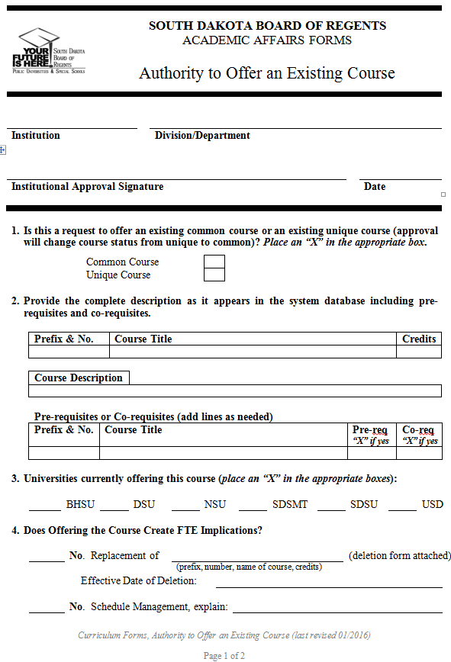

Table 6-3 Authority to Offer an Existing Common Course Form (cont’d)
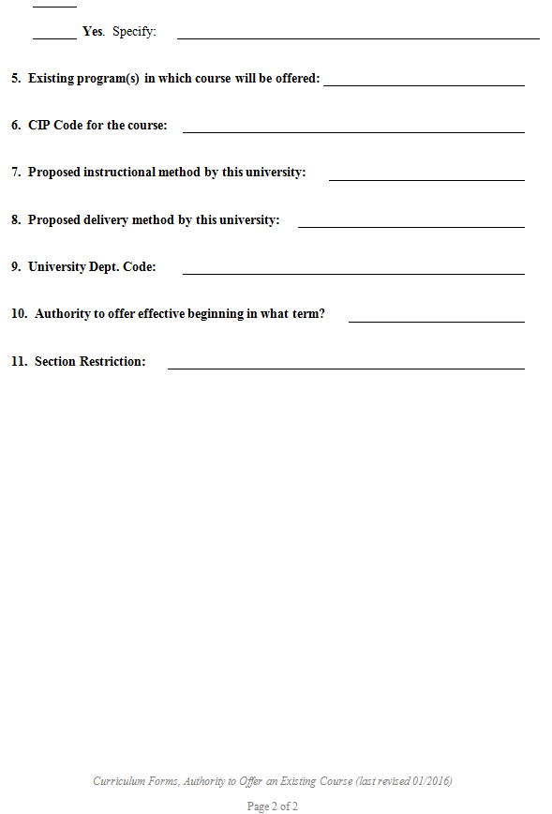

Table 6-4 Experimental Course Notification Form 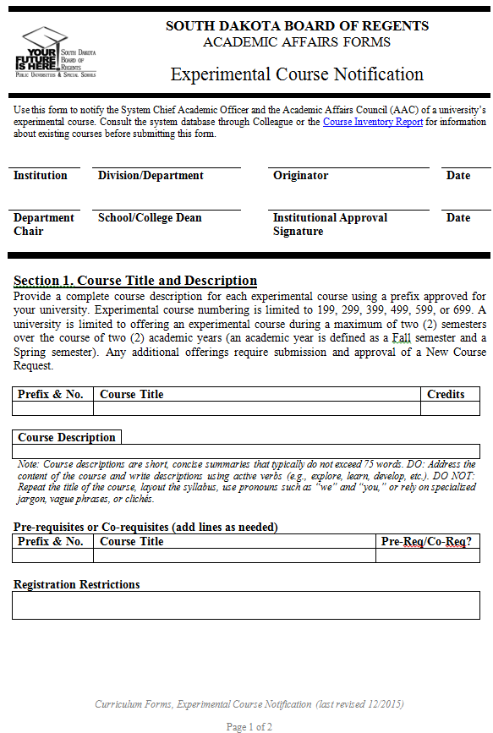
Table 6-4 Experimental Course Notification Form (cont’d) 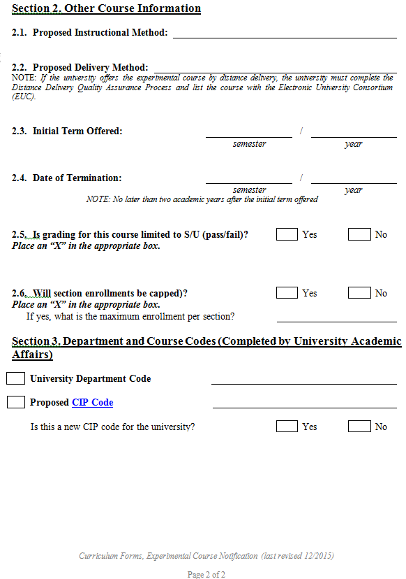

Table 6-5 Existing Courses Minor Course Modifications Form
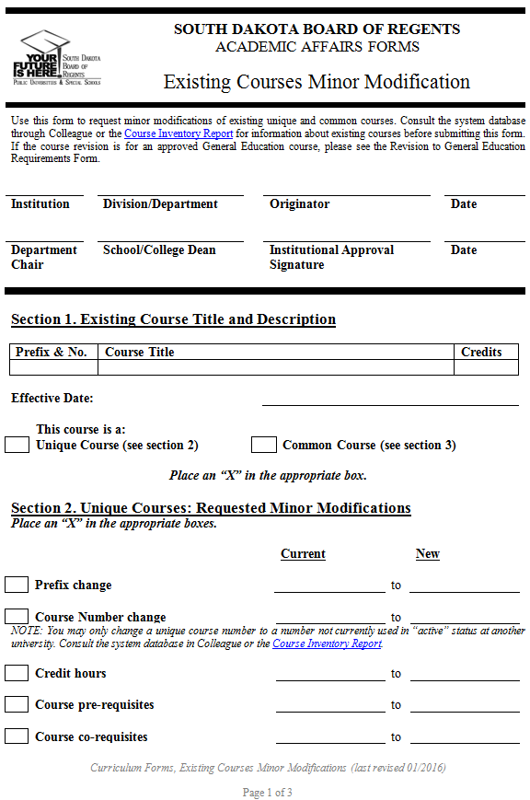

Table 6-5 Existing Courses Minor Course Modifications Form (cont’d)
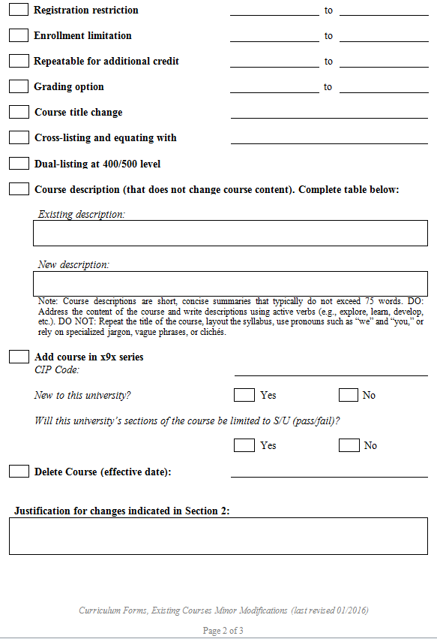
Table 6-5 Existing Courses Minor Course Modifications Form (cont’d)
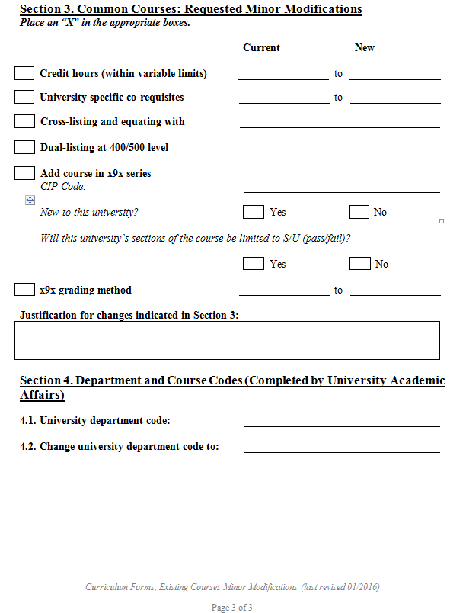

Table 6-6 New Courses Request Form
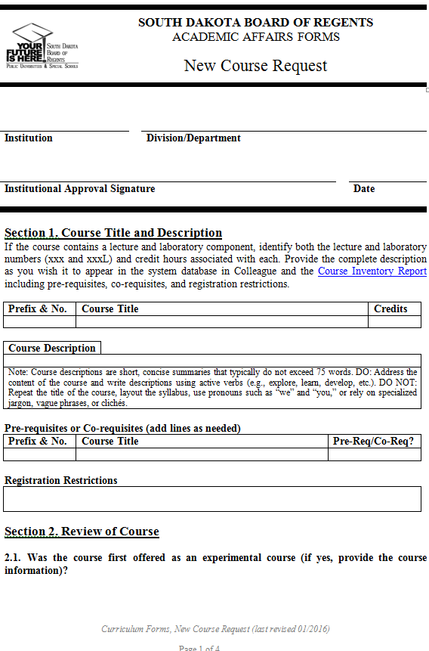

Table 6-6 New Courses Request Form (cont’d)
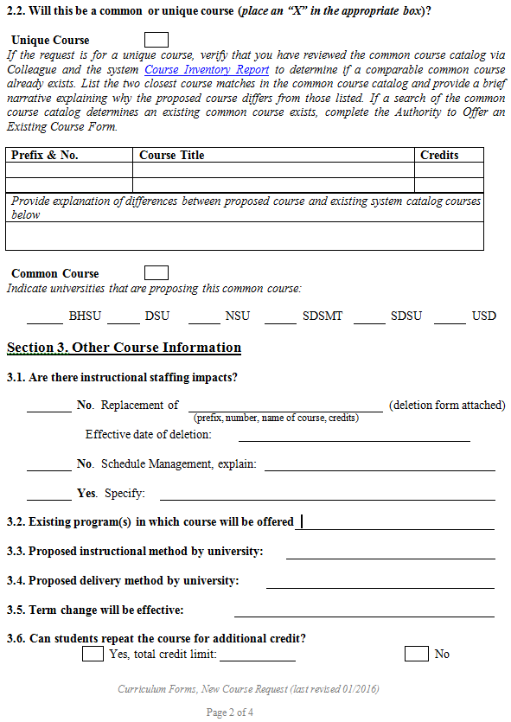

Table 6-6 New Courses Request Form (cont’d)
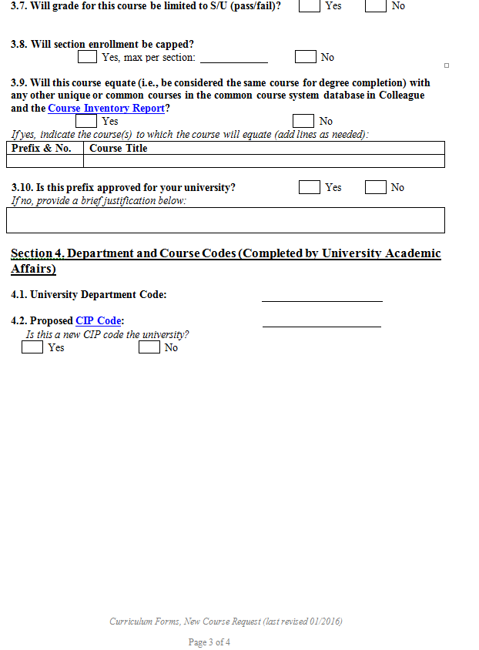

Table 6-6 New Courses Request Form (cont’d)
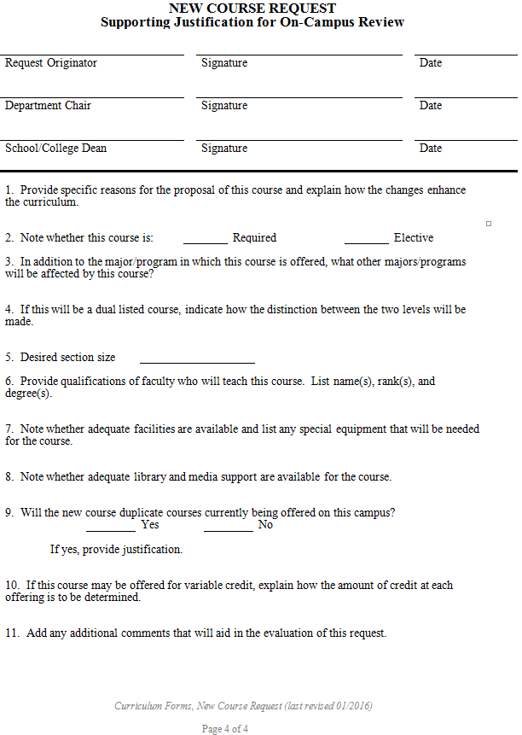
Table 6-7 Revised Existing Course Form - Common Course
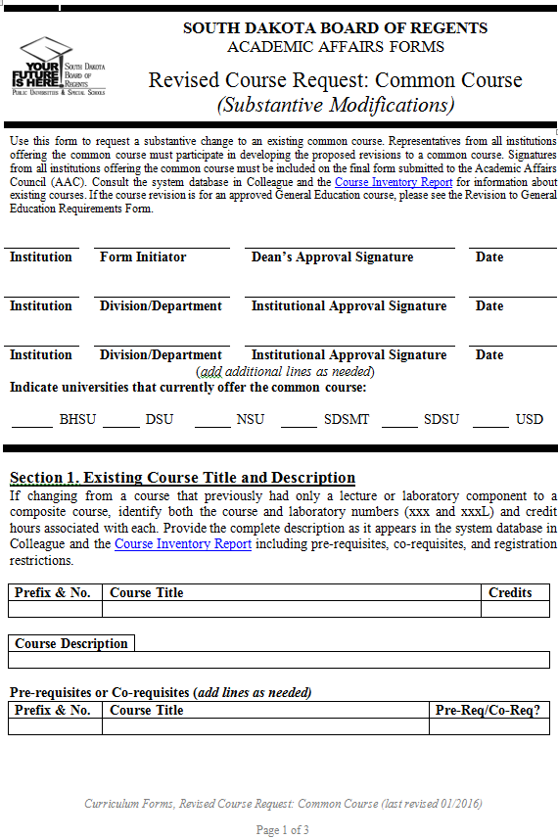

Table 6-7 Revised Existing Course Form - Common Course (cont’d)
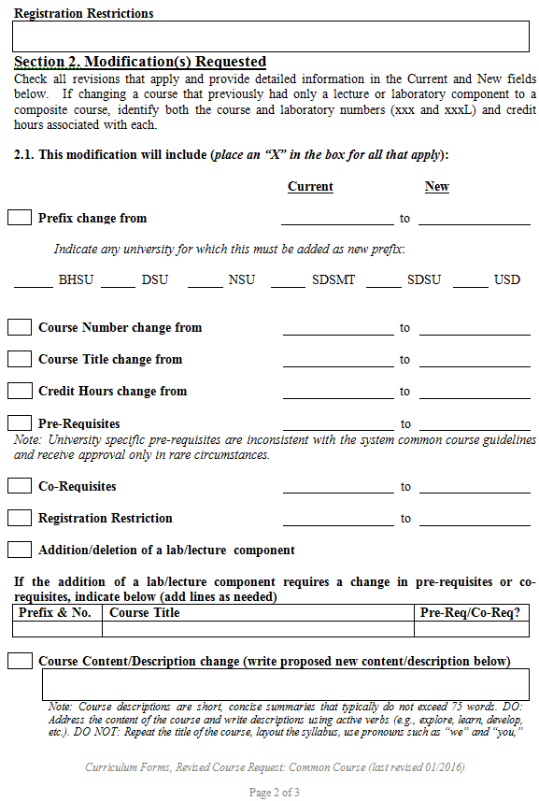
Table 6-7 Revised Existing Course Form - Common Course (cont’d)
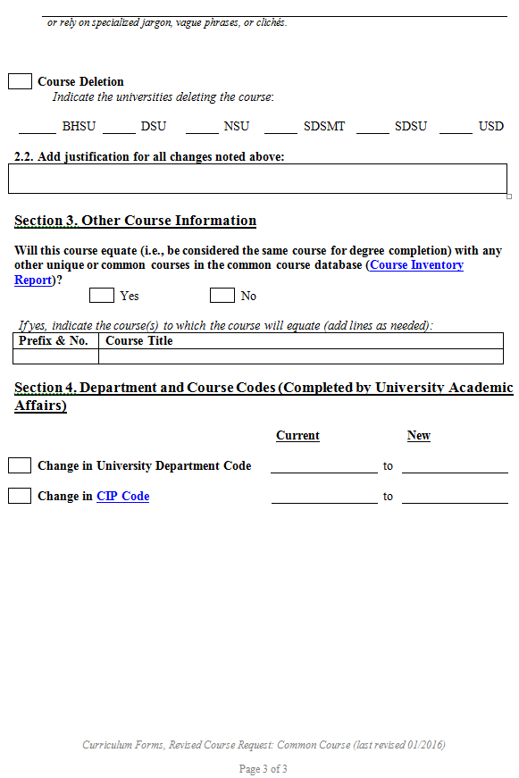

Table 6-8 Revised Existing Course Form - Unique Course 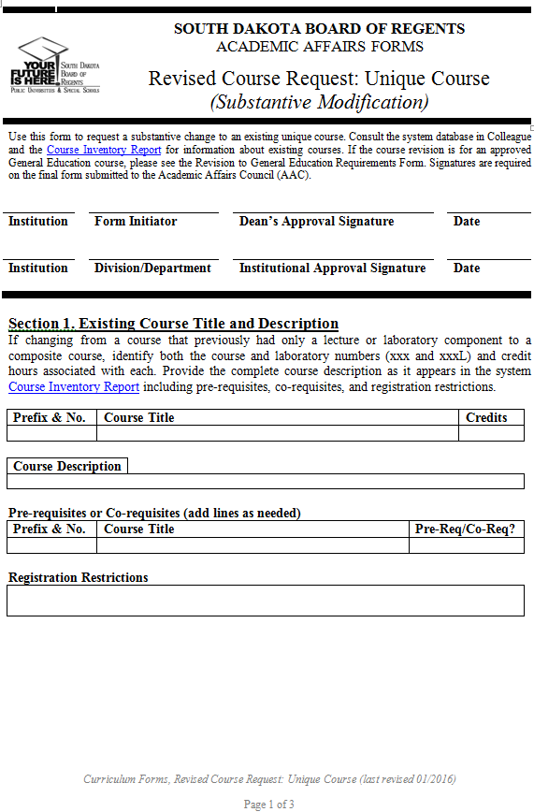
Table 6-8 Revised Existing Course Form - Unique Course (cont’d) 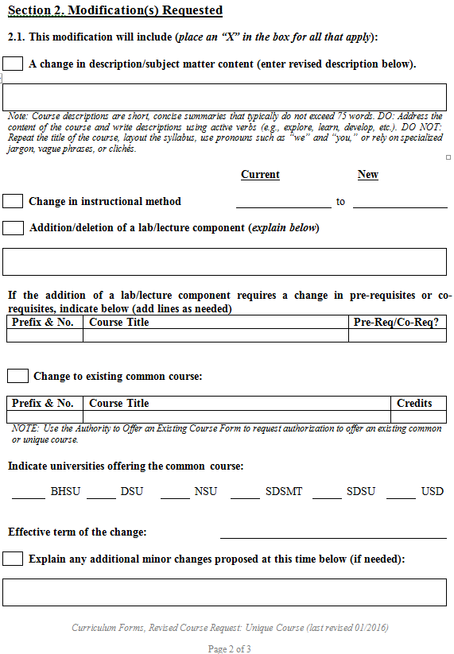

Table 6-8 Revised Existing Course Form - Unique Course (cont’d)
