CRITERION 4 - CONTINUOUS IMPROVEMENT

This chapter contains information on the Continuous Improvement System (CIS) developed and employed by the BS. Met Engineering Degree Program

- Student outcomes
The student educational was reviewed by program faculty and the department’s Advisory Board and upheld as appropriate during the period 2009-2016.
- Apply Knowledge of Math, Science, and Engineering
- Design and Conduct Experiments and Analyze and Interpret Data and Information
- Optimally Select Material and Design Materials Treatment and Production Processes
- Function Well on Teams
- Identify, Formulate, and Solve Engineering Problems
- Know Professional and Ethical Responsibilities and Practices
- Communicate Effectively
- Know Engineering's Global Societal Context
- Engage in Life-Long learning
- Know Contemporary Issues
- Use Engineering Techniques, Skills, and Tools

- Continuous improvement
The BS Metallurgical Engineering Program has employed a Continuous Improvement System (CIS) since 1970. Since 2003 all of the routine tabulation and presentation of results are performed by Excel VBA MACRO automation and posted at www.ABETMetEng.org. This makes all CIS results and data easily available to program faculty, administrators, students, Advisory Board members, and other interested parties at any time. For the ABET visit all CIS documents will be available in hard copy. This Self Study Report contains pertinent summary data and examples of collection documents so that the Program Evaluator will have clear understanding of what documents and records are available for detailed inspection. The CIS process is shown in Figure 4-1. The upper part of the figure shows the process for the continuous evaluation of program objectives, no longer required by ABET, while the lower half shows the process for outcome assessment.

The Metallurgical Engineering Department does not view operating the CIS as an ABET requirement but rather are of the position that ABET requirements will be met as a consequence of the department’s long-established CIS system. Of course, the system has been modified over the years to meet ABET’s interests and requirement for the sake of efficiency. ABET’s discontinuance of Program Objective Evaluation since the last visit would not mean that the program would discontinue that long-established endeavor in the CIS program. Therefore, diagrams such as Figure 4-1 may show processes beyond the scope of the ABET review but are, nevertheless, an integral part of the program’s Continuous Improvement System.

Next, the system for assessing outcomes (e.g. - student educational outcomes) will be discussed. Before presenting the details of the assessment process, it should be noted that the CIS keeps no
Figure 4-1 – The BS Metallurgical Engineering Continuous Improvement System
data by academic year, because using the historical academic year referencing proved very confusing, was the source of many time-consuming recording errors, and stymied clarity in
discussions of curriculum among program faculty. Consequently, all dates in the CIS are strictly calendar year style and everything in the CIS runs by calendar year and has since 2003.

Figure 4-2 shows the Annual Assessment cycle starting in January. The annual reviews of the calendar year’s assessments are completed in the early part of the spring semester and necessary changes to curriculum are made. Changes in curriculum are planned and implemented for the next course offerings. In some cases, those are implemented immediately, but the great majority of changes, the remainder of the spring semester and the summer is available to implement the modifications. Changes occurring immediately are usually anticipated from the results of the previous spring semester interim assessments and so spring semester course syllabi are able to accommodate such adjustments. Experience shows that it is less efficient to implement changes in the summer break, because there is less faculty availability during the summer than during the winter break since faculty are salaried for academic curriculum work during the winter semester break but not during the summer break.

Fall

Sem

Summer Break

Winter Break

Spring Sem
Faculty decide and report on program changes
Faculty acts on recommendations
Program faculty evaluates data and prepares report
Collection of data and information needed for assessment of actions taken
Interim summary of spring semester assessments
Collection of data and information needed for assessment of actions taken

Figure 4-2 - The Annual Cycle of Outcome Assessment and Evaluation

Before describing the CIS system, a description of terms is in order.

Program Educational Objectives: Information for program educational object evaluation is derived from meetings with the Advisory Board, surveys of alumni, and meetings with constituent focus groups. The reports from these groups and the surveys and the program review including actions and accomplishments are stored digitally in the Continuous Improvement System (CIS) computers and uploaded to the CIS website. Access to these files may be attained by contacting Dr. Michael West, Head, Department of Materials and Metallurgical Engineering.

Program Outcomes: Information for the program outcomes is derived from a wide range of sources (called instruments), including student work, presentations, surveys, exams, etc. To the extent that the source of the information is concrete (viz.-student reports, homework), it is stored in hard copy form in the CIS Archive located in the departmental office, MI 115. Currently, these files fill a file cabinet in MI 115. Each of these archival records is accompanied by its score card onto which assessment scores are recorded. When abstract information is used to assess outcomes (viz.- presentations, design fairs), the score cards completed by the assessor are filed in the CIS hard copy archives often with a summary document describing the instrument. All of the score card information is recorded and rendered into summary format digitally and uploaded onto the CIS website. Any file requested by the program evaluator will be available in hard copy at the time of the visit.

To assist the program evaluator in finding and indicating the documents need to review the program’s processes, a summary of its salient elements are listed in Table 4-1 in the order in which information flows for outcome assessment. Each of the items in the table is a document except for abstract instruments such as an oral presentation. Figure 4-3 shows the flow of assessment elements in the CIS. The entire process begins with the Instrument Inventory. There is an Instrument Inventory for each calendar year. It contains a listing of all instruments used for the entire assessment of Outcomes (a – k). Table 4-2 shows the 2015 Instrument Inventory. The inventory consists of instruments that encompass a range of assessment methodologies as described in the headers in columns two through four: Method 1 - Archival Records/Portfolios; Method 2 - Standardized Exams, Simulations, Performance Appraisals, External Examiner, and Oral Exam; and Method 3 - Surveys, Exit Interviews. Using a range of method provides for assessment triangulation that mitigates the effects and identifies the question use of biased methodology.

The inventory is used to automatically generate score cards for each instrument. Figure 4-4 shows a typical score card. There are specific metrics for assessment of each (a-k) outcome. Example metrics are shown in Table 4-3. For each metric there is column on the score card to record assessment results, which consist of a 1, 3, or 5 corresponding to poor, moderate, and high achievement.

The results for each score cards for one year and for one outcome are summarized on an Outcome Summary an example of which is shown in Table 4-4. The outcome summaries are consolidated the Assessment Summary, which shows all outcome results for one year. Table 4-5 shows an example Assessment Summary. Assessment summaries are consolidated over the

Table 4-1 Elements of CIS Outcome Assessment
Instrument | The collection of a specific document, one per student or team, used to assess a Program Outcome. Examples of the specific document may be a completed homework assignment or an exam, faculty member-completed oral presentation assessment form, or students’ standardized exam results.
Score Card | A Microsoft Excel® table document on which the Program Outcome assessment results for one instrument are recorded. These are typically completed by one designated faculty assessor.
Outcome Summary | A Microsoft Excel® table document for a specified Program Outcome onto which the all the score card assessment results for the specified outcome are summarized and tabulated for one calendar year.
Assessment Summary | A Microsoft Excel® document consisting of a Table and a Chart onto which all Program Outcomes results are organized for one academic year.
Grand Summary | A Microsoft Excel® document that shows the assessment results for all outcomes for all years, any one outcome over time, or all outcomes for any selected year.
Outcome Review | A Microsoft Excel® worksheet onto which a designated metallurgical engineering faculty member documents his critical review of a selected Program Outcome for a specified academic year and includes actions needed.
Outcome Review Summary | A Microsoft Excel® worksheet that contains a complete sequential history of the evaluation, actions, and results for one Outcome Review for all years.

years into what is called the Grand Summary. The Grand Summary is a bar chart that shows all the annual results for each outcome over time: a summary of all Assessment summaries. Figure 4-5 shows the Grand Summary for the period 2004 through the last completed assessment year, 2015. Since the CIS is a web-based system, there are many other data presentation and viewing configurations available to the user, but those are of peripheral importance to the Self Study Report so are not described here.

Average outcome assessment showing student achievement above 4.0 is considered to be satisfactory warranting no corrective action. A continuing or trending downward to an average outcome assessment below 3.5 is of great concern and requires action. A watch is usually issued for possible transient moves below 3.5. If the low performance persists, an action is needed. For performance between 3.5 and 4.0, a watch is invoked most often. However, depending on faculty workload and status, actions may be imitated for outcomes scoring in the 3.5 to 4.0 range. Faculty status includes such things as the level of key faculty experience for a particular outcome. That is, new faculty would be expected to improve as they gain experience. This could affect the construction of questions used in archival work used for assessment, their assessment of instruments used in CIS, as well as their instructional effectiveness. These are all considered when deciding on when to initiate an action.

In the CIS the word review is used to determine what action is taken based on the Outcome Summary. (The word evaluation is used to describe program objectives information processing

Figure 4-3 Schematic of the CIS Assessment Process Records

Table 4-2 Instrument Inventory for 2015
Outcome Assessment Plan - Instrument Inventory |  |  |  |  |  | 2015
Criteria |  | Method 1 |  | Method 2 |  | Method 3
 |  | Archival Records/Portfolios |  | Standardized Exams, Simulations, Performance Appraisals, External Examiner, and Oral Exam. |  | Surveys, Exit Interviews
a
Apply knowledge of math, science, and engineering |  | MET 320 - (F) |  | MET 465 - (S) |  | MET 465 - (S)
 |  | . Final Exam |  | . Local Exam |  | . Senior Survey
 |  | MET 330 - (F-odd)
 |  | . Final Exam
 |  | MET 332 - (F-odd)
 |  | . Final Exam
b
Design and conduct experiments Analyze and interpret data and information |  | MET 330 - (F-odd) |  | MET 465 - (S) |  | MET 465 - (S)
 |  | . Tool Lab |  | . Local Exam |  | . Senior Survey
 |  | MET 231 - (S or F)
 |  | . Hardness and Statistics Labs
c
Optimally select material and design materials treatment and production processes |  | MET 465 - (S) |  | MET 465 - (S) |  | MET 465 - (S)
 |  | . Final Design Report |  | . Local Exam |  | . Senior Survey
 |  | MET 465 - (S)
 |  | . Design Fair Presentation Evaluations
d
Function well on teams |  | MET 465 - (S) |  | MET 465 - (S) |  | MET 465 - (S)
 |  | . Final Design Report |  | . Local Exam |  | . Senior Survey
e
Identify, formulate, and solve engineering problems |  | MET 321 - (S-odd) |  | MET 465 - (S) |  | MET 465 - (S)
 |  | . Final Exam (or All Exams) |  | . Local Exam |  | . Senior Survey
f
Know professional and ethical responsibilities and practices |  | MET 465 - (S) |  | MET 465 - (S) |  | MET 465 - (S)
 |  | . Final Design Report |  | . Local Exam |  | . Senior Survey
g
Communicate effectively |  | MET 231 - (S or F) |  | MET 465 - (S) |  | MET 465 - (S)
 |  | . Charpy Impact Lab |  | . Local Exam |  | . Senior Survey
 |  | MET 330 - (F-odd)
 |  | . Student Choice Lab Report
 |  | MET 465 - (S)
 |  | . Final Design Report
 |  | MET 465 - (S)
 |  | . Design Fair Presentation
h
Know engineering's global societal context | MET 321 - (S-odd) |  | MET 465 - (S) |  | MET 465 - (S)
 | . Pyromet Processing Issues |  | . Local Exam |  | . Senior Survey
 | MET 465 - (S)
 | . Design Report Global-Societal Considerations

Table 4-2 Instrument Inventory for 2015 (cont’d)
i
Engage in life-long learning | MET 321 - (S-odd) | MET 465 - (S) | MET 465 - (S)
 | . Cognitive Devel Writing Assignment | . Local Exam | . Senior Survey
j
Know contemporary issues | MET 321 - (S-odd) | MET 465 - (S) | MET 465 - (S)
 | . Pyromet Processing Issues | . Local Exam | . Senior Survey
k
Use engineering techniques, skills, and tools | MET 220 - (S) | MET 465 - (S) | MET 465 - (S)
 | . Microtrack Lab Report | . Local Exam | . Senior Survey
 | MET 320 - (F)
 | . ThermoCalc
 | MET 321 - (S-odd)
 | . Excel Worksheets

rather than outcomes.) As show in Figure 4-2, the program faculty members meet and review the performance of the students as measured by the assessment of the instruments in the inventory.

The usual practice (except for training new faculty) is for each Outcome Summary to be reviewed by a single faculty member. The result of the review is a completed Review an example of which is shown in Figure 4-6. The final step in the review process is for the entire teaching faculty to review all decisions and agree on any needed remedial courses of action. Of course the action is then implemented into the curriculum of the assessment process as needed.

The review process may take into consideration as much additional information as the reviewer deems necessary. Certainly the review must take into consideration the previous year’s recommendations, if any. If the results show consistently high performance, there may be no need to look further into the results; however, large differences in scores among outcomes may require additional analysis. Each review always consists of two parts: 1) review of curricular effectiveness based on assessed student performance and 2) assessment of the functioning of the assessment system. The former having implications on curricular change while the latter suggests changes in the means of measurement.

Every review of each outcome each year results in one of four possible entries being placed on the review form for both the curriculum and the system review: N, W, A, or C denoting the following:
- N - No action
- W - Watch for possible future action
- A - Action
- C - Comment

The last three entries require a written input in the action table on the review form. If no action is needed, no further description is required. The review form shows the previous year’s summary statements and requires a summary statement be entered for the current year. These
statements may be thought of as start-of-the-year and end-of-the-year statements or, if an action was required, actions needed and results achieved. Table 4-6 shows an example summary of all reviews called a Review Summary for all specified years for one outcome. A Review Summary is available for each outcome in Appendix E.

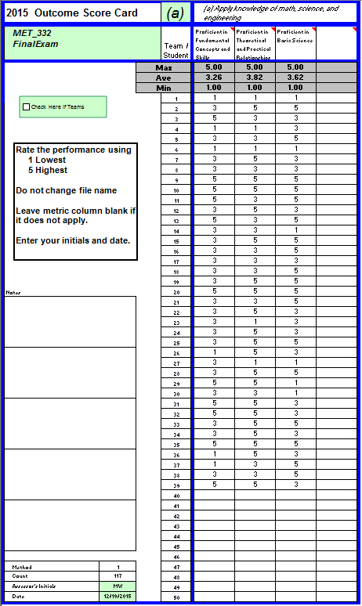

Figure 4-4 –Score Card for Outcome (a) 2015, MET 332 Final Exam example

Table 4-3 Metrics for Outcome (a) example
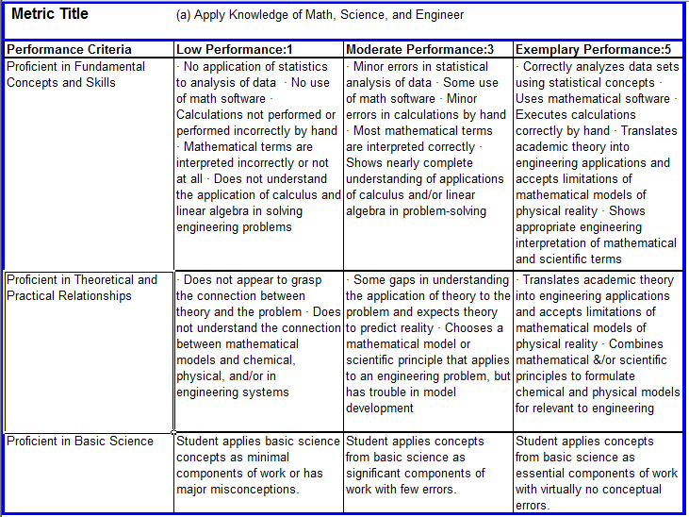

Table 4-4 Outcome Summary (a) 2015 example
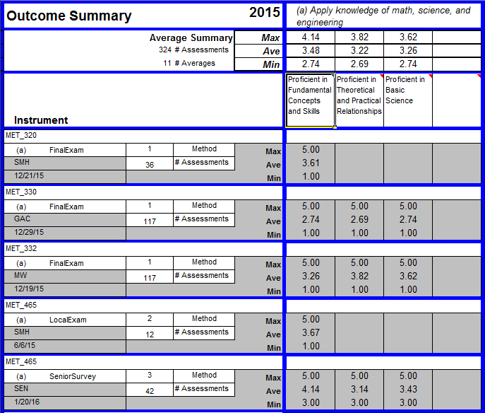

Table 4-5 Assessment Summary 2015 example
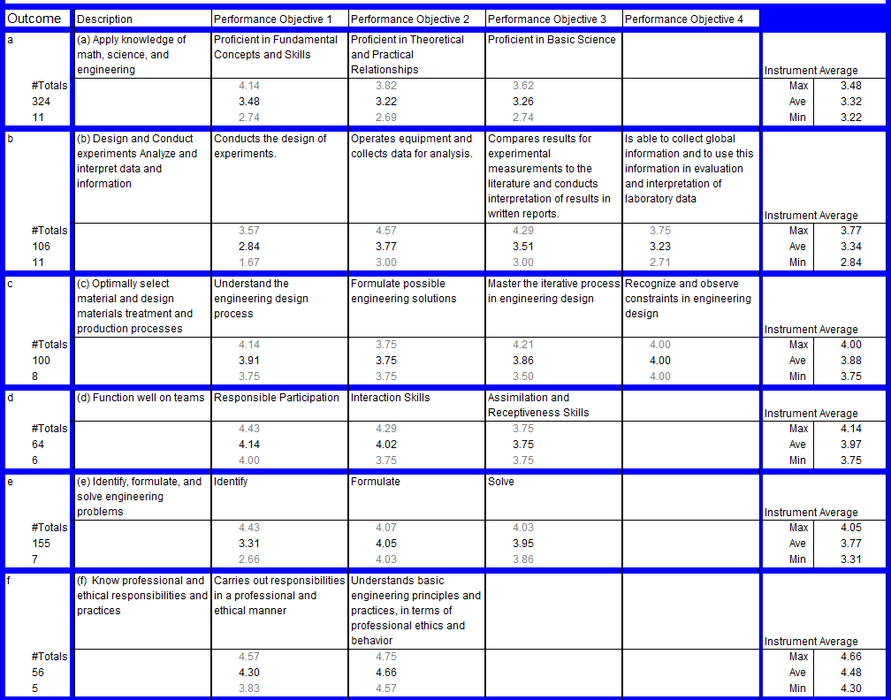

Table 4-5 Assessment Summary 2015 example (cont’d)
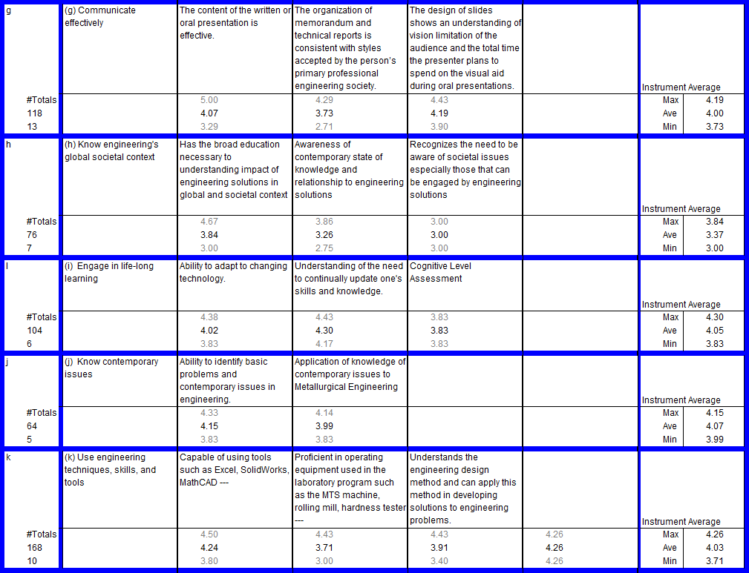

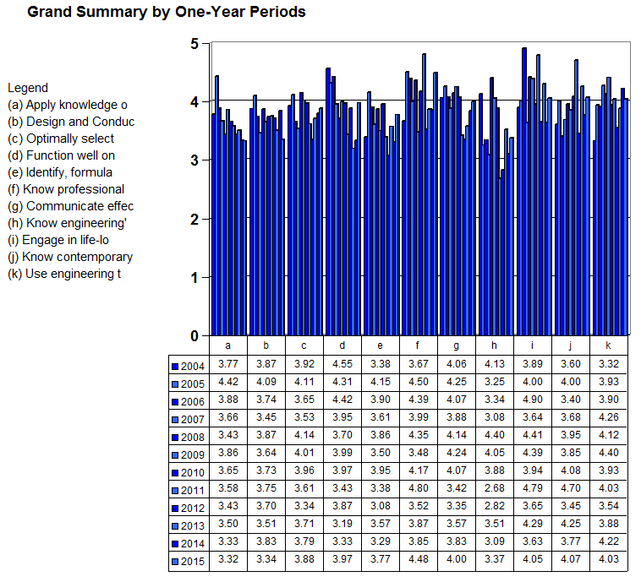
Figure 4-5 Grand Summary of assessment results 2004-2015
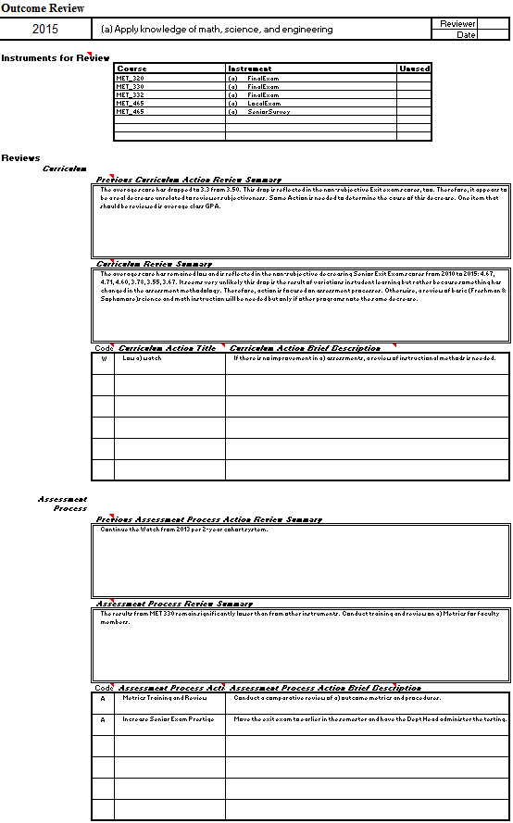

Figure 4-6 Example review of Outcome (a): 2015

Table 4-6 Review Summary for Outcome (a) example
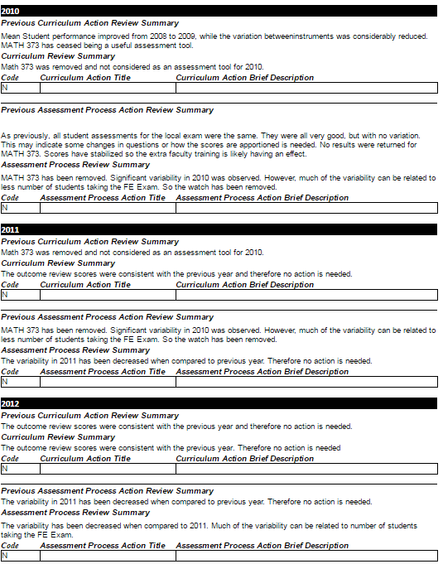

Table 4-6 Review Summary for Outcome (a) example (cont’d)
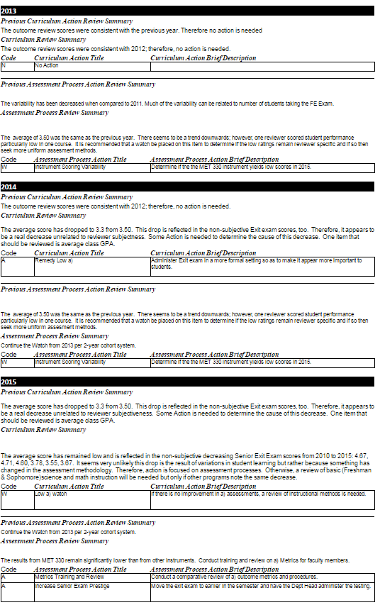

Additional information
Appendix E contains the following additional assessment and evaluation documents for Outcome (a-k):

Outcome Metrics E - 2
- Outcome Assessment Forms E-13
- Outcome Assessment Summaries E-20
- Outcome Assessment Results E-27
- Outcome Reviews E-39
- Alumni Survey Summary E-73
- Advisory Board Reports E-77

Items not present in Appendix E but available in hard copy form at the time of review are

Archival Records

Score Cards

Outcome Summaries

A panoply of Grand Summary renderings including
  - Graphical Summary of each outcome over time
  - Graphical Summary of all outcomes for each year
  - Two-year Averaged Grand Summary

All of this information is also continuously available to program faculty via the CIS web site.

Major curricular changes during 2010-15
Program faculty implemented a number of substantial changes into the curriculum during the last six years since the last ABET visit. These are cited below by outcome and by course.

The outcomes are listed here for convenient reference.
a) Apply knowledge of mathematics, science, and engineering
b) Design and conduct experiments, as well as to analyze and interpret data
c) Design a system, component, or process to meet desired needs within realistic constraints such as economic, environmental, social, political, ethical, health and safety, manufacturability, and sustainability
d) Function on multidisciplinary teams
e) Identify, formulate, and solve engineering problems
f) Understand professional and ethical responsibility
g) Communicate effectively
h) Know the broad education necessary to understand the impact of engineering solutions in a global, economic, environmental, and societal context
i) Recognize the need for life-long learning
j) Know of contemporary issues
k) Use the techniques, skills, and modern engineering tools necessary for engineering practice.

Outcomes
(b)
New design of experiments exercises were introduced in MET 310L beginning in 2012.

(c)
Substantial changes were made to the MET 351/352 and MET 464/465 design sequence in 2012 with more emphasis on material and process selection. In 2013, more open-ended material selection problems were introduced into MET 332 course. (c)

(g)
Both junior and senior faculty made presentations in the design class (Met 351/464) to students attended so the department can form cohesive standards. All faculty members attend their colleagues presentations, and the overall effort led by Dr. Crawford.

(h)
The Global Societal Instructional Module was relocated in the curriculum to the combined Junior-Senior Design Sequence (MET 351/352/464/465).

Courses
MET 110 Introduction to Metallurgical Engineering
Beginning in fall of 2014, Dr. West made the following changes to the MET 110 course content.
1) Introduction of lab specific modules where students were expected to analyze data using software (excel). These changes address analyzing and interpreting data (b), ability to use tools (k).
2) Introduction of a new capstone project on “forensics of artifacts.” In this project, several reputed metallurgical artifacts and materials were gathered from a variety of sources (e.g. reputable galleries, ebay, internet). Student teams then conducted a metallurgical investigation to determine the authenticity of the artifacts. The investigation involved designing a plan using available departmental equipment and extensive use of lab characterization equipment used in metallurgical engineering. The investigation also included historical context of the time periods of metallurgy. These changes are connected to designing and conducting experiments (b), teamwork (d), and modern engineering tools (k).

MET 220L Mineral Processing and Resource Recovery
In the spring semester 2014 Dr. Kellar made substantial changes to the MET 220L course content. Specifically, the scientific and engineering content surrounding individual unit operations remained, but roughly 50 percent of the class was devoted to use of the unit operations on a team-based “real world” mineral separation problem. These changes were made to better engage the students in the laboratory with the goals of improving teaming (d), communications (g), analyze data (a) and to better solve engineering problems (e). For example in 2016 the student teams were separate garnet from spent water jet cutting residue. Some background is warranted here. The water jet in question takes dry garnet (Barton minerals) and injects it with water under high pressure to cut the material in question. The spent water/garnet/fines slurry drops into a collection bed beneath the cut object. The slurry is typically removed and land filled. The manufacturer of the water jet cutter, OMAX, had an interest in recovering and reusing the garnet that still meets the original spec. We use the 80 HPA grade for the waterjet cutter located in the foundry. The MET 220 students found that approximately 30 percent of the garnet falls out of specification during water jet cutting, so the challenge was how to recover the garnet that can be dried and reused. The material from the cutting piece is typically very fine and would report with the smaller, out of specification garnet. The MET 220 project was deliberately left open ended and the students tried sieving, tabling, and magnetic and flotation to separate the materials. The most valuable results were found by dry screening. During this process the student teams had a Q & A session with an OMAX engineer, and gave both final oral and written reports. The final written report was shared with OMAX. http://www.barton.com/wp-content/uploads/2012/03/HPA_PSD_Graph.pdf

MET 231 Properties of Materials Laboratory
Dr. West and Dr. Jasthi developed two new course modules in the last reporting period. In 2013, they developed a lab critique module where students provide feedback to other students on a written laboratory report. In 2014, they developed a new laboratory assignment on mechanical properties of polymers. This was developed in conjunction with mechanical engineering faculty to introduce students to time dependent deformation principles. In 2015, they introduced a new seminar and workshop on technical report writing. In this workshop, faculty worked directly with student teams to re-write one of their early labs. The changes address engineering principles (a), conducting experiments (b), written communication (g), and ability to use engineering tools (k).

MET 310 Aqueous Extraction, Concentration and Recycling (2010, 2012, 2014)
The primary changes in MET 310 related to ABET curriculum outcomes have occurred to address outcomes e, f, h and k. With respect to outcome (e) and (k), homework problems specifically focused on formulating and solving engineering problems and using excel add-ins, like solver, to obtain answers for the engineering problems were added in 2014 and continued in 2016. An ethics-related writing component was added in 2014 and continued in 2016 (outcome (f)). In addition, global and societal context (outcome (h)) was more directly included in a writing assignment beginning in 2014 and continuing in 2016.

MET 310L Aqueous Extraction, Concentration and Recycling Lab (2010, 2012)
Beginning in 2010 and continuing in 2012, Design of Experiments (DOE) components were added to MET 310L. These included multiple lectures on statistics and how they relate to DOE, lectures on using statistical software to perform DOE, and guiding the student groups through designing and performing a 2² full factorial experiment related to leaching of minerals. These changes relate to outcome (b). In the spring of 2014, Dr. Safarzadeh applied some modifications to the MET 310L course content. These modifications include the introduction of experimental design approach for systematic implementation of the experiments to improve (b), and addition of three new experiments which would impact the students’ skills in data analysis (a) and to better solve engineering problems (outcome e). In spring of 2015, professional and ethical responsibilities (f) were emphasized through lectures highlighting the importance of proper literature citations and cases of plagiarism.

MET 320 Metallurgical Thermodynamics
In the fall of 2015, Dr. Safarzadeh offered additional problem-solving sessions (in addition to the regular class meetings) to improve students’ capabilities to apply their knowledge to solve engineering problems (a).

MET 321 High Temperature Extraction, Concentration, and Recycling
In the spring of 2015, Dr. Safarzadeh offered two additional homework to emphasize the contemporary issues (j) and also the global societal context (h) in the context of high temperature processing (pyrometallurgy) of metals. In these homework, the students were assigned two papers to read and submit a summary of the global issues associated with smelting operations.

MET 332 Thermomechanical Processing
In 2011, Dr. West introduced two new in-class team problem solving exercises - one on hardenability of steels and the other on identification of an unknown aluminum alloy using heat treating. In 2013, Dr. West introduced several open-ended alloy selection take-home problems. The changes are linked to applying knowledge of engineering (a), ability to solve engineering problems (e), and teaming (d).

MET 351/352/464/465 Metallurgical Engineering Design
Broadened outcomes (c) and (h) – All design reports were broadened to include formal sections on outcomes (c) and (h). Additionally, faculty members begin making presentations on 1) economic, environmental, social, political, ethical, health and safety, manufacturability, and sustainability constraints and 2) global, economic, environmental, and societal issues .

Design Student Evaluations - Implementation of self-evaluations, peer-evaluations, and faculty evaluations of individual student design performance in the areas of quality, timeliness, teamwork, and overall contribution. The primary reasons for implementing this evaluation program were to (1) encourage strong team performance and contribution from all members, (2) provide a mechanism for evaluating individual student performance in the design course. (d)

Group Evaluations - Group evaluations were developed as anonymous surveys (grouped by design team) where students reflect on their overall group performance, team effectiveness, project suitability, and, more generally, about the design course itself. (d)

Industry inspired design projects - In the Fall of 2013, a new initiative was started to develop industry inspired design projects. In the first year, five industry inspired design projects were developed with five different industry partners. In subsequent years (2014 and 2015), seven industry inspired design projects were conducted each year. In each case, an industry lead and Met faculty member mutually identify ideal design project areas. Industry leads then actively participate as design advisors through weekly design meetings with the student design team. In many cases the industry partners have invited students for onsite visits of their facility. The overall objectives of this initiative were to engage students in practical industry design problems and to provide a mechanism for strengthening ties with relevant industry partners. To date the program has been an extreme success and will be continued in the future. (c), (h), (e)

Round-robin faculty evaluations - During this evaluation period we have modified the manner in which design reports and student oral presentations are evaluated. In this regard, semester design reports are now evaluated by a minimum of three faculty members and all comments are collected and returned to the student team. Furthermore, group oral reports (three per semester) are now evaluated by all faculty members and feedback is collected and returned to the student teams. This form of immediate and broad review has proved beneficial in helping students avoid pitfalls in the design process while also providing significant improvement in technical communication skills. (g)

Individual Technical Assignments – During this evaluation period a each student is required to complete an individual technical assignment which is directly supportive of their design project. This activity was initiated to (1) ensure application of technical skills developed through the MET undergraduate curriculum in the design process, and (2) to encourage full group participation in the design project (preventing so-called “social loafing”). (a), (e), (k)

Project Management Design Content – During this evaluation period, program faculty have made a concerted effort to increase student exposure to project management based content through the introduction of both formal lectures and practical training exercises into the design sequence. (g), (g)

MET 330/330L
Primary changes involve increased emphasis on state-of-the-art materials characterization tools and techniques. (k) Introduction of new laboratory exercises including a new lab focused on teaching the basics of dislocation properties using the “Bubble Raft” model. (a), (b)

MET 422 Transport Phenomena
In fall of 2014, Dr. Safarzadeh emphasized the application of students’ knowledge in transport phenomena in solving metallurgical engineering problems (a) by assigning homework problems that were directly linked to the real-world metallurgical problems.

MET 426 Steelmaking
Dr. Jasthi added the topics on “Early history of Iron and Steel Making” to bring a historical perspective to the students. He also demonstrated several steel making process simulations on “Steel University”. These interactive simulations have been designed as an educational and training tool for students for better understanding of steelmaking operations. These changes are linked to the selection of materials and design of materials for a specific production processes (c).

MET 430/430L Welding Metallurgy and Engineering
Dr. Jasthi developed additional lab modules on laser welding, cold spray and corrosion testing of weld joints. The changes address selection of materials (c), conducting experiments (b), and ability to use engineering tools (k). Dr. Jasthi also added several new sections to the course curriculum related to welding issues and corrosion in weldments. These topics are connected to the application of knowledge of science and engineering (a) and with the materials selection (c)

MET 440/440L Mechanical Metallurgy and Mechanical Metallurgy Laboratory
Introduction of new laboratory exercises including laboratories on fracture toughness testing, fatigue testing, and nanoindentation. (b), (k)

MET 445 Oxidation and Corrosion of Metals
Dr. Jasthi developed few lab modules on electrochemical corrosion testing during the last reporting period. With this introduction of these new lab modules, the students were able to get hands-on experience and were able to conduct experiments, analyze and interpret the data (b).

MET 450 Forensic Engineering
Course module on failure analysis of microelectronics was added. (e)

(intentionally blank)

