CRITERION 2 - PROGRAM EDUCATIONAL OBJECTIVES

The terms and definitions used throughout this report are consistent with ABET publications and guidelines. Appendix F contains a glossary of important terms used throughout this self-study document.

A. Mission statement
The Mission of SDSM&T is codified in state statutes (SD Codified Law Statute 13-60-61) and defined in SDBOR Policy 1:10:3. As articulated in state law, the mission is worded for lawmakers for policy purposes and does not speak clearly and effectively to the public at large. In fall 2013, the mission and vision were expressed as a single clear and aspirational statement. This statement is used for planning and is the effective mission of SDSM&T. It is found at http://www.sdsmt.edu/About/Office-of-the-President/Vision-and-Mission/ and worded as follows:
Our vision is for the South Dakota School of Mines and Technology to be recognized as an exceptional engineering and science university. Our mission is to prepare leaders in engineering and science, to advance knowledge and its application, and to serve the state of South Dakota, the region, and the nation.

The goals of the Strategic Plan were established in fall 2012. Delay in full articulation and publication of the Strategic Plan was the result of then President Warton’s untimely death followed by the Provost assuming for one year the dual role of Interim President and Provost.

The Executive Council revisited in 2013 the institutional values as articulated in 2011 through a campus-wide process. The value of “excellence” was added, and the values are published on the back cover of the Strategic Plan. The values of the institution are as follows: Excellence, Respect, Integrity, Collaboration, and Service. Between October 2013 and January 2014, the academic departments and center directors were asked to take the Strategic Plan goals articulated in 2012 and to create a 2-5 page summary of priorities, initiatives, and ideas for development. The summaries were universally shared, and an all-campus meeting that included key external stakeholders was held. Six overarching themes were discussed. The considerable feedback from this open planning session was studied and used to update and more fully flesh out the Strategic Plan goals and to ensure congruence between mission and program development. Table 2-1 shows the summary flyer of the Strategic Plan. More details and information on the Strategic Plan is available at http://www.sdsmt.edu/About/Strategic-Plan/.

The feasibility-study phase of a capital campaign was also executed in 2014. The president of the foundation and the president of the institution traveled to visit 45 major donors, partners, and alumni in 20 cities to get input on the strategic plan and issues of mutual concern. Input from these constituents was used to ensure congruence between mission, program development, and constituent needs. The In Pursuit of Excellence: Mines Strategic Plan was published in late spring 2014 and updated in fall 2015. The institution is managing to the six goals as articulated

Table 2-1 Mines Strategic Plan
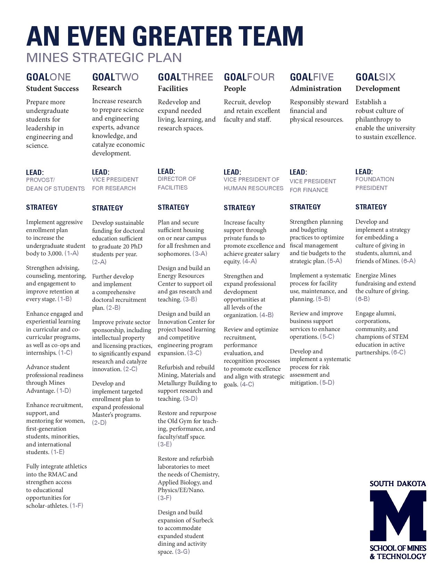
in the 2014 Plan. SDSM&T follows an annual cycle to review, update, and refine the six goals of the Strategic Plan. Progress on the goals is reviewed twice annually. Additional information on the SDSM&T Foundation is available at http://foundation.sdsmt.edu/

The context of SDSM&T in the South Dakota Higher Education System helps ensure fidelity between institutional program array and mission. The institution has a clear role in the System as a demanding STEM-focused institution and members of the executive leadership team, including the president and all the vice presidents work through system-level advisory councils (e.g., The Council of Presidents and the Academic, Business, and Student Development councils). Governance of all institutions in the system by a sole Board of Regents and a broad spectrum of system-wide councils, committees, and task forces promote collaboration and reinforce the distinctive contributions and strengths of each university in the SD system.​

The mission of the Department of Materials and Metallurgical Engineering appears in the catalog and on the web site at http://www.sdsmt.edu/Academics/Departments/Materials-and-Metallurgical-Engineering/Accreditation---Assessment/.

The Mission of the Department of Materials and Metallurgical Engineering is to
- Provide a quality program leading to the degree BS in Metallurgical Engineering
- Participate in multi-disciplinary programs leading to the MS and PhD degree programs in materials engineering and science
- Contribute to the expansion of knowledge in the area of materials and metallurgical engineering through scholarly activities
- Help local, regional, national and international materials and metallurgical industries through research and development activities

B. Program educational objectives
The objectives of the BS in Metallurgical Engineering Degree program are to graduate students who can
- Successfully apply metallurgical engineering principles in their employment
- Meet societal needs through science and technology
- Grow professionally and personally
- Serve their profession and community

These objectives appear on the departmental bulletin board, on the departmental web page http://www.hpcnet.org/ABETMetEngMissionObjectives, in the 2010-2011 university catalog, and on selected departmental promotional literature.

Figure 2-1 shows an overall view of the university vision; the university and department, and program mission; and the program objectives.

C. Consistency of the program educational objectives with the mission of the institution
The metallurgical engineering program objectives are derived from the institutional mission. Table 2-2 shows the relationships among the institutional and the metallurgical engineering program objectives.

Figure 2-1 Overview of Vision, Missions, and Objectives
Table 2-2 Alignment of the BS Metallurgical Engineering program objectives with SDSM&T institution’s objectives.
SDSM&T Mission  BS MET ENG | Prepare Leaders in Engineering and Science | Advance Knowledge and Application | Serve the State of South Dakota, Region, and Nation
Apply Met Eng Principles
Meet Societal Needs
Grow Prof & Personally
Serve Community & Profession

D. Program constituencies
The program constituents are those who employ our graduates. These are
- Private industry
- Public agencies
- University graduate programs
- Self-employed entrepreneurial alumni

Constituent input is gained during the Materials and Metallurgical Engineering Advisory Board meetings and through input from alumni as they visit campus throughout the year. The Advisory Board includes alumni so they represent now-informed (former) student interests.

Undergraduate students in the BS Metallurgical Engineering program are considered a special constituency group in the area of providing direct feedback on the quality of the classroom and laboratory instruction for required and elective courses in the program. They do not have sufficient experience or knowledge to be considered a constituency group for evaluation and revision of PEOs. Each academic semester these students have opportunity to provide feedback into the program in the form of the student evaluations that are mandatory for every class taught every semester by Assistant and Associate Professors and once every three years for Full Professors. The university uses the IDEA Student Ratings of Instruction instruments. These data are collected and maintained by the Department Head and are discussed with individual faculty each semester the student ratings are completed. Student ratings constitute substantial portions of the individual faculty member’s promotion and tenure review process, as well as providing information on areas to adjust curriculum based on student expectations. Recent graduates, having gained some perspective, are highly valued as part of the program’s objectives and student outcomes review process.

E. Process for establishing program educational objectives
The department has a long tradition of external evaluation dating to 1970. Periodic surveys of both alumni and their employers were routinely performed and acted on. The department was the source of the current campus student opinion surveys starting in 1971. The department was also the point of initiation for Industrial Advisory Boards (now called the Advisory Boards) beginning in 1972.

The design of the continuous improvement system began in 2000 and was followed by a staged collection of materials beginning in the 2001-2 academic year. During the subsequent two years, the system was continually refined and brought to full implementation. Although informal reviews and system refinements were occurring on a weekly basis throughout 2001-2003, the first comprehensive objective review involved all data collected up to the end of 2003. This initial “closing of the loops” occurred during the Spring Semester of 2004. During the period from 2001 to 2004 the entire department faculty has met once or twice a week during the academic year to create the continuous improvement system now in place. Departmental faculty members also attended ABET training sessions and numerous campus sessions on continuous improvement methodologies. With the substantial faculty retirements (Stone, Han, and Marquis) from 2005-2007, subsequent biannual Advisory Board reviews were renewed in 2007 with the newly contracted faculty (Medlin, West, and Cross). Subsequently, the board met in 2009, 2011, 2013, 2015, and again March 4, 2016 in review of the upcoming ABET review as well as planned implementation of new Student Educational Outcomes.

As departmental faculty members have retired and been replaced, new faculty members unfamiliar with the department’s continuous improvement system undergo extensive training. As of 2015, all program faculty members are well versed and directly involved in supporting and managing the continuous improvement system. All teaching faculty members in the metallurgical engineering program are actively engaged in periodic reviews of the program educational objectives. The program faculty members are asked to review the objectives each year for appropriateness and thoroughness. Reviews are also conducted by the Advisory Board which reflects our constituents.

The Program Objectives and the Student Educational Outcomes have been reviewed periodically by the Metallurgical Engineering Advisory Board. The board is comprised historically of representatives primarily from industry but occasionally there is governmental laboratory and outside university representation. The SDSM&T MES faculty members represent graduate program representation and recent program alumni are reflections of informed student opinion.

The composition of the 2013-2018 Advisory Board is as follows:
- Terry Rasmussen, Nucor, Board Chairman
- Dr. Ray Peterson, Aleris International, Past Board Chairman
- Ms. Wendy Craig, Gerdau Steel
- Ms. Jenifer Galvin, SDSM&T MS Candidate*
- Mr. David Gildemeister, Alcoa
- Ms. Michelle Jensen, SDSM&T MS Candidate*
- Mr. Andy Johnson, AdvTech-Consulting
- Mr. Wayne Douglas, Barrick
- Mr. Christopher Misterek, John Deere
- Ms. Lisa Schlink, Freeport-McMoRan
- Mr. Shawn Veurink, RPM and Associates
- Mr. John Walenta, Caterpillar Inc.
- Mr. Richard Wensel, Micron Technology
* Recent Alumni
The department holds regular meetings with its Advisory Board to conduct a review of Program Objectives and the department’s success in achieving them. The review also includes a re-examination of the objectives to assure they are current and significant. Informational material presented to the board includes placement data, curriculum changes, continuous improvement assessment data, faculty professional activities, funding status, enrollment data, and laboratory and equipment status. The board members are selected to represent as many of the program’s constituents as possible.

The Advisory Board used to be provided surveys from employers and constituents but that has been replaced by populating the board with those who have first-hand knowledge of graduate performance through their employer positions. The board is asked to offer input on specific topics such as the currency of the program and the adequacy of education objectives. The board is encouraged to offer any constructive comments. The Advisory Board reviews are held approximately every two years. They also serve as the constituent focus group. The program faculty members consider and implement recommendations of the board. The review culminates with action statements that are posted on the program’s continuous improvement web site (www.ABETMetEng.or/SD). Figure 2-2 shows the process to determine progress in meeting program outcomes.

Evaluate
and
assess
Determine outcomes required to achieve objectives
Determine
how outcomes will be achieved
Determine how outcomes will be assessed
Establish indicators that objectives are being achieved
Instruction and student activities
Input from constituencies
Determine educational objectives

Loop 2
(ABET)
Loop 1

Figure 2-2 Continuous Improvement System (CIS) for the metallurgical engineering program

(intentionally blank)

