Part IV

Outcome Assessment Summaries
2004-2009

Contents
Outcome Assessment Summaries(a) E-27
Outcome Assessment Summaries(b) E-28
Outcome Assessment Summaries(c) E-29
Outcome Assessment Summaries(d) E-30
Outcome Assessment Summaries(e) E-31
Outcome Assessment Summaries(f) E-32
Outcome Assessment Summaries(g) E-33
Outcome Assessment Summaries(h) E-34
Outcome Assessment Summaries(i) E-35
Outcome Assessment Summaries(j) E-36
Outcome Assessment Summaries(k) E-37

These summaries show the evaluation of previous year actions and the statement of new actions.

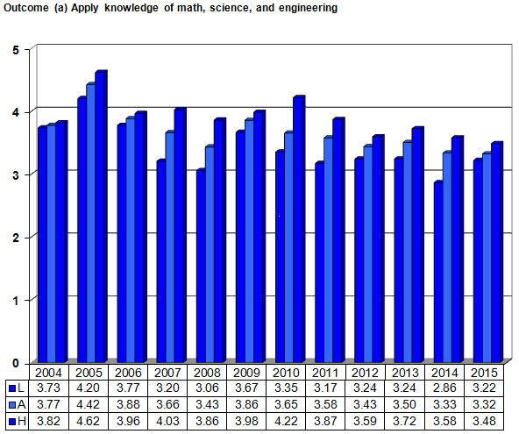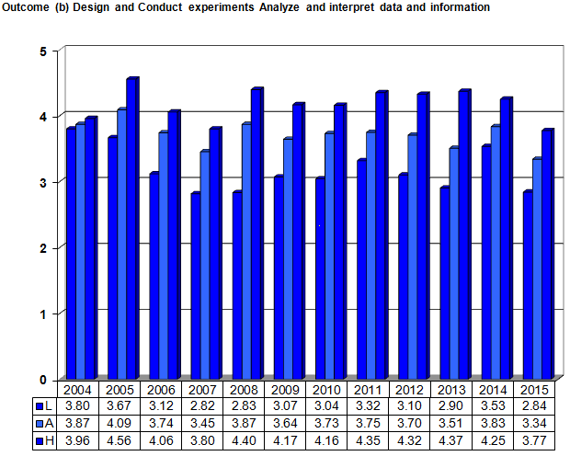
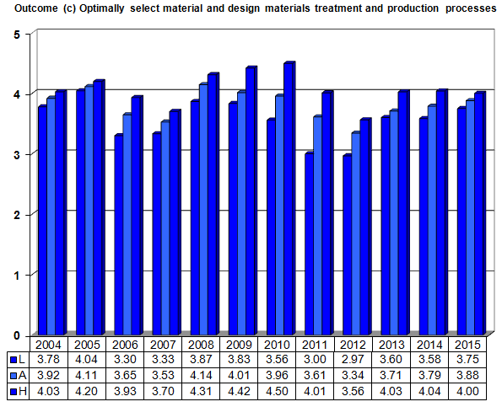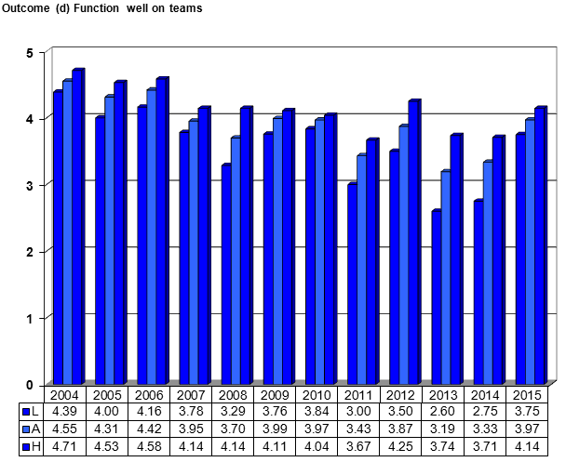
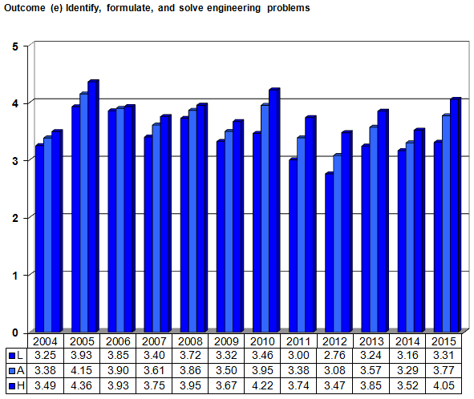
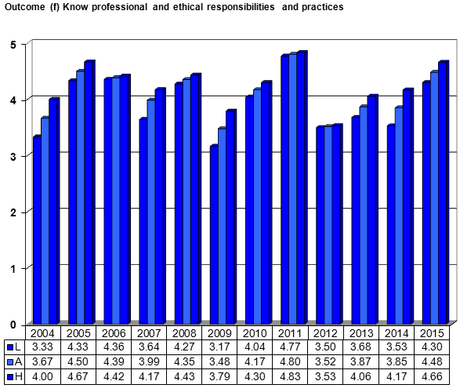
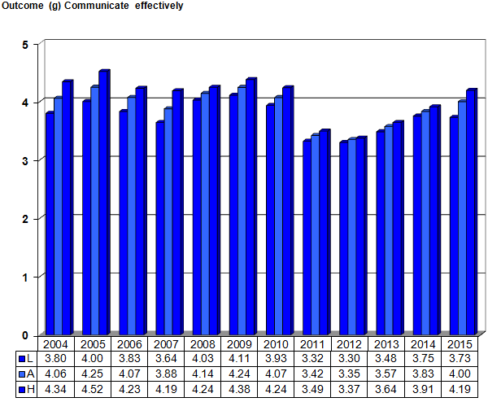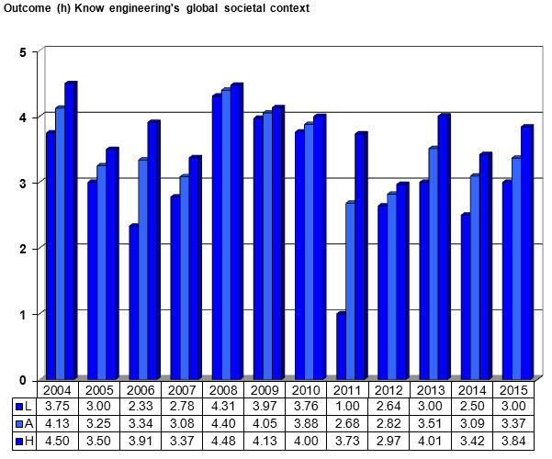
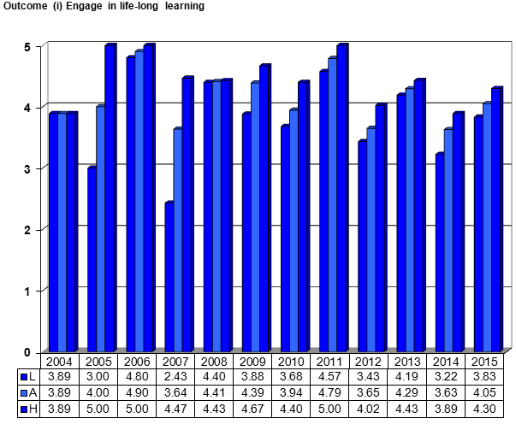
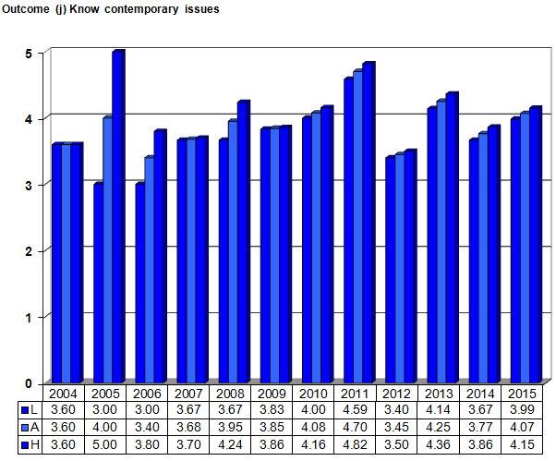
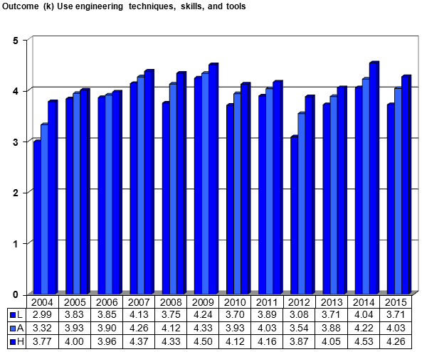

Part V

Outcome Reviews and Actions

Outcome reviews contain a summary of all conclusions deriving from outcome assessment, actions taken if warranted, and the results of such actions. The always contain reviews of two major elements: 1) the curriculum as it pertains to student performance and 2) the assessment process so as to focus on effective and efficient methods.

Contents
Review for Outcome (a) E-39
Review for Outcome (b) E-42
Review for Outcome (c) E-45
Review for Outcome (d) E-48
Review for Outcome (e) E-51
Review for Outcome (f) E-54
Review for Outcome (g) E-57
Review for Outcome (h) E-60
Review for Outcome (i) E-63
Review for Outcome (j) E-66
Review for Outcome (k) E-69

Review Summary (a)
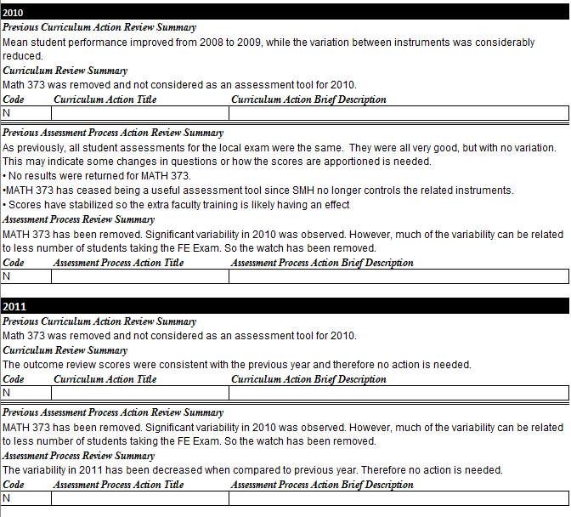

Review Summary (a) (cont’d)
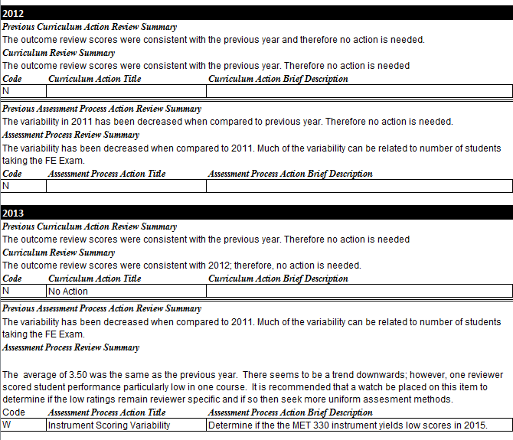

Review Summary (a) (cont’d)
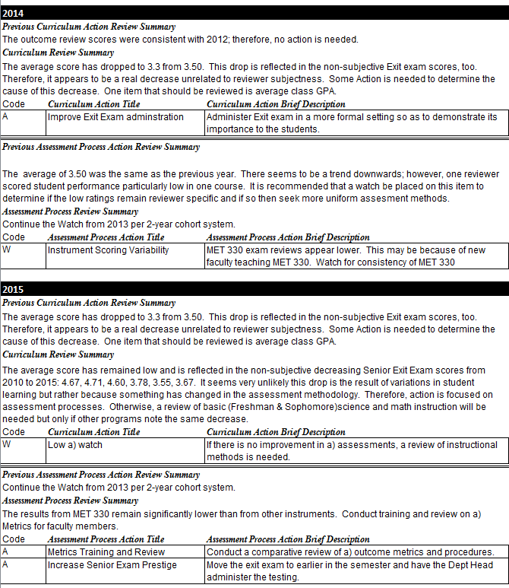

Review Summary (b)
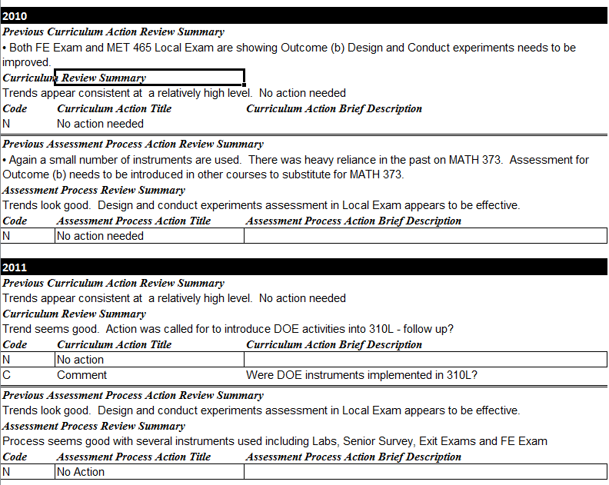

Review Summary (b) (cont’d)
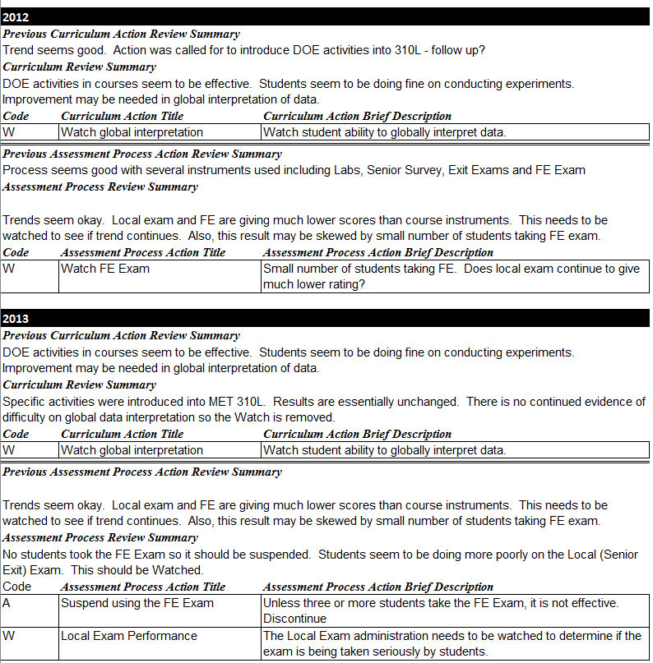

Review Summary (b) (cont’d)
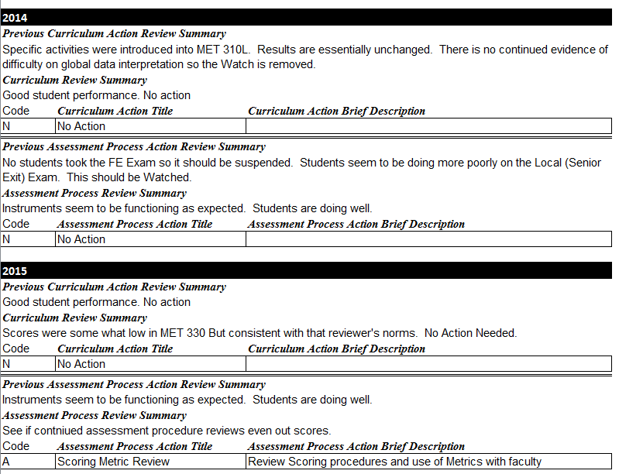

Review Summary (c)
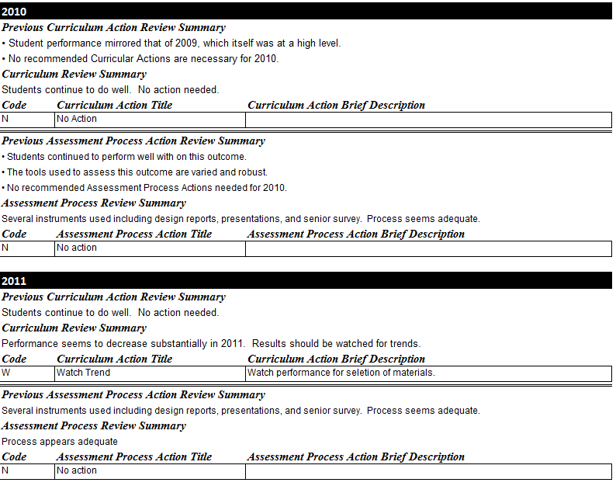
Review Summary (c) (cont’d)
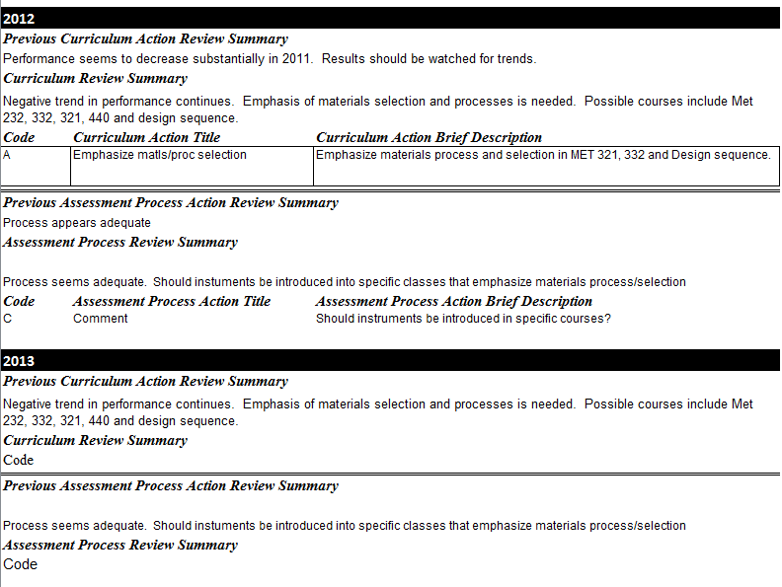

Review Summary (c) (cont’d)
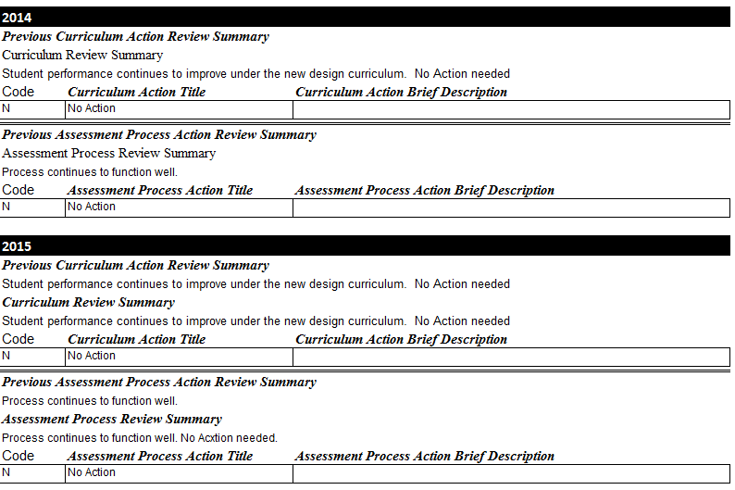

Review Summary (d)
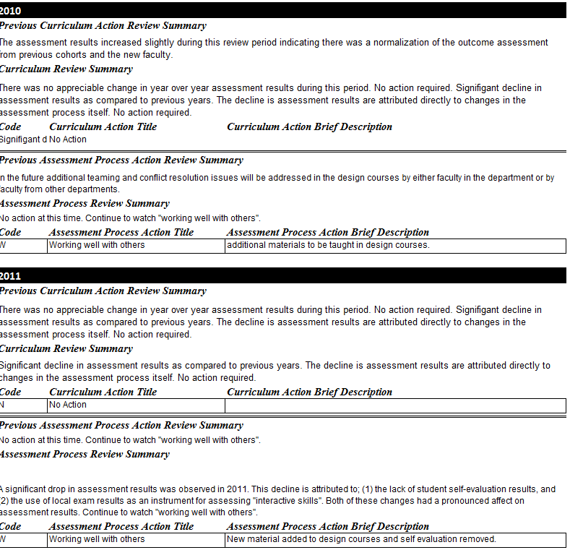

Review Summary (d) (cont’d)
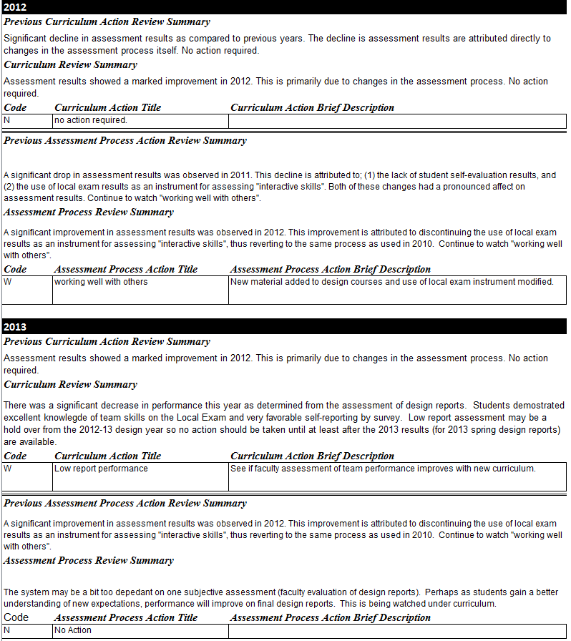

Review Summary (d) (cont’d)
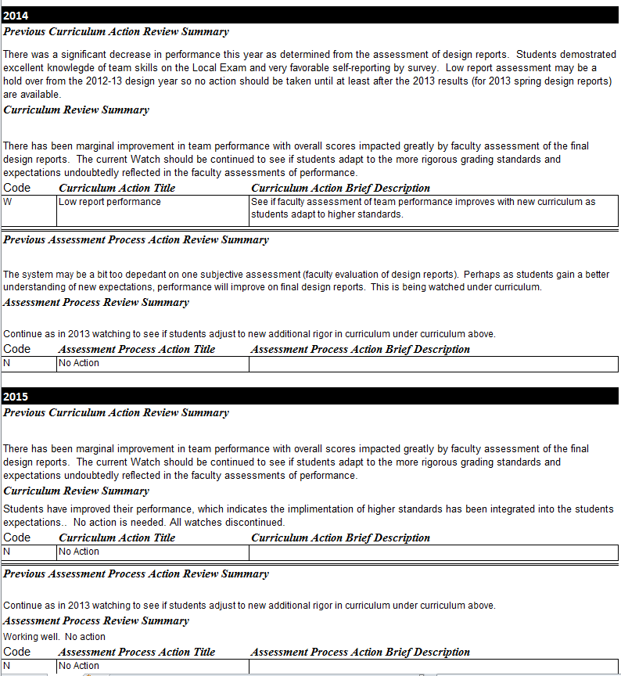

Review Summary (e)
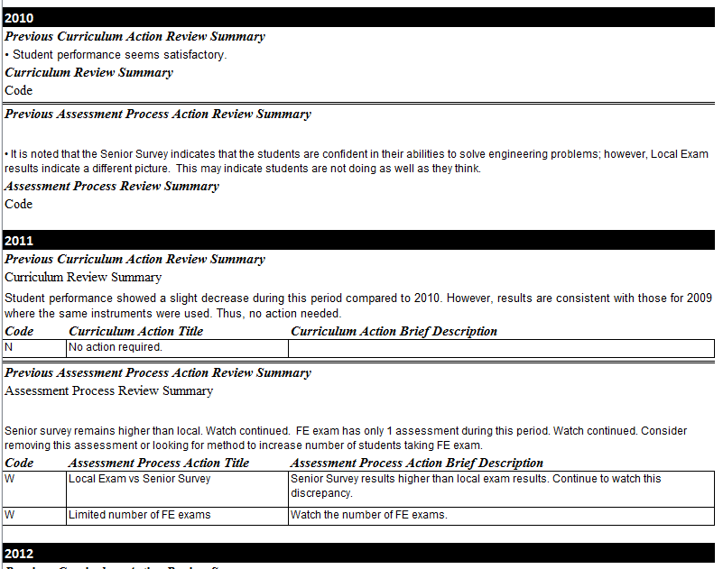

Review Summary (e) (cont’d)
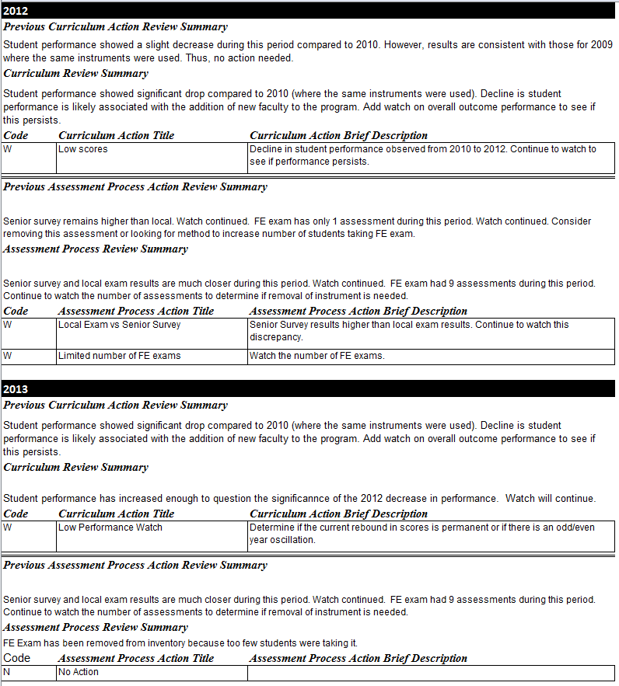

Review Summary (e) (cont’d)
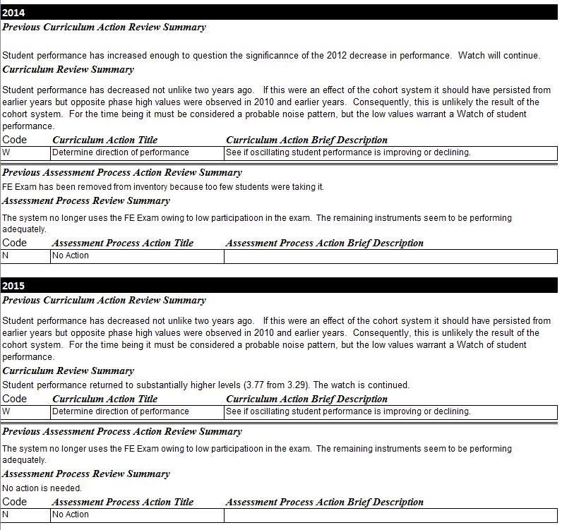

Review Summary (f)
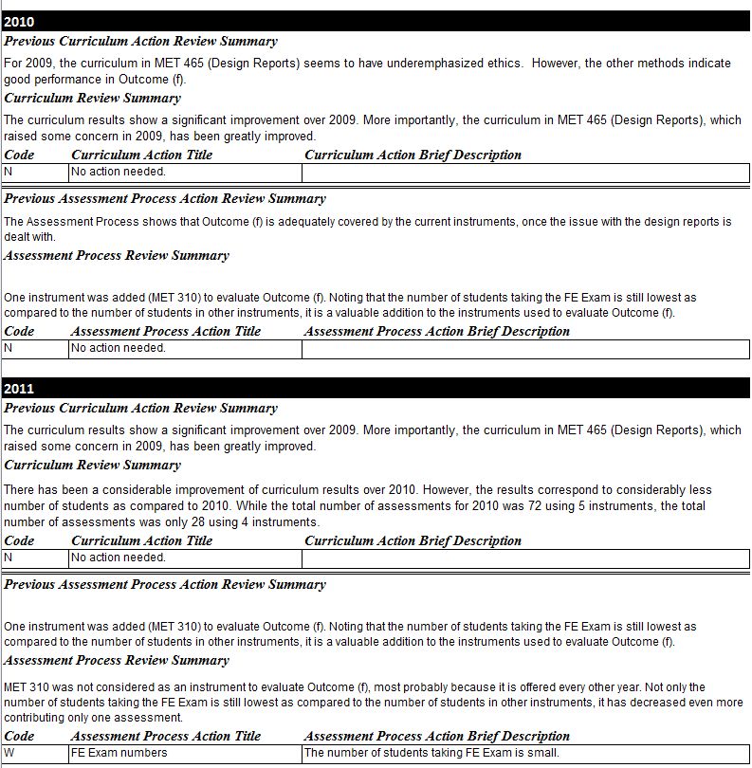

Review Summary (f) (cont’d)
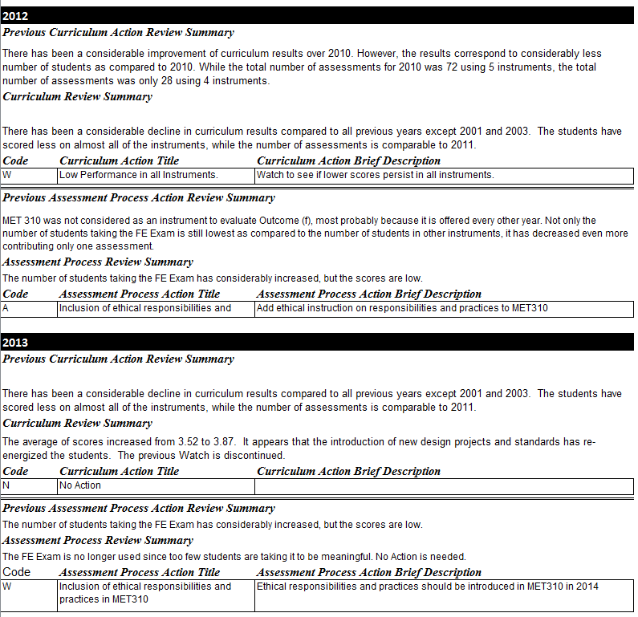

Review Summary (f) (cont’d)
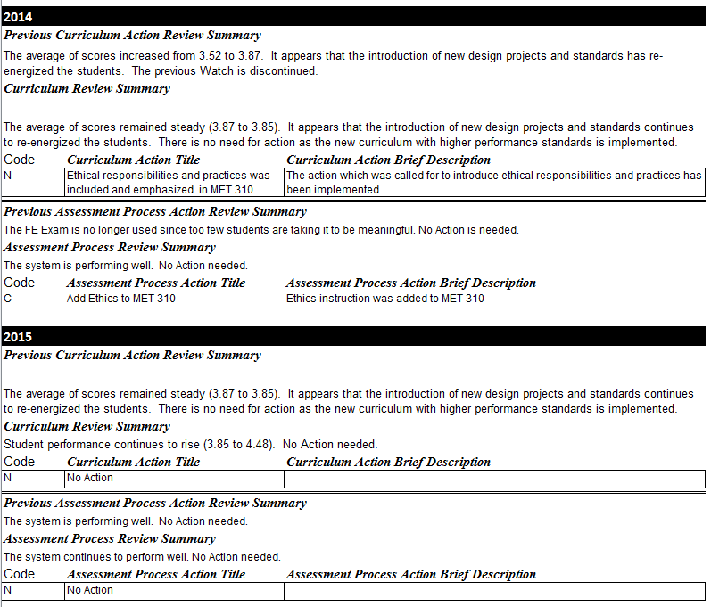

Review Summary (g)
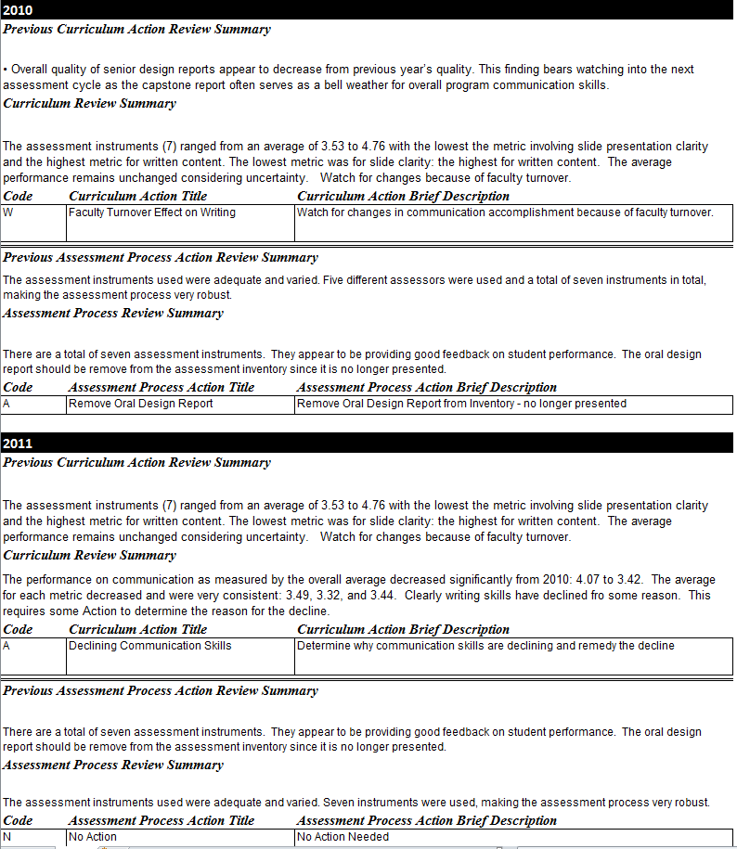

Review Summary (g) (cont’d)
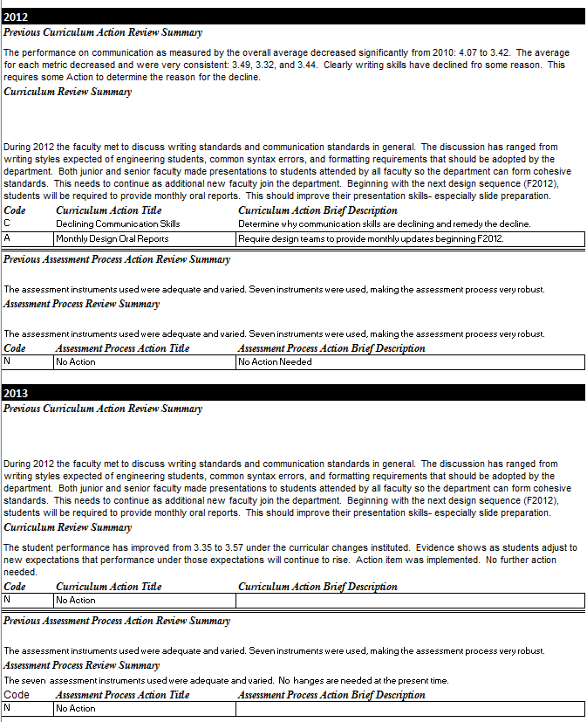

Review Summary (g) (cont’d)
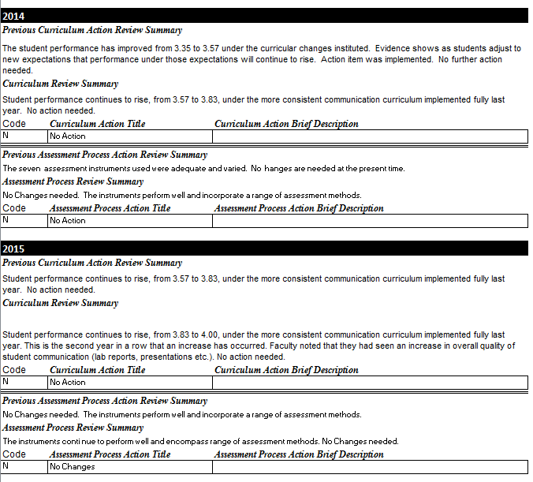

Review Summary (h)
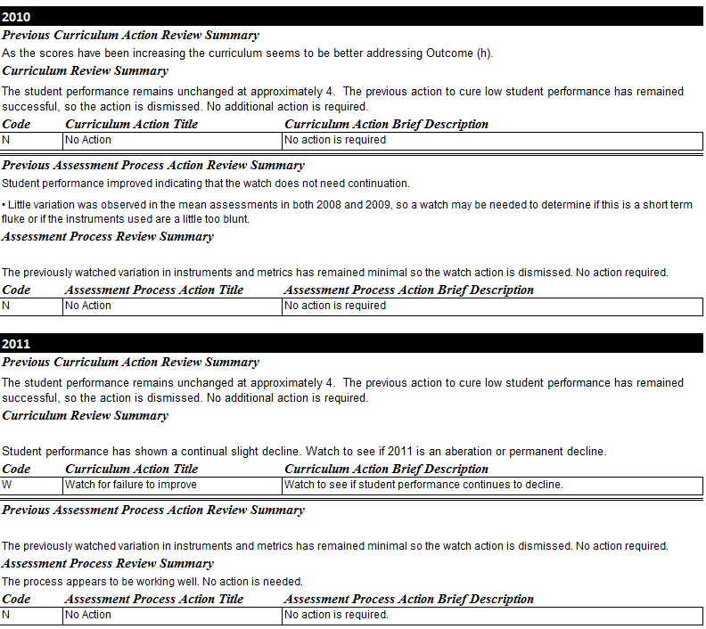

Review Summary (h) (cont’d)
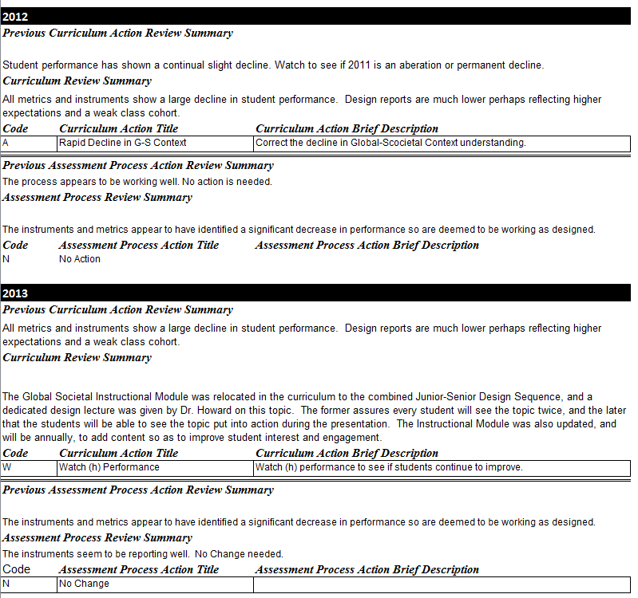

Review Summary (h) (cont’d)
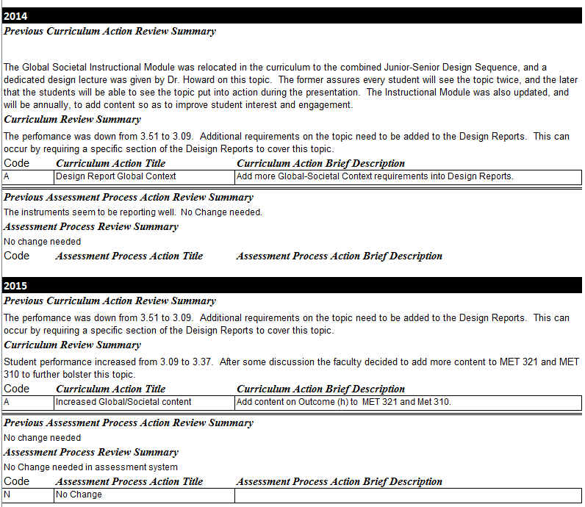

Review Summary (i)
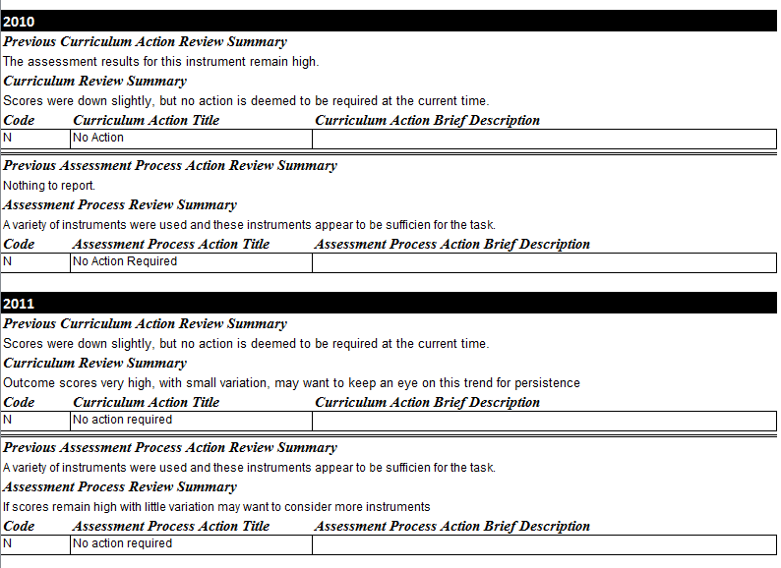

Review Summary (i) (cont’d)
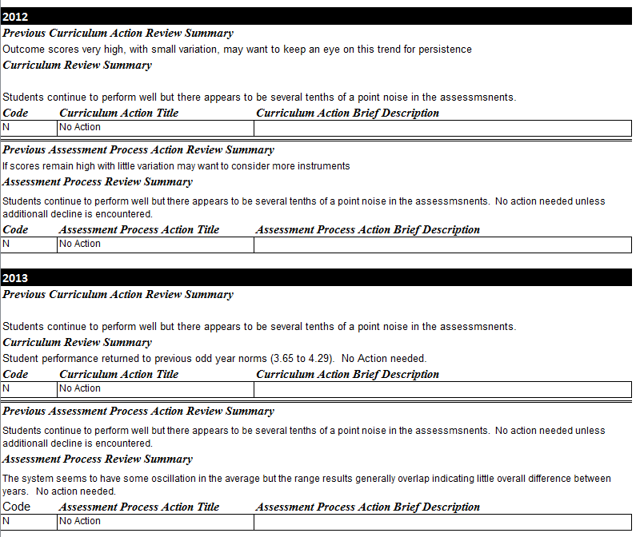

Review Summary (i) (cont’d)
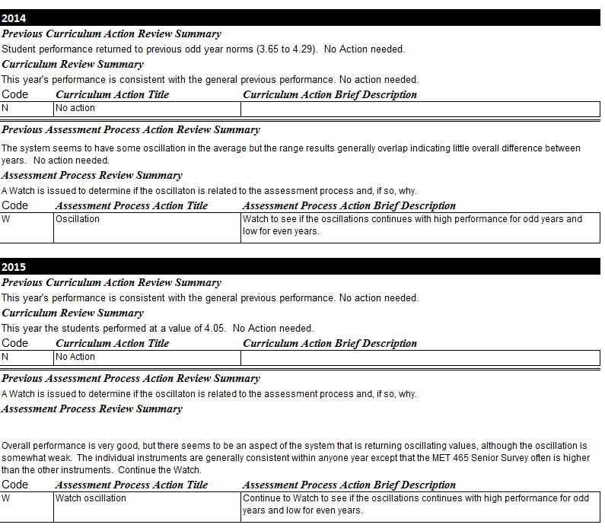

Review Summary (j)
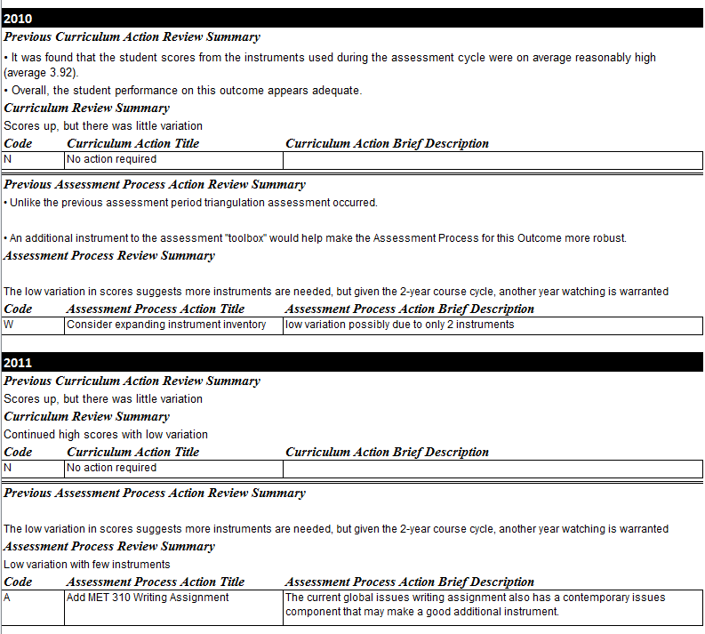

Review Summary (j) (cont’d)
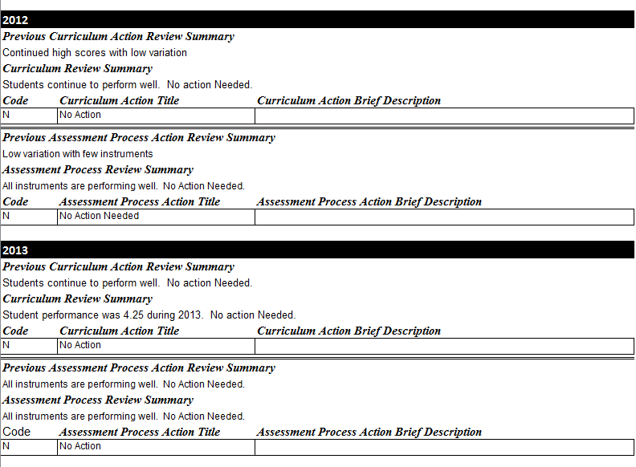

Review Summary (j) (cont’d)
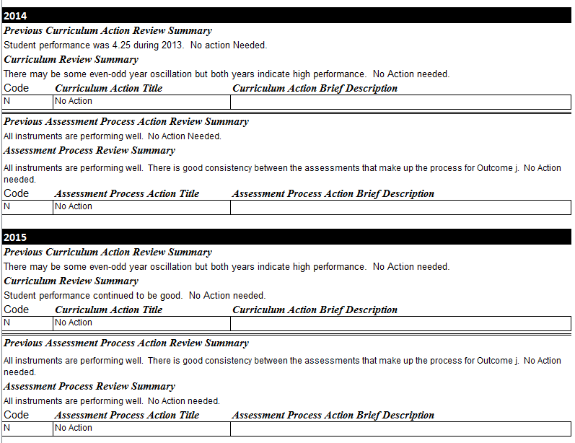

Review Summary (k)
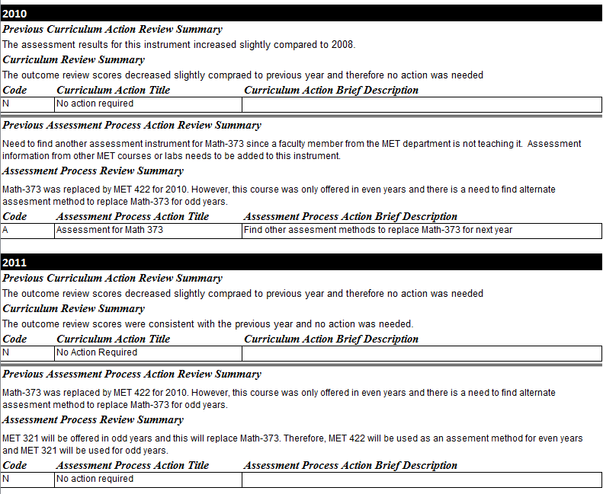

Review Summary (k) (cont’d)
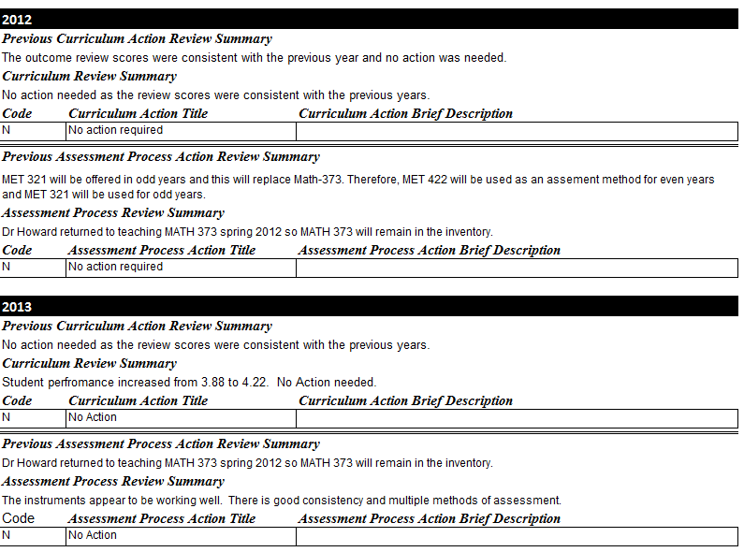

Review Summary (k) (cont’d)
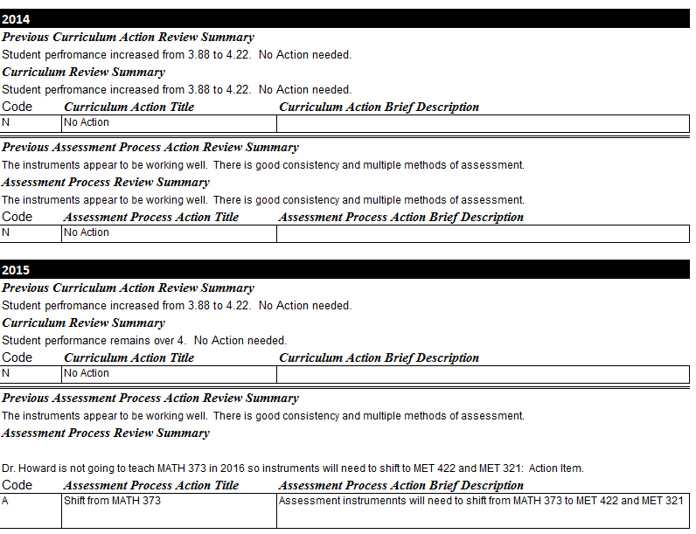

Part VI

Alumni Survey Summary

Contents
2004-08 graduates E-73
2010-16 graduates E-75

Table E-VI-1 Alumni Survey Report for 2002-08 graduates
Numbers represent number of responses out of 51 respondents. Survey return was 51/54.

Table E-VI-2 Alumni Survey Report for 2002-08 graduates (cont’d)

Table E-VI-2 Alumni Survey Report for 2010-16 graduates
How much does your current employment involve metallurgical engineering? |  | Number
 | Frequently | 27
 | Sometimes | 8
 | Rarely | 3
 | Never | 2
Employer's Primary Business |  | Number
 | Primary Metals | 11
 | Manufacturing | 17
 | Electronic materials | 0
 | Recycling, Environment | 1
 | Material use, performance, or properties | 0
 | Education | 4
 | Other engineering | 3
 | Other | 4
Which of the following skills do you use in your work? (Check all that apply.) |  | Number
 | Report Writing | 29
 | Oral Presentations | 32
 | Team Interactions | 35
 | Technical Computations | 29
 | Advanced Engineering Tools and Equipment | 19
 | Design | 18
How do you serve your profession or local community? (Check all that apply.) |  | Number
 | Member of one or more Professional Societies | 23
 | Service on Professional Boards or Societies | 2
 | Community Volunteer | 18
 | Attend Community Activities | 17
 | Other Service | 8
 | No Public Service | 5
Numbers represent number of responses out of 51 respondents. Survey return was 41/63.
Table E-VI-2 Alumni Survey Report for 2010-2016S graduates (cont’d)
Single Response Survey Questions
 | Item | Very High | High | Low | Very Low
 | To what extent do you feel that your job meets societal needs through science and technology? | 24 | 12 | 4
 | How satisfied are you with the overall effectiveness and value of your SDSM&T Met Eng education? | 32 | 7 | 2
 | How satisfied are you with your ability to use analytical methods and solve engineering problems? | 24 | 17
 | How important in your position is the use of analytical methods to solve engineering problems? | 14 | 17 | 8 | 1
 | How satisfied are you with your ability to use computational methods and solve engineering problems? | 12 | 28 | 1
 | How important in your position is the use of computational methods to solve engineering problems? | 6 | 18 | 15 | 1
 | How satisfied are you with your ability to use math, science, and engineering principles? | 27 | 14
 | How important in your position is the use of math, science, and engineering principles? | 20 | 15 | 5
 | How satisfied are you with your ability to make engineering decisions? | 25 | 16
 | How important in your position is the making of engineering decisions? | 17 | 18 | 4 | 1
 | How satisfied are you with your ability to design engineering systems? | 7 | 30 | 3
 | How important in your position is the design of engineering systems? | 7 | 13 | 14 | 6
 | How satisfied are you with your ability to work in teams? | 23 | 15 | 2
 | How important in your position is working in teams? | 28 | 8 | 3 | 1
 | How satisfied are you with your ability to use communication skills? | 22 | 18
 | How important in your position is the use of communication skills? | 32 | 6 | 2
 | How satisfied are you with your ability to use instruments and measurement tools? | 23 | 17
 | How important in your position is the use of instruments and measurement tools? | 17 | 13 | 8 | 2
 | How satisfied are you with your ability to anticipate the societal impacts of your work? | 16 | 25
 | How important in your position is the anticipation of societal impacts? | 14 | 11 | 12 | 3
 | How satisfied are you with your ability to recognize the potential environmental impact of your work? | 12 | 29
 | How important in your position is the recognition of potential environmental impacts? | 18 | 12 | 8 | 2

Part VII

Advisory Board Reports

Contents
2009-10 E-78
2013-14 E-81
2015-16 E-87

Table E-VII-1 Advisory Board Report for 2009-10

Report from
The Advisory Board
For the Department of Materials and Metallurgical Engineering
At
SDSM&T

Review Date: October 16, 2009

Team Members Participating (in person, by phone, or in later correspondence):

Everett Bloom Oak Ridge National Laboratory - Retired
Wendy Craig MacSteel
Chris Misterek John Deere
Ray Peterson Aleris International
Shane Vernon Nucor Steel
Shawn Veurink RPM and Associates
Richard Wensel Micron Technology

SUMMARY

The faculty and staff of the Materials and Metallurgical Engineering Department at the South Dakota School of Mines and Technology (SDSM&T) have made outstanding progress in addressing fundamental issues impacting the department since our last on-site Advisory Board Review. In particular they have skillfully navigated the transitional period of three faculty retirements (out of five positions) during a period when the school administration did not seem particularly interested in sustaining the department. They have increased the number of students in the department and they have dramatically increased their outside research funding. All actions have improved the strength of the department and benefited the larger goals of the school.

The Department continues to produce quality students who are well accepted by industry and academia, both regionally and nationally. The future concerns for the Department to address include planning for and executing the transition of a retiring faculty with the concurrent hiring of a qualified replacement, providing opportunities for a full spectrum of materials science curricula, and increasing the faculty level by at least one member. The addition of one more faculty member could help increase the breadth of class offerings and allow faculty members the opportunity to continue to seek more outside research funding opportunities.

The B.S. Metallurgical Degree Program educational objectives remain current and appropriate. Alumni surveys and feedback from board members on the program’s alumni performance in the
workplace indicate that the objectives are being met and that no specific changes in curriculum beyond the suggestions below are needed.

Observations by the AB Regarding The Department of Materials and Metallurgical Engineering

Strengths:

- The faculty of Materials and Metallurgical Engineering Department has taken a strongly proactive approach to improving the department. They addressed most of the major concerns of the AB in our last on site review in 2002 (several teleconferences have been held in the interim). Two of the five faculty positions are partially endowed with the possibility of becoming fully endowed. Self assessment rates by recent alumni (for ABET) were extremely high and the overall impression by alumni was that they were well prepared for their careers. The new Samurai Sword Senior Project was laid out in a manner so that all students contributed in different ways to a single goal, much like a company would operate. Students were able to succeed or fail in their own areas and learn from the experience. The faculty also creatively modified the class schedule such that class sizes could be increased through combining grade levels. The larger classes produced a stronger and more dynamic teaching environment.

- Strong progress in undergraduate student enrollment has been made resulting in the highest levels of enrollment in 18 years. This is not an accident, but the result of active involvement by the faculty members. They have added programs and activities to increase student involvement with the department and the materials profession, thereby engendering more student interest. Some of these programs and activities include:
- A weekly blacksmithing workshop that is entertaining, but still ties back into the students’ education by linking processing paths to microstructure and properties.
- A Samurai sword Senior Design Project covering all areas of metallurgy.
- Integrating the artistic side of Materials Science with the industrial side. Examples include blacksmithing, glass blowing, jewelry crafting, and copper working.
- Extra efforts to attract and retain non-traditional students to the metallurgy field (women and minorities) through the WIME program and an NSF REU.
- Outreach to scientifically oriented high school students with the ASM Materials Camp.

- The five teaching and one research faculty members are currently responsible for bringing in over $6.7M of external research funding (17 total awards). This equates to $1.3M per faculty member – at or near the top for any department within SDSM&T. They are supervising approximately 15 Masters students and approximately 10 PhD students. Development and expansion of MS / PhD programs has helped to bring in external funding as well as new equipment.

- As already mentioned the enrollment numbers for students in the Materials and Metallurgical Engineering Department are at all time highs. In addition to the active student recruitment program, the Department has developed a strong scholarship program so that over two-thirds of the undergraduate students receive some form of scholarship
- stipend. The graduating seniors experience a high placement rate in many types of industries and research facilities both regionally and nationally. Additionally a significant portion of the students progress on to graduate level programs (1 in 3 goes on) with approximately 40 % enrolling outside of SDSM&T. The graduating students are of a high caliber and are in demand due to strong technical backgrounds and good work ethics.

Opportunities and Concerns:
- The Department continues to have a focus on traditional metallurgy. This is both strength and a weakness. Very few schools still produce students who can go into a traditional metallurgical operation and not require significant on the job training. On the hand, the world of Materials Science is much larger than it used to be (ceramics, biomaterials, polymers, electronic materials, composites, etc.) and training in other areas might open doors for the students. Perhaps one or two survey classes could be a partial remedy.

- Dr. Howard is nearing retirement. It is critical that the proper replacement be found for him and that this transition proceeds as smoothly as possible.

- As the number of research projects within the Department has increased, the need for project management tools has become critical. Examples of information that need to be collected and tracked for the multiple projects includes: PI and researcher hours, purchases and expenses, and progress to goals. Outside assistance has been offered.

- Some class space, laboratories, and offices need infrastructure upgrades and repair to meet current standards. There have been some new additions of equipment to the Departmental laboratories in recent years, but not a lot of change. While expensive and difficult to do, the faculty and school need to ensure that laboratories are current so the students can be adequately prepared for future jobs or additional training at research universities.

- The Department should find more opportunities for students to work in summer or co-op jobs to gain experience. This is an area where alumni and other contacts could be used beneficially.

- Faculty numbers are still low for the number of enrolled students and the level of research funding being performed. Many MSE departments have student to faculty ratios of about 12 : 1. This department is 16 : 1. With five faculty members, the department is always just one step away from a dilemma should a member be lost. Adding another faculty member with the correct skill set could also be a method to broaden the department’s range of abilities and class offerings.

Table E-VII-2 Advisory Board Report for 2013-14
Advisory Board Analysis for Department of Metallurgical Engineering
Date: June 3, 2014

Background
The Advisory Board for the Metallurgical Engineering Department of South Dakota School of Mines and Technology met telephonically with the faculty in December, 2013. Department Chair Michael West and his faculty members presented a departmental review. Also students were given an opportunity to speak to the AB. Based on these inputs, each of the AB members created a SWOT (Strengths – Weaknesses – Opportunities - Threats) chart. All inputs were compiled and grouped by topical area or theme to help identify successes and opportunities.

Conclusions
The AB members are pleased to see the addition of two new faculty members to the department which brings the total teaching staff up to seven professors. This action helped to address one of the major concerns the AB identified in its last departmental review.

With the addition of the new faculty members it should be possible to both increase the number of class offerings and increase the undergraduate enrollment while maintaining the close student – faculty interaction cited by so many as an important part of the Met E culture. With expanded faculty numbers it may be possible to move away from the 2-year rotating class schedule which limits student’s opportunities in many ways. To increase undergraduate enrollment will require continued exploration of new and varied recruiting techniques. Increasing student enrollment will strengthen the department’s position within the university and help to secure funding for needed laboratory upgrades and building improvements or replacements.

The AB believes it is important for the department to continue to nurture the strong relations it has with industry including placement of its students in industrial positions. While it is exciting to develop new class content, it is also important to maintain strengths in the niche markets that the Met E department has traditionally served. Stronger relationships with industry could improve outside funding for laboratories and facilities as well as scholarships. Placement of graduates has been virtually 100% for the last few years indicating outside approval of your primary product – new engineers.

The Metallurgical Engineering Department will need to address near term issues including:
a.) replacement of aging buildings and laboratories so that thee students remain relevant to the changing job market, b.) investigation of increasing undergraduate enrollment size, c.) possible changes to the two-year rotating class schedule, and d.) determination of future curricula (traditional focus versus new and more speculative area of research).

Recommendations

The AB feels that the Metallurgical Engineering Department should develop specific short and long term goals to increase the department’s strength and health. Example goals could include raising the undergraduate enrollment to 100 students and replacement of the aging Minerals Industry Building. Based on these large goals, individual actions and activities could be reviewed and assessed for their impact to meet these overall goals.

SWOT Analysis for Department of Metallurgical Engineering

Responder: Combined Responses

Strengths | Weaknesses
- Student – Faculty Ratio (Low student to professor ratio, Student : Teacher ratio; Student/Faculty ratio is small, so interaction between the two is good; Expanded faculty; excellent student/professor ratio; Small class size – Instructor/Student interaction)  - Strong Student - Faculty Interactions Possible (Strong faculty – student interaction; Student/Faculty ratio is small, so interaction between the two is good; Engaged faculty; Small class size – Instructor/Student interaction)  - Increased Faculty Headcount (Seven member department now; New faculty to bring in new research and courses; Expanded faculty; excellent student/professor ratio)  - Ability to attract students with scholarships (Better than school average scholarships; Ability to give scholarships)  - Graduating students are in demand (Strong job placement (100%) with good salaries; Excellent dollar value and job placement, this is true for SDSM&T in general; Reputation – on campus & in industry)  - Maintained focus in traditional Metallurgy curriculum and found a niche (1 of 7 MetE undergraduate programs in US; Course work in extractive and physical met; Ferrous Metallurgy; Reputation – on campus & in industry)  - Other (Increased enrollment; Summer Materials Camp; Senior Design Project has been revamped to work more closely with industry; Ability to obtain research grants) | - Current two-year class schedule is viewed negatively (Two year rotating class schedule; Poor class schedule options for Coop Students; 2 year curriculum hinders ability for coops; Two-year cohort program)  - Age and wear on laboratory equipment and Minerals Engineering Building (Old labs and obsolete equipment; Aging Lab Facilities in Met Dept.; Aging building – facilities do not compare well to some other schools; Mineral Industries Building; Limited lab equipment)  - While above historically low levels, current level of undergraduate enrollment are worrying (Already at full capacity of MET Dept.; Cannot keep up with growth goals without increasing undergrad capacity; Still weak on female enrollment; Low enrollment leads to fewer resources allocated to the dept.)  - Other (Extractive metallurgy elective selection seems light; Number of faculty; Lots of plans and activities – unclear strategy [research, faculty, curriculum, and capital plan aligned with to-be-determined department goals]; Clear Department goals for future [in support of university strategy.]; Need clear “WIG’s (wildly important goals)”)

Opportunities | Threats
- Growing the department offers possibilities for improvement (Increase number of classes or size of classes with increased faculty; Develop new courses; Growth potential in Metallurgical Enrollment)  - Maintain or enhance relationship with industry (Continue to create a niche for supplying engineers to key metallurgical industries; Continue to develop industry and interdisciplinary design projects; Increase Industrial support/funding; Use industrial efforts to promote school/department; Poll industry to determine their needs when designing new laboratory facilities; Poll industry to determine their needs when designing new laboratory facilities)  - Continue to test techniques to improve student recruiting (Glassblowing club – Growth of this group could help attract more female (or male) students that are more “artsy”; Expand Foundry. Attract more hands on students. Build on science/art link; Increase brand awareness, aka: recruiting; Capitalize on strong research support – increase undergrad/graduate enrollment; Undergraduate center for Manufacturing / Metal working / Entrepreneurship; Utilize the REU sites on campus. (strategic printing, foundry))  - Other (Collaboration with other fields such as BME and NSNE fields; Planned Maintenance of Laboratory Equipment; University leadership thinks highly of the department… and is supportive of capital projects. Leverage this and make sure the department grows in the appropriate direction) | - Students are annoyed and alienated by 2 year rotating schedule. This schedule limits their ability to participate in co-op programs or deviate from a regimented schedule without impacting their graduation date.  - Outdated facilities negatively impact student training and faculty research (The labs and building are becoming small and outdated; Need to identify resources for capital updates)  - Changing curriculum away from traditional Metallurgy program to Material Science (Curriculum becomes too materials based and loses focus on metallurgy; There continues to be a push away from Metallurgical to Materials department - following this trend could alienate many employers; Industry hiring trends vs. curriculum focus areas and research experience; Serving industry vs. serving research dollars - Are these aligned / supporting each other?)  - While the number of faculty positions has grown, the department is still small in relation to other departments on campus which could cause funding and perception problems (department is still small compared to others on campus; “Best kept secret on campus” – more than a running joke – this may be a significant threat to the MetE dept.)  - MES program is in jeopardy (No base support for MES program; No dedicated faculty/staff for MES program)  - Increasing student enrollment could lead to growth pains (Increase in enrollment could outpace facility growth; Job placement as enrollment increases to planned levels

SWOT Analysis for Department of Metallurgical Engineering

All Responses – No combining of answers

Strengths | Weaknesses
1. Strong faculty – student interaction.  2. Seven member department now.  3. Increased enrollment.  4. Better than school average scholarships.  5. Strong job placement (100%) with good salaries.  6. Low student to professor ratio.  7. New facility to bring in new research and courses.  8. Ability to give scholarships.  9. Summer Materials Camp  10. Student : Teacher ratio  11. Excellent dollar value and job placement, this is true for SDSM&T in general.  12. Student/Faculty ratio is small, so interaction between the two is good.  13. Senior Design Project has been revamped to work more closely with industry.  14. Reputation – on campus & in industry  15. Ability to obtain research grants  16. Expanded faculty; excellent student/professor ratio  17. 1 of 7 MetE undergraduate programs in US  18. Engaged faculty  19. Ferrous Metallurgy  20. Small class size – Instructor/Student interaction  21. Course work in extractive and physical met | 1. Two year rotating class schedule.  2. Poor class schedule options for Coop Students.  3. Old labs and obsolete equipment.  4. 2 yr curriculum hinders ability for coops.  5. Extractive metallurgy elective selection seems light.  6. Aging Lab Facilities in Met Dept.  7. Aging building – facilities do not compare well to some other schools.  8. Already at full capacity of MET Dept. Cannot keep up with growth goals without increasing undergrad capacity.  9. Still weak on female enrollment  10. Low enrollment leads to fewer resources allocated to the dept.  11. Two-year cohort program.  12. Lots of plans and activities – unclear strategy (research, faculty, curriculum, and capital plan aligned with to-be-determined department goals)  13. Clear Department goals for future (in support of university strategy.) Need clear “WIG’s”  14. Mineral Industries Building  15. Number of faculty  16. Limited lab equipment

Opportunities | Threats
1. Increase number of classes or size of classes with increased faculty.  2. Continue to create a niche for supplying engineers to key metallurgical industries.  3. Develop new courses.  4. Continue to develop industry and interdisciplinary design projects.  5. Poll industry to determine their needs when designing new laboratory facilities.  6. Glassblowing club – Growth of this group could help attract more female (or male)student that are more “artsy”  7. Growth potential in Metallurgical Enrollment  8. Expand Foundry. Attract more hands on students. Build on science/art link.  9. Industrial efforts to promote school/department.  10. Increase Industrial support/funding  11. Increase brand awareness, aka: recruiting  12. Collaboration with other fields such as BME and NSNE fields.  13. Utilizing the REU sites on campus. (strategic printing, foundry).  14. Capitalize on strong research support – increase undergrad/graduate enrollment  15. University leadership thinks highly of the department… and is supportive of capital projects. Leverage this and make sure the dept grows in the appropriate direction.  16. Undergraduate center for ‘Metalworking, Manufacturing, and Entrepreneurship’  17. Mfg/Metallworking/Entrepreneurship  18. Planned Maintenance of Laboratory Equipment | 1. Alienate students with 2 year rotating schedule.  2. Need to identify resources for capital updates.  3. Increase in enrollment out paces facility growth.  4. Curriculum becomes too materials based and loses focus on metallurgy.  5. MS&T offer’s Materials Camp at no cost to the student.  6. There continues to be a push away from Metallurgical to Materials dept. Following this trend could alienate many employers.  7. The labs and building are becoming small and outdated.  8. Dept is still small compared to others on campus.  9. Industry hiring trends vs. curriculum focus areas and research experience  10. “Best kept secret on campus” – more than a running joke – this may be a significant threat to the MetE dept.  11. Serving industry vs. serving research dollars. Are these aligned / supporting each other?  12. No base support for MES program  13. No dedicated faculty/staff for MES program  14. Job placement as enrollment increases to planned levels.

Advisory Board Members:
Wendy Craig
Chris Misterek
Ray Peterson
Terry Rasmussen

Lisa Schlink
John Walenta
Rich Wensel

Table E-VII-3 Advisory Board Report for 2015-16

Date: 4/21/2015

Attendees: Ray Peterson (Real Alloy), Wayne Douglas, (Barrick), Terry Rasmussen (Nucor Steel), Lisa Schlink (Freeport McMoRan), Shaun Veurink (RPM), John Walenta (Caterpillar)
Attended on conference call: Wendy Craig (Gerdau Steel), Andy Johnson, GE (retired)*
Absent with regrets: Rich Wensel (Micron), David Gildemeister (ALCOA), Chris Misterek (John Deere)

Summary
The Metallurgical Engineering Department has made significant progress in rectifying problems identified over the last few years. Examples of progress made include:
- Increased Enrollment to over 100 students with larger Freshman and Sophomore Classes
- More Faculty
- Significant progress in updating the lab areas
- Significant effort in increasing diversity in enrollment
- Having 65% of student enrollment from out of state
- 100 % placement of students into employment or graduate school
- Strong research activities by all professors
- Development of new classes and exploring opportunities for sharing video classes with Montana Tech
- Strong ABET reviews
Observations

Curriculum: The number of lab sections has been increased to accommodate the higher number of students. The curriculum standards are being raised in increase the quality of education/students. The advisory board believes this will lead to stronger graduates.
The department continues to maintain a good balance between research and teaching using the two-year cohort model. The department has identified optimal coop times starting Spring of Sophomore and Junior years. Some flexibility on Coop options is still recommended and may be accomplished through distance learning. Utilization of remote access to classes was discussed as one possibility of adding flexibility to coops. Flexibility on Lab Classes was discussed. If a class corresponded to the coop, and the coop company was able to supply equivalent experience, that could help. The difficulty in making this work is recognized, however, we recommend that this be considered further.
The department continues to improve the design sequence by partnering with industry on nearly all design projects. Projects in the last sequence were well represented in all three areas of metallurgical engineering – extractive, process, and physical.
The board is pleased to see the plans to continue the Culture and Attitude scholarship program for Women in Engineering. This could lead to the development of new curricula to support women in engineering.

Recruiting and retention: Department enrollment continues to grow. 2014 found enrollment at 105 students, which was a significant increase from 2013. The 2015 class was the largest freshman class ever. The department continues to do a good job with recruiting and retention activities.

The ASM Summer camp for high school students continues to provide a portion of the Freshmen enrollment. With the loss of the campus residential summer camp program, the ASM camp will be scaled back to local residents, but provided at little or no cost. This option keeps the program going, but does miss out on a lot of potential students. Many former campers came from out of state and have come to SDSM&T as students. This may result in reductions in enrollment in the MET department. During the first summer of implementation, many students still came from out of state but this trend should be watched to make sure the camp is reaching a broader geographic base of students.

Other outreach programs and internships and visit programs are still in place and should be continued. Blacksmithing continues to be a draw to the department and provides a fun way for students to be involved in a group program, that also helps them learn metallurgy. The Blacksmithing Club has grown to one of the largest student organizations on campus. The department is also re-introducing foundry activities.

Mentor programs continue to grow nationwide as a way to retain students and help them succeed. It is imperative that students be encouraged to succeed. It is good to see implementation of MET peer mentors by the university as well as WISE (Women in Science and Engineering) mentors.

The Go To Mines event in October brings in high school students interested in attending Mines. Next year, Industry will be invited to attend and talk to student and parents about the opportunities for engineers in industry. This could be a great recruiting opportunity for the school and for industry. The department has recently teamed with industry during the Go to Mines day as a way to show career pathways. This model could be replicated with other departments on campus.

SDSM&T enrollment is now over 50% out-of-state students. Out of State students are attending for a variety of reasons, one being the cost of education. It’s interesting to note that 1 in 4 out-of-state students finds their first job after graduation in the state of South Dakota.
To maintain and grow the department, the department needs to continue to grow the available discretionary funds to have $100-150K in departmental scholarships available. The scholarship level needs to increase going forward. Endowments are the preferred method of scholarship provision. While the board agrees that endowments are ideal, pay as you go scholarships may be easier for some companies/people to provide and should be encouraged as well. This may include partnerships with new industry partners.

Student placement: Student placement is down slightly due to the sag in the economy. However several new employers have been present on campus. Increased representation of hiring companies is a key element in maintaining and growing the department/school. The department should develop a strategy to engage new partners to broaden the portfolio of companies that come to recruit. The department has done a good job to engage new companies through the design sequence as a way to provide new opportunities for student placement.

ABET accreditation: The plan for presentation to ABET for accreditation is well mapped out. The board was briefed on the metallurgical engineering department’s continuous improvement process. We find that the constituents are complete and appropriate. The student educational outcomes are clearly stated. In general, the documentation that was set up for ABET is appropriate and covered the topics and requirements set by ABET. One note is that safety and leadership are not mentioned specifically as topics directly. These are important requirements as students are entering industry.

Current facilities: A tour of labs presented a significant improvement in the housekeeping and organization of the laboratories. Updating of lab equipment is still needed, however the improvement is encouraging. The grad student office renovation provides a much improved facility. Some areas were noted to still be going through improvement, such as the Blacksmithing/Foundry area and Hydrometallurgy Lab. There is a critical need for additional space throughout the MI building given the growth in enrollment of the department particularly in the undergraduate labs. The department has done started work to try to consolidate labs to efficiently use space but more improvement is needed in general housekeeping. The Foundry building also needs additional space added if casting activities are to be reintroduced.

MI Building initiative: The current Mineral Industries Building (MI) is in desperate need of renovation in order to provide more space and better classroom and lab space. The renovation of the current building will cost approximately 60% of what a new facility would cost. Proposed layouts are attached below. The possibility of the USGS attaching a new 15,000 sq. ft. section to the building on the South side was presented. This additional space would be used by the USGS, but some of the Federal funds provided would help with the renovation of the rest of the building. The USGS addition is still being discussed and is not finalized. The relocation of the Atmospheric Sciences department will provide some of the additional space needed by the MI departments (Metallurgy, Geology, Mining).

Only $1.5M is currently designated to be used for the renovation. That money was donated by unnamed companies that hire many of the MI graduates. More donations are needed to reach the goal. All board members are encouraged to help raise the needed funds in any way they can. Dr. Heather Wilson stated she will continue fundraising until the entire $17M is raised.
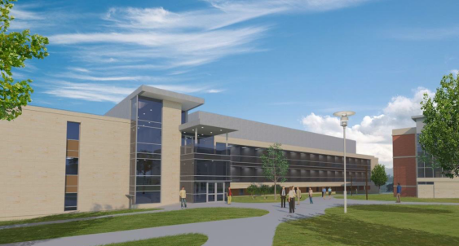

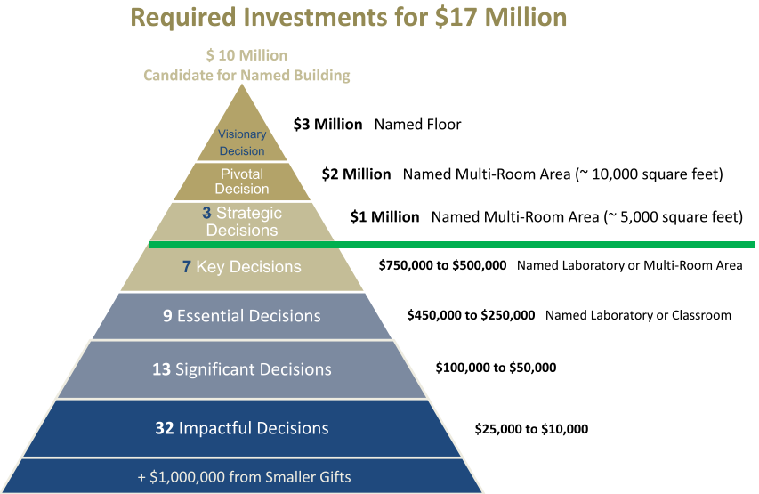
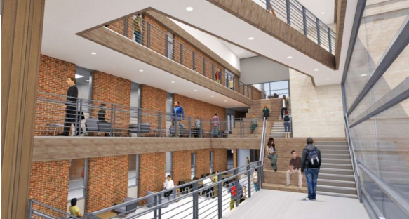

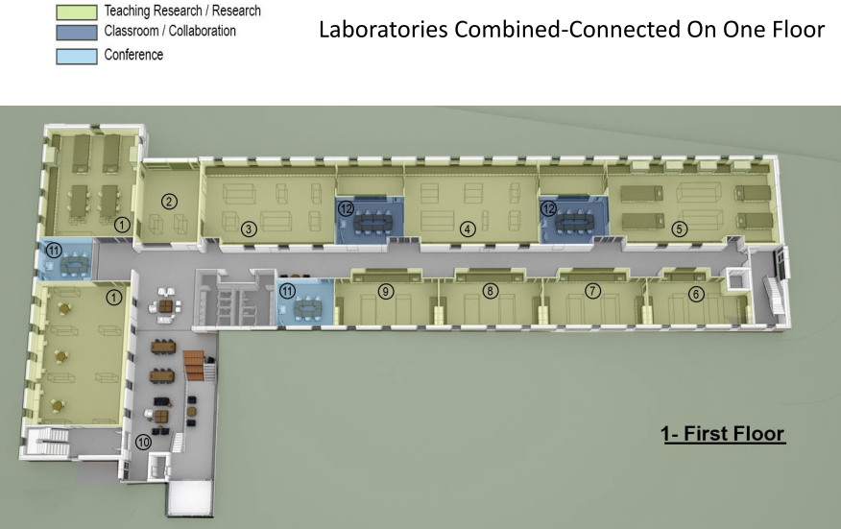
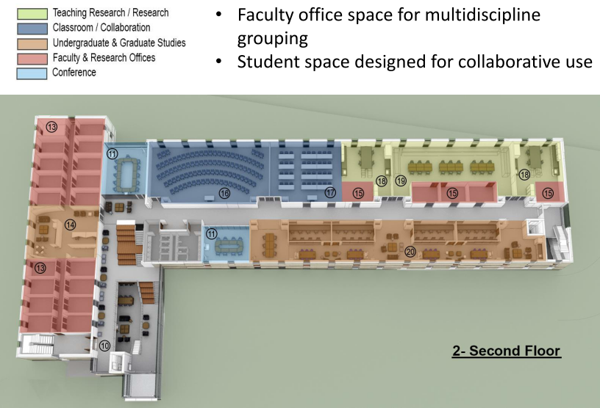

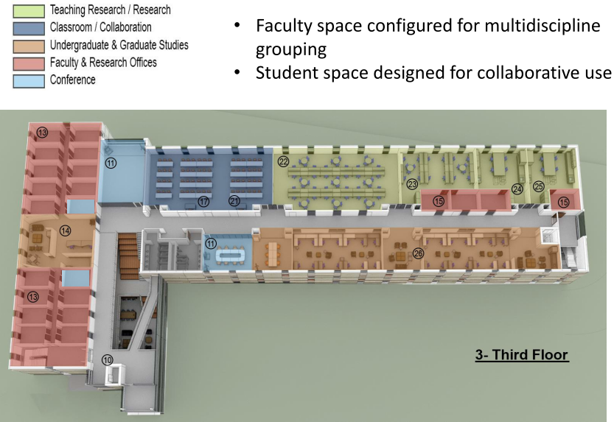

Recommendations
The board recommends that the department continue to strengthen high quality curriculum and develop new industry partnerships. It was recommended that the following sub-committees of the advisory board be established to help with future needs of the department.
- Safety & Housekeeping – Veurink, Rasmussen
Monthly audits, work with faculty and students to bring up to industry expectations
- Scholarship - Douglas
Need to coordinate with Foundation
- MI Building Initiative – Rasmussen
Coordinate with other AB’s from Mineral Industry Departments
- Personal Skills Building – Wensel, Gildemeister
Potentially coordinate with ongoing professional development activities on campus
- Industrial Advisory Board Expansion
Increase membership up to 20. Improve industry-faculty-student contact/mentoring. Increase funding opportunities. Increase commitment to the department/school

(intentionally blank)

