**Appendix E - Continuous Improvement System (CIS) documents**

**Contents**

#### Part Title Page

## Outcome Metrics E - 2

1. Outcome Assessment Forms E-13
2. Outcome Assessment Summaries E-19
3. Outcome Assessment Results E-26
4. Outcome Reviews E-38
5. Alumni Survey Summary E-72
6. Advisory Board Reports E-76

Items not present in Appendix E but available in hard copy form at the time of review are

## Archival Records

## Score Cards

## Outcome Summaries

## A panoply of Grand Summary renderings including

* + Graphical Summary of each outcome over time
  + Graphical Summary of all outcomes for each year
  + Two-year Averaged Grand Summary

All of this information is also continuously available to program faculty via the CIS web site.

**Part I**

**Metrics for Program Outcomes (a-k)**

**Description:**

The following metrics are used to assess the program outcomes (a) – (k). Each outcome instrument is scored with a 1, 3, or a 5. The (a-k) descriptors for each metric are truncated on each table and serve only as a reminder of each outcome’s focus.

Metrics for Outcomes (a) E- 3

Metrics for Outcomes (b) E- 4

Metrics for Outcomes (c) E- 5

Metrics for Outcomes (d) E- 6

Metrics for Outcomes (e) E- 7

Metrics for Outcomes (f) E- 8

Metrics for Outcomes (g) E- 9

Metrics for Outcomes (h) E-10

Metrics for Outcomes (i) E-11

Metrics for Outcomes (j) E-11

Metrics for Outcomes (k) E-12

**Table E-I.1: Metric for Assessing Outcome (a)**



**Table E-I.2: Metric for Assessing Outcome (b)**



**Table E-I.3: Metric for Assessing Outcome (c)**



**Table E-I.4: Metric for Assessing Outcome (d)**



**Table E-I.5: Metric for Assessing Outcome (e)**



**Table E-I.6: Metric for Assessing Outcome (f)**



**Table E-I.7: Metric for Assessing Outcome (g)**



**Table E-I.8: Metric for Assessing Outcome (h)**



**Table E-I.9: Metric for Assessing Outcome (i)**



**Table E-I.10: Metric for Assessing Outcome (j)**



**Table E-I.11: Metric for Assessing Outcome (k)**



**Part II**

**Assessment Forms**

**Description:**

Table E-II.1: Score Card Input Form - Sample for Outcome (a) E-15

Each Outcome instrument is assessed using a Score Card Input Form that is filed   
with the instrument documents (student work, etc.). The data from these forms is compiled on an Outcome Summary.

Table E-II.2 Outcome Summary - Sample for Outcome (a) E-16

All Score Card Summaries for one year are consolidated onto the Assessment   
Summary

.

Table E-II.3 Outcome Assessment Summary E-17

Outcome Assessment Summaries are used to populate the Grand Summary data base from which the outcome assessment results are rendered into many useful graphical collections.

Table E-II.4: Outcome Review Form E-18

The results of each Outcome Review (for one year) are summarized on the   
longitudinal Outcome Review Summary form. The completed forms for   
outcomes (a)–(k) are shown in Part V below.

Table E-II.5: Outcome Review Summary Form E-19

The completed forms for outcomes (a)–(k) are shown in Part V below.

**Table E-II.1: Outcome Assessment Score Card Input Form (Sample for Outcome (a))**



**Table E-II.2 Outcome Assessment Score Card (Sample for Outcome (a))**



**Table E-II.3: Assessment Summary form**

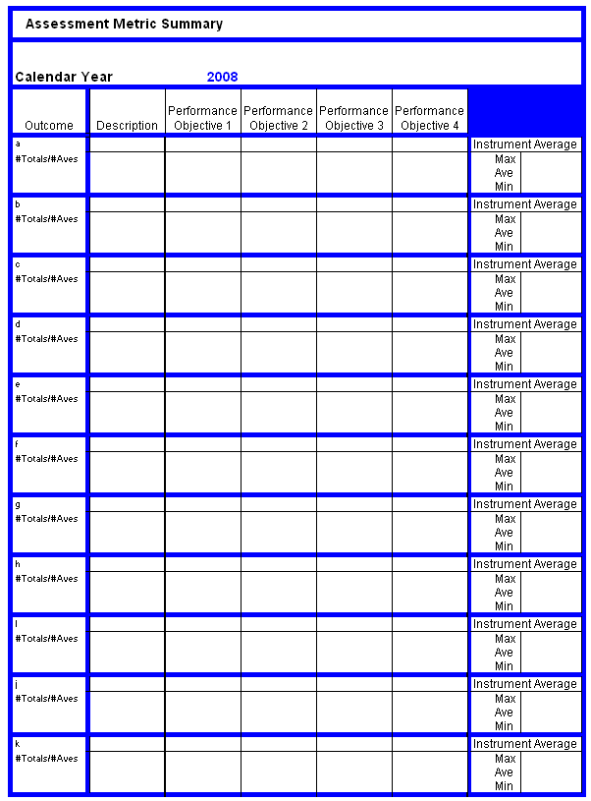

**Table E-II.4: Outcome Review Form**

**Outcome Review Form Met Eng**

**Calendar Year:**

**Outcome:**  (a) Apply Knowledge of Math, Science, and Engineering

**Reviewer:**

**Date:**

Please complete the following table and indicate if 1) any instruments were missing or incomplete and 2) if you reassessed any instrument.

**Course Instrument Missing Reassessed**

**Review Results:**

Each review always consists of two elements: curriculum results and assessment processes.

**Recommendations**

Curriculum Result

Perform a critical analysis on the accuracy, validity, and value of this outcome’s assessment based on the Outcome Summary. This review may also include a review of the actual assessment documents but such depth is not typically required. Note any significant differences among instruments, performance criteria, and instrument assessors. Compare the assessed performance with previous years’ performance and recommend curriculum improvements, as needed. The improvement does not need to be curriculum specific, but it would be helpful to suggest possible improvements for faculty consideration. If no improvement is needed, state that the curriculum is performing adequately. If a problem may be developing but there is inadequate evidence on which to act, note that the outcome should be watched and note the concern.

(Insert review here)

Assessment Process

Comment on the adequacy of the assessment instruments and related processes. Suggest possible changes that would improve the assessment of this outcome. Possible discussion might include such things as the adequacy of triangulation by multiple assessment methods, statistical variations from small class size, sparse student participation, etc. If the process appears to be functioning adequately, state that.

(Insert review here)

**Table E-II.5 Outcome Review Summary Form**

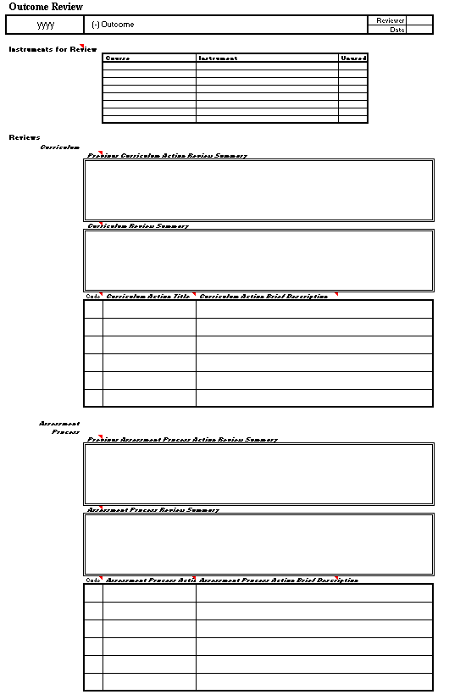

**Part III**

**Outcome Assessment Results**

**For all Instrument Collections up to and Including 2009**

**Contents**

1. Tabular Outcome Assessments Summaries

* 2010 E-21
* 2011 E-22
* 2012 E-23
* 2013 E-24
* 2014 E-25
* 2015 E-26