Appendix D – Institutional Summary

This summary contains vital information about SDSM&T including address, president, provost, its organization and control.

The institution
- South Dakota School of Mines and Technology
501 E. Saint Joseph St.
Rapid City, SD 57701

- Dr. Heather Wilson, President
O’Harra building, room 215a
Heather.Wilson@sdsmt.edu
605-215-2411

- Dr. Demitris Kouris, Provost and Vice President for Academic Affairs
O’Harra building, room 215b
Demitris.Kouris@sdsmt.edu
605-394-2256

- Organizations by which the institution is now accredited and the dates of the initial and most recent accreditation evaluations.

Accreditation Unit | Date of Initial Accreditation | Date of Most Recent Accreditation or Approval
Higher Learning Commission of the North Central Association | 1925 | 2014-2015
Engineering Accreditation Commission of ABET, Inc. | 1936 | Mining Engineering 2010  Chemical Engineering 2011  Civil Engineering 2011  Computer Engineering 2011  Electrical Engineering 2011  Geological Engineering 2011  Industrial Engineering and Engineering Management 2011  Mechanical Engineering 2011  Metallurgical Engineering 2011
American Chemical Society* | 1950 | Chemistry 2007 (approval for 2015 review cycle is pending)
Computing Accreditation Commission of ABET, Inc. | 1992 | Computer Science 2014
* The American Chemical Society “approves” programs in chemistry on a 5-year review cycle

Type of control
State public university, governed by the South Dakota Board of Regents

Educational unit
Academic Affairs at SD Mines is a single division without colleges. Fifteen departments (listed in Section 4 below) offer 16 undergraduate programs, 14 Master’s programs, and 9 Ph.D. programs (see http://www.sdsmt.edu/Academics/Degrees/All-SD-Mines-Degrees/). The department heads and program chairs or directors meet twice monthly with Dr. Kouris, Provost and Vice President for Academic Affairs, in the Academic Leadership Council (ALC). In addition, the department heads meet as needed on a one-on-one with the provost.

The department heads of all programs under review by the EAC of ABET, Inc. in the 2016-2017 cycle are members of the Academic Leadership Council (ALC) and, as such, report directly to the provost. The provost reports directly to Dr. Wilson, President of SD Mines. An associate provost, Dr. Kate Alley, and an associate provost for academic administration, Molly Moore, assist the provost but are not members of the ALC.

The Dean of Graduation Education, Dr. Doug Wells, reports to Dr. Kouris, Provost and Vice President for Academic Affairs and is a member of the ALC. (See the Office of Graduate Education at (http://www.sdsmt.edu/GraduateEducation/).

Additional units reporting directly to the provost include the Center for Advanced Manufacturing and Production (CAMP), the Deveraux Library, Information Technology Services, Admissions and the Registrar and Academic Services, the Museum of Geology, Youth Programs, and the Women in Science and Engineering program.

The organizational chart for SD Mines is below in Figure D-1 and can be viewed in larger format online at
http://www.sdsmt.edu/About/Office-of-the-President/Organizational-Chart/

Academic support units
The following are the department names and the names and titles of the individuals responsible for each of the units that teach courses required by the program being evaluated or may be taken by students in the program being evaluated:

Chemical and Biological Engineering
Dr. Robb M Winter, Head and Professor Chemical and Biological Engineering, Chemical and Biological Engineering building, room 2202A, (605) 394-1237, robb.winter@sdsmt.edu secretary: Lila.Baskerville@sdsmt.edu, 605-394-2421

Chemistry and Applied Biological Sciences
Dr. Richard R Sinden, Head and Professor Chemistry and Applied Biological Sciences, Chemical and Biological building, room C219, (605) 394-1678, Richard.Sinden@sdsmt.edu, secretary: Tara.Huber@sdsmt.edu (605) 394-1238

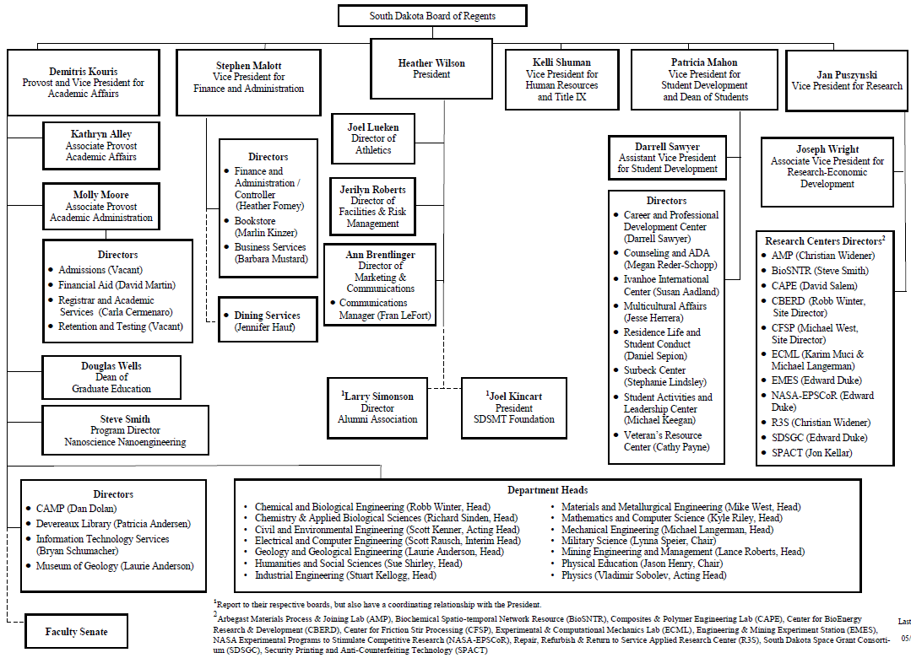

Figure D-1 Organizational Chart for SD Mines (updates 05/04/16)

Civil and Environmental Engineering
Dr. Scott J Kenner, Interim Department Head and Professor Civil and Environmental Engineering, Civil and Mechanical Engineering building, room 122, (605) 394-1697, scott.kenner@sdsmt.edu secretary: Ellen.Haffner@sdsmt.edu (605) 394-2490

Electrical and Computer Engineering
Dr. Scott E Rausch, Interim Department Head and Instructor Electrical and Computer Engineering, Electrical and Computer Engineering building, room 318, (605) 394-1219, Scott.Rausch@sdsmt.edu secretary: deb.tompkins@sdsmt.edu (605) 394-2451

Geology and Geological Engineering
Dr. Laurie C Anderson, Head and Professor Geology and Geological Engineering, Metallurgical building, room 303, (605) 394-1290, Laurie.Anderson@sdsmt.edu secretary: Cleo.Heenan@sdsmt.edu (605)-394-2461

Humanities
Dr. Sue Shirley, Head Social Sciences, Head and Professor Humanities, Classroom building, room 310, (605) 394-2482, susan.shirley@sdsmt.edu secretary: debra.zeidler@sdsmt.edu (605) 394-2481

Industrial Engineering
Dr. Stuart Kellogg, Department Head and Pietz Professor Industrial Engineering, Devereaux Library lower level, (605) 394-6152, stuart.kellogg@sdsmt.edu secretary: c.krein@sdsmt.edu (605) 394-1271

Materials and Metallurgical Engineering
Dr. Michael K West, Head and Associate professor Materials and Metallurgical Engineering, Metallurgical building, room 108, (605) 394-1283, Michael.West@sdsmt.edu secretary Jessica.Zacher@sdsmt.edu (605) 394-2341

Mathematics and Computer Science
Dr. Kyle L Riley, Head and Professor Mathematics and Computer Science, Math and Computer Science building, room 308, (605) 394-2471, kyle.riley@sdsmt.edu secretary: Reta.Davies@sdsmt.edu, (605) 394-2471

Mechanical Engineering
Dr. Michael A. Langerman, Head and Professor, Mechanical Engineering
Civil and Mechanical Engineering building, room 133, (605) 394-2408, michael.langerman@sdsmt.edu, secretary: Leslee A Moore (605) 394-2401

Military Science
Col Lynna M. Speier, Classroom building room 115, (605)-394-2769, Lynna.Speier@sdsmt.edu

Mining Engineering and Management
Dr. Lance A. Roberts, Head and Professor Mining Engineering and Management, Metallurgical building, room 235B, 605-394-1973, Lance.Roberts@sdsmt.edu secretary: cindy.hise@sdsmt.edu, (605) 394-2344

Physical Education
Jason P. Henry, Head Men's Basketball Coach/Assistant Athletic Director/Department Chair/Associate Professor, King Center building, room 118, (605) 355-3023, Jason.Henry@sdsmt.edu

Physics
Dr. Andre Petukhov, Head and Professor Physics, Electrical and Computer Engineering building, room 235A, (605) 394-2364, Andre.Petukhov@sdsmt.edu secretary: Connie.Krosschell@sdsmt.edu, (605) 394-2361

Social Sciences
Dr. Sue Shirley, Head Social Sciences, Head and Professor Humanities, Classroom building, room 310, (605) 394-2482, susan.shirley@sdsmt.edu secretary: debra.zeidler@sdsmt.edu (605) 394-2481

Non-academic support units
The following are the department names and the names and titles of the individuals responsible for each of the units that provide non-academic support to the program being evaluated:

Admissions
Molly Moore, O’Harra building room 216A, 605-394-5236, Molly.Moore@sdsmt.edu

Athletic Department
Joel Lueken, King Center room 113, 605-394-2352, Joel.Lueken@sdsmt.edu

The Career and Professional Development Center
Darrell Sawyer, Surbeck Center, (605) 394-2667, Darrell.Sawyer@sdsmt.edu

Dean of Students Office
Dr. Patricia Mahon, Surbeck Center, (605) 394-2416, Patricia.Mahon@sdsmt.edu

Devereaux Library
Patricia M Andersen, Library 213, (605) 394-1255, Patricia.Andersen@sdsmt.edu

Disability Services/ADA – Counseling
Megan Reder-Schopp, Surbeck Center, 394-6988, Megan.Reder-Schopp@sdsmt.edu

Information Technology Services
Bryan J Schumacher, Electrical Engineering Building room 134, (605) 394-5102, Bryan.Schumacher@sdsmt.edu

Ivanhoe International Center
Susan R Aadland, Surbeck Center room IIC, (605) 394-6884, Susan.Aadland@sdsmt.edu

Multicultural Affairs
Jesse Herrera, Surbeck Center lower Level, (605) 394-1828, Jesse.Herrera@sdsmt.edu

Office of Residence Life
Dan Sepion, Surbeck Center, (605) 394-2348, Daniel.Sepion@sdsmt.edu

Office of the Registrar and Academic Services
Carla Cermenaro, O’Harra building room 201, 605-394-2649, Carla.Cermenaro@sdsmt.edu

The Omniciye Bridge Program and Jump Start Program
Jesse Herrera, Surbeck Center lower Level, (605) 394-1828, Jesse.Herrera@sdsmt.edu

Student Activities and Leadership Center
Michael Keegan, Surbeck Center lower level, (605) 394-2336, Michael.Keegan@sdsmt.edu

Testing, Tutoring and Academic Support
Tom Mahon, Devereaux Library room 110, (605) 394-2428, Thomas.Mahon@sdsmt.edu

Tiospaye in Engineering and Tiospaye in Science Program
Dr. Carter J. Kerk, McLaury 104A, room 309, (605) 394-1291/(605) 394-6067, carter.kerk@sdsmt.edu

University Counseling
Megan Reder-Schopp, Surbeck Center, 394-6988, Megan.Reder-Schopp@sdsmt.edu

Veterans’ Resource Center
Cathy Payne, Surbeck Center lower level, (605) 394-2560, catherine.payne@sdsmt.edu

Women in Science and Engineering (WiSE)
Lisa Carlson, McLaury room 202, (605) 394-5261, Lisa.Carlson@sdsmt.edu

- Credit unit
One semester credit represents one class hour or three laboratory hours per week. One academic year normally represents at least 28 weeks of classes, exclusive of final examinations.

- Tables
Tables D-1 and D-2 show enrollment data and summarize personnel data for the BS Metallurgical Engineering program.

Table D-1 BS Metallurgical Engineering Program Enrollment and Degree Data
Academic Year | FT/PT | Year of matriculation  (fall enrollment) |  |  |  |  |  | Total  undergrad | Total  grad | Degrees awarded  (For one year period))
 |  | 1st | 2nd | 3rd | 4th |  | 5th |  |  | Assoc  (N/A) | Bachelors  (Met Eng) | MS* | PhD*
2015-16  (Current) | FT | 48 | 32 | 17 |  | 25 |  | 122 | 20 |  | 17 | 6 | 0
 | PT | 1 |  | 3 |  | 7 |  | 11 | 14
2014-15 | FT | 42 | 17 | 17 |  | 26 |  | 102 | 20 |  | 13 | 8 | 2
 | PT |  | 2 | 4 |  | 3 |  | 9 | 12
2013-14 | FT | 21 | 20 | 8 |  | 27 |  | 76 | 19 |  | 7 | 5 | 2
 | PT | 3 | 1 |  |  | 2 |  | 6 | 10
2012-13 | FT | 15 | 12 | 17 |  | 19 |  | 63 | 22 |  | 14 | 6 | 1
 | PT |  | 1 |  |  | 4 |  | 5 | 11
2011-12 | FT | 20 | 15 | 21 |  | 19 |  | 75 | 22 |  | 16 | 7 | 1
 | PT |  | 1 |  |  |  |  | 1 | 9
*Number of MES and Biomedical Engineering graduates having a MET ENG major thesis advisor

Table D-2 Personnel in Metallurgical Engineering in 2015-16
Category | HEAD COUNT |  | FTE
 | FT | PT
Administrative  (West) | 1 |  | 0.5
Faculty (tenure-track)  (Crawford, Cross, Jasthi, Kellar, Safarzadeh, Salem, West, Widener) | 8 |  | 7.5
Other faculty  (Howard) |  | 1 | 0.3
Student teaching assistants |  | 5 | 5.0
Technicians/specialists  (Hong, Meruga, Qiung, Randle) | 3 | 1 | 4.064
Office/clerical employees  (Schweigerdt, Zacher) | 2 |  | 2.0
Others (none)
One FTE equals the institutional-defined full-time load. For student teaching assistants, one FTE equals 20 hours per week of work or service. For undergraduate and graduate students, one FTE equals 15 semester credit-hours per term of institutional course work.

Table D-3 SDSM&T executive metrics (cont’d)

Table D-3 SDSM&T executive metrics (cont’d)

Table D-3 SDSM&T executive metrics (cont’d)

Table D-3 SDSM&T executive metrics (cont’d)
(intentionally blank)

