CRITERION 1. STUDENTS
A. Student Admissions
Incoming freshmen at the School of Mines are required to declare a major. Admission standards apply to the institution overall and are not differentiated by program. Effective fall 2006, admission standards were raised such that automatic admission is granted to any incoming freshman with an ACT composite score of 25 or greater and a math ACT score of 25 or greater. Automatic admission is also granted to applicants with a high school GPA of 3.5 or greater and four or more years of years of higher-level math. Applicants with ACT composite scores of 20 or lower or a high school GPA of 2.0 or lower are denied admission. All other applicants are evaluated on an individual basis by the Admissions Committee. Non-traditional students (i.e., age 24 or older), transfer students, and students seeking readmission are treated according to Board of Regents policy 2:3, which can be viewed at http://www.sdbor.edu/policy/2-Academic_Affairs/documents/2-3.pdf

Once admitted, students with an ACT math score of 25 or greater take the COMPASS test to determine initial math placement. Students with an ACT math score of 24 or lower are placed in math based on that ACT score. These automatically placed students may elect to take the COMPASS in order to challenge their placement but are not required to do so. Table 1-1.1 below shows the history of admission standards for all freshmen at the School of Mines over the last five years. Table 1-1.2 shows the history of admission standards for the BS in Metallurgical Engineering program.

Table 1-1.1. History of Admissions for Freshmen: All Students¹
Term | Composite  ACT |  | Composite  SAT |  | % Rank  High School |  | # Fed Cohort Students Enrolled¹
Term | Min. | Avg. | Min. | Avg. | Min. | Avg. | # Fed Cohort Students Enrolled¹
Fall 2009 | 16 | 26.1 | 840 | 1165.1 | 0.0% | 72.5% | 361
Fall 2008 | 15 | 26.1 | 770 | 1176.5 | 10.0% | 73.6% | 314
Fall 2007 | 17 | 25.8 | 780 | 1129.6 | 4.7% | 73.6% | 348
Fall 2006 | 17 | 25.5 | 820 | 1187.6 | 9.2% | 74.3% | 279
Fall 2005 | 14 | 24.4 | 790 | 1092.2 | 0.5% | 71.0% | 352
Fall 2004 | 15 | 24.3 | 760 | 1179.5 | 0.9% | 70.0% | 338
¹Counts all students in IPEDS Federal Cohort, which means all first-time full time degree-seeking students

Table 1-1.2. History of Admissions for Freshmen: BS Metallurgical Engineering
Term | Composite ACT |  | % Rank in High School |  | New Students Enrolled
Term | Min. | Avg. | Min. | Avg. | New Students Enrolled
Fall 2009 | 23 | 28.1 | 37.7% | 67.0% | 16
Fall 2008 | 20 | 27.4 | 27.3% | 73.5% | 14
Fall 2007 | 21 | 25.6 | 50.9% | 75.5% | 14
Fall 2006 | 21 | 26.2 | 38.1% | 76.1% | 19
Fall 2005 | 19 | 25.0 | 30.0% | 74.9% | 13
Fall 2004 | 19 | 24.6 | 23.8% | 76.6% | 8
Note: Composite SAT was not tracked for BS Metallurgical Engineering students

B. Evaluating Student Performance
Student performance in each course is monitored by the course instructor in lecture courses through homework assignments, hour exams, classroom participation; in laboratory courses through laboratory reports and participation; and in design courses through periodic oral reports presented to the entire design course and supervising faculty, periodic written reports that are reviewed by the instructor and returned for incorporation of improvements, and faculty interaction with the team. Students typically receive all graded work within one week of submitting it. Course exam statistics (high low, average) are routinely reported to each class when the exams are returned along with the instructor’s assessment of the students’ aggregate performance. Students are welcomed to receive an individual performance assessment anytime during the semester. The university maintains an optional mid term grading system for reporting failing student performance. Final grades are reported to the students with 72 hours after the end of final exams via online system.

C. Advising Students
Summarize the process by which students are advised regarding curricular and career matters.

Academic Advising and Academic Support for key student groups
Campus-wide structures and processes for delivering targeted advising and academic support to students who are “traditional,” transfer, “non-traditional,” Native American, female, veterans of military service, international, and/or deemed to be ‘at risk’ are described below.

- “Traditional” students are newly graduated from high school, less than 21 years of age, and are enrolling in college for the first time. These students fill out a Course Registration Survey that solicits the information needed for the office of the Registrar and Academic Services to create their course schedules for the first year. While alterations to a student’s schedule can be readily made in response to advisor input, providing a schedule for incoming students has proven to be the best way to get first-time, full-time students off to a good start.

All universities in the SD State System consider College Entrance Examination Board Advanced Placement scores of 3, 4, or 5 for course credit. Similarly, the System recognizes the rigor of the International Baccalaureate (IB) courses and the IB Diploma Program and considers higher-level courses for which students earned a five (5) or better on the final exam for credit. Details on System policies regarding AP and IB credits can be found at <http://www.sdbor.edu/administration/academics/CredValidation.htm>

The office of the Registrar and Academic Services (RAS) assigns each freshman a “freshman advisor” from his or her discipline or a closely related discipline. These freshman advisors are faculty members identified by the academic programs for designation as “freshman advisors” because of their training, their mentoring skills, or both.

- “Transfer students” enter the School of Mines with previously earned post-secondary credits. See Section D below on “D. Transfer Students and Transfer Courses.”

- “Non-traditional” students are 21 years of age or older and may have previous post-secondary experiences and/or professional and life experiences that qualify as credit towards a degree. For such students, we offer the College Board‘s College Level Examination Program (CLEP) and credit by verification processes. Credit by examination can be arranged on a case-by-case basis; however, credits earned through validation methods other than nationally recognized examinations (that is, university-administered tests and verification like military credit or prior learning) are not allowed. Credit by all examination methods cannot exceed 32 credits for baccalaureate degrees. For details, see <http://www.sdbor.edu/administration/academics/CredValidation.htm>.

- Native American students enjoy the advocacy and support of the Office of Multicultural Affairs (OMA) and the American Indian Science and Engineering Society (AISES) student group. While the (OMA) responds to the needs of all under-represented students, including African Americans, Latino/a students, and Asian Americans, concerted efforts are made to offer Native Americans a structured support network that includes academic support services, peer mentoring, workshops focused on career and personal development, and promotion of cultural competence through access to community diversity education seminars. The School of Mines runs targeted outreach to Native American high school students and has a thriving NSF-funded Tiospaye in Engineering academic support and scholarship program designed to improve the recruitment and retention of Native American students. (Additional information is available at <http://multicultural.sdsmt.edu> and http://tiospaye.sdsmt.edu>.)

- Female students make up roughly 30% of the overall student population and have been supported since 2005 by the Women in Science and Engineering (WISE) program. Between 2005 and 2010, a dedicated director position existed for the coordination of WISE programming, including a mentor and mentees (M&M) program that paired upper class women with freshmen and sophomore students. The WISE office also conducts extensive outreach to middle- and high-school girls, and the annual “Girls’ Day” event has brought 200+ young women to campus for a day-long engineering and science experience since 2005. Administrative oversight of the WISE program is in transition and housed within Admissions as of the writing of this self-study.

Within the BS Metallurgical Engineering program, female students are encouraged to participate in the Women in Metallurgical Engineering (WIME) and Culture and Attitude scholarship programs.

- “Veterans” are a growing sub-group of students with distinctive needs. In 2009, to supplement the support given to veterans by the Veteran’s Information Registration Officer in RAS, a Veteran’s Resource Center was created (See < http://vrc.sdsmt.edu/>). A Veteran’s Club for deployed and returning veteran students is strongly supported by faculty and staff members in the Department of Military Science and in the division of Student Affairs.

- International students are supported throughout their time on campus by the Ivanhoe International Center <http://www.hpcnet.org/international> A special online checklist is maintained to guide international students through the enrollment process <http://www.gotomines.com/admissions/accepted/international> , and Ivanhoe Center staff assist with all matters, from VISA requirements to housing.

- “At risk” students are identified as such via multiple indicators, such as academic probation, multiple academic appeals and/or referral to the Early Alert Team by staff and instructors. At risk students are contacted by the Director of Retention and referred to support services, including University Counseling and ADA services, the Tech Learning Center for tutoring, supplemental instruction sessions, and the Career Center for consultation on career interests and aptitudes.

Students whose cumulative grade point average falls below a 2.0 are placed on academic probation and advised not to enroll in more than twelve (12) credits. While on academic probation, a term grade-point average of 2.0 or better must be maintained in order to avoid academic suspension. Suspension means a student must sit out of school for two semesters or seek early readmission through the academic appeal process.

SD State System policy allows a student to register for a course three times before he or she must receive permission from the Academic Appeals Committee to make a 4th attempt at a course. A comprehensive plan to radically reduce the number of multiple attempts in foundational courses in math and chemistry is being implemented at the School of Mines and will be fully operational by fall 2010. The plan involves week-four evaluation of student progress and a schedule of highly structured and mandatory interventions, including attendance at a weekly University Success Symposium.

Academic Advising and Academic Support for all Students
Incoming freshmen are required to declare a major, and admission decisions are processed by Admissions Office personnel as described above in Section A. Student Admissions.

Online interactive checklists are offered and updated each semester to guide first-time, non-traditional, and international students through each step of the enrollment process. The standard “New Student Checklist” directs students to clubs, organizations, and support services in order to ensure a good transition to college. An example can be viewed at <http://www.gotomines.com/admissions/accepted/checklist/standard/spring10>.

The ACT sub-scores for math and English are used to place students into mathematics and English courses. A student may be required to take the ACT COMPASS test if
- The ACT scores are five years old and no college-level courses in math or English have been taken in the intervening time
- The ACT math sub-score is 24 or greater
- The ACT math sub-score is 24 or lesser and the student wants to challenge the automatic placement into a math course
- The ACT writing sub-score is 17 or less
- The ACT reading sub-score is 16 or less

The office of the Registrar and Academic Services (RAS) assigns each freshman a “freshmen advisor” from his or her discipline or a closely related discipline. Transfer students are assigned to the transfer advisor for the student’s major area of study. Freshmen and transfer advisors are faculty members identified by the academic programs for these designations because of their training, their mentoring skills, or both.

All academic programs have a Curriculum Check Sheet and most also have curriculum flow charts. These items are reviewed and the checklist updated by the student hand his or her advisor according to a schedule established in each program. All students are strongly encouraged to visit advisors at the beginning of every semester; in addition, students can augment their advising experience through the use of the on-line WebAdvisor software and the online student catalog anf student handbook. Registration holds, regularly scheduled degree audits by the registration officer, and mandatory degree-check events designed by each program help keep a student on track and well advised.

The SD State System general education requirements must be met prior to the junior year, with an exception made for the School of Mines in the case of ENGL 289, Technical Communication II and for three credit hours of humanities or social sciences. These two classes can be taken after the sophomore year. The general education requirements prompt the registration officer to carefully track each student’s academic progression and to place a registration hold on any student who advances too far into his or her major program of study prior to completing his or her general education. An additional check and formative assessment of student progress is the System requirement that all students take and score well on the Collegiate Assessment of Academic Proficiency (CAAP) examination. Completion of 48 credit hours at or above the 100 level is required for eligibility to take the exams. Students must take the exams during the first semester in which they become eligible. Because satisfactory performance is required for subsequent registration and the baccalaureate degree, low exam scores provide another indicator that an intervention and/or targeted advising are needed.

Academic Advising and Academic Support for BS Metallurgical Engineering Program Students
Each academic program has an individualized process for transitioning new students from their freshmen or transfer advisors to the advisor in the major who will remain the student’s advisor throughout their undergraduate study. For the Metallurgical Engineering program, all faculty are assigned undergraduate students for advising. Dr. Medlin, Dr. Cross and Dr. West are the primary freshman advisors. Those advisees that are majoring in Metallurgical Engineering stay with these advisors through their sophomore year. Following their sophomore year, Metallurgical Engineering student advising is split equally between the five BS Metallurgical Engineering program faculty. Dr. Kellar is responsible for the final degree audit prior to graduation.

The BS Metallurgical Engineering program maintains strong scholarship support for it students. For the 2009-2010 academic year, 60 program scholarships, totaling $59,150 were distributed to 56 program students. Thus, nearly 75% of all program students received scholarship support.

For the BS Metallurgical Engineering program, the relevant curriculum check sheet is shown in Table 1-1.3; the current (Table 1-1.4) and future (Table 1-1.5) curriculum flow charts are also given, along with a listing of program approved science electives (Table 1-1.6). These aids are used with the recommended curriculum given in the catalog (http://resources.sdsmt.edu/catalog/current-catalog.pdf) to help students in maintaining progress toward graduation. For new students, the three new student advisors email all new advisees to establish contact and to begin to develop a secure mentoring relationship. All advisees of Metallurgical Engineering program faculty are invited to program extracurricular activities, including the weekly Hammer-In and Hammer-In-A-Q blacksmithing activities, Materials Advantage student chapter activities including monthly meetings, and a “Meet The Professors” Dinner. In addition, the female advisees are invited to participate in the Women in Metallurgical Engineering (WIME) activities. All these activities have active program faculty participation often resulting in informal discussions concerning student academic progress, general happiness and other important areas implicit in advising and mentoring college students. Finally, advisors and students can informally check their degree progress through WebAdvisor.

Career Advising for All Students and for Students in the BS Metallurgical Engineering Program
The Career Center is centrally located in the student center and very active in promoting services that range from interest and aptitude inventories, career counseling; assistance with participating in the Students Emerging as Professionals (STEPS) program for professional development; resume and interview preparation; and linking students with coop, internship, and employment opportunities. More detail can be found at <http://careers.sdsmt.edu>.

The Career Center hosts two career fairs on campus per year, one each in the fall and the spring. At the time of the last general review, in fall 2004, fifty-seven employers were represented at the Career Fair. The number and variety of employers represented increased each year and totaled 145 in fall 2008. Economic conditions depressed the number of employers represented last year to 76 in fall 2009. The percentage of students who graduate having completed an internships or coop experiences (i.e. 75% as of academic year 2008-09), job placement rates (i.e., 98% for 2007-08 graduates), and average starting salary (i.e., $56,215 for 2008-09 graduates) remain very solid. Since 2005, for graduates of the BS Metallurgical Engineering program, the percentage of students with internships or coop experience was 80-90%; the job placement rate was 100%. The ten 2008-09 program graduates had an average starting salary of $51,500.

Table 1-1.3. BS Metallurgical Engineering Curriculum Check Sheet
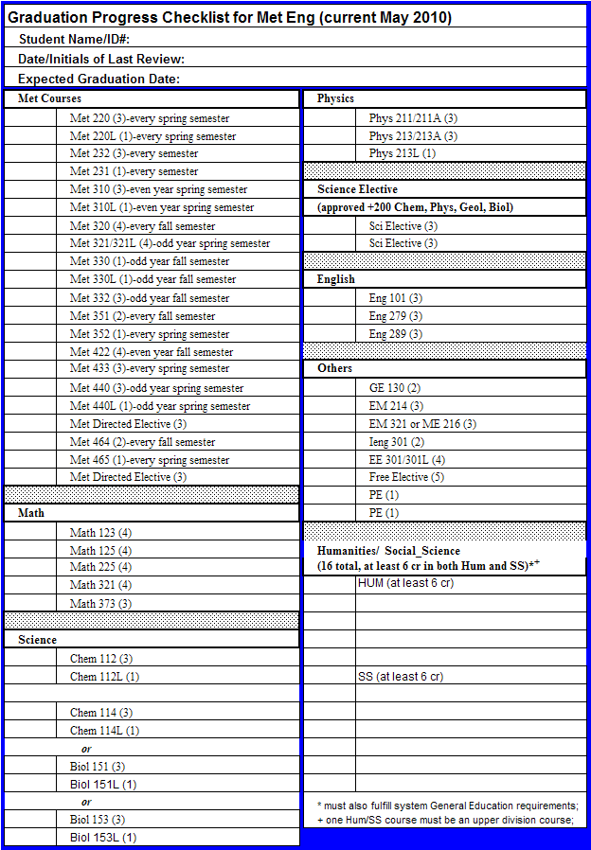

Table 1-1.4. BS Metallurgical Engineering Curriculum Flow Diagram 2009-2010
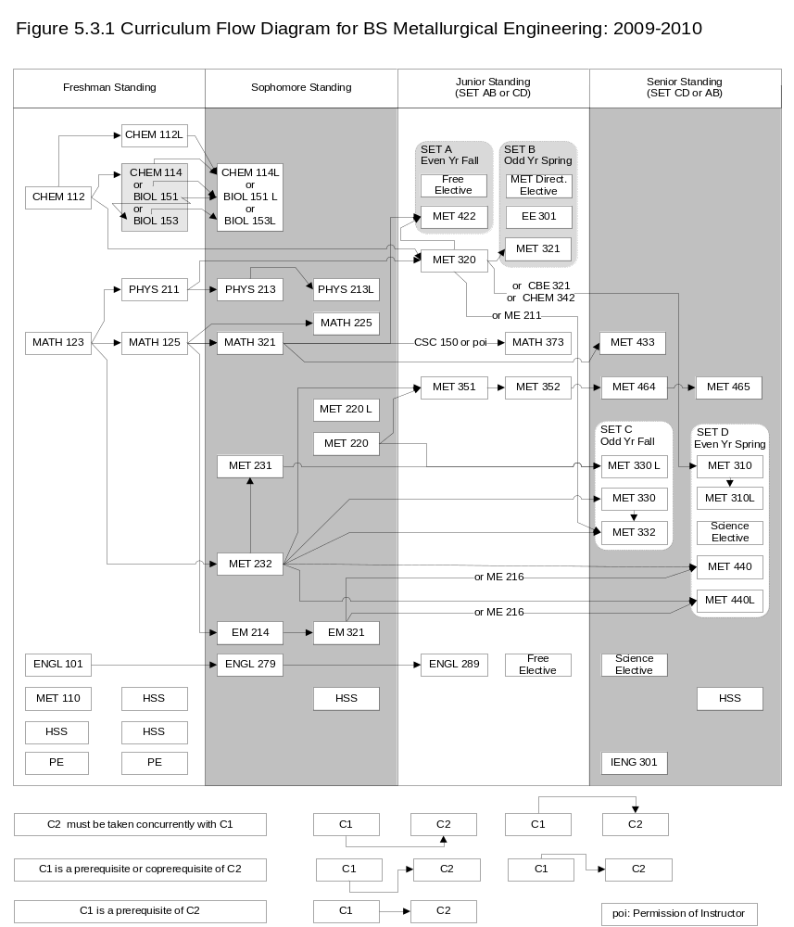

Table 1-1.5. BS Metallurgical Engineering Curriculum Flow Diagram 2010-2011
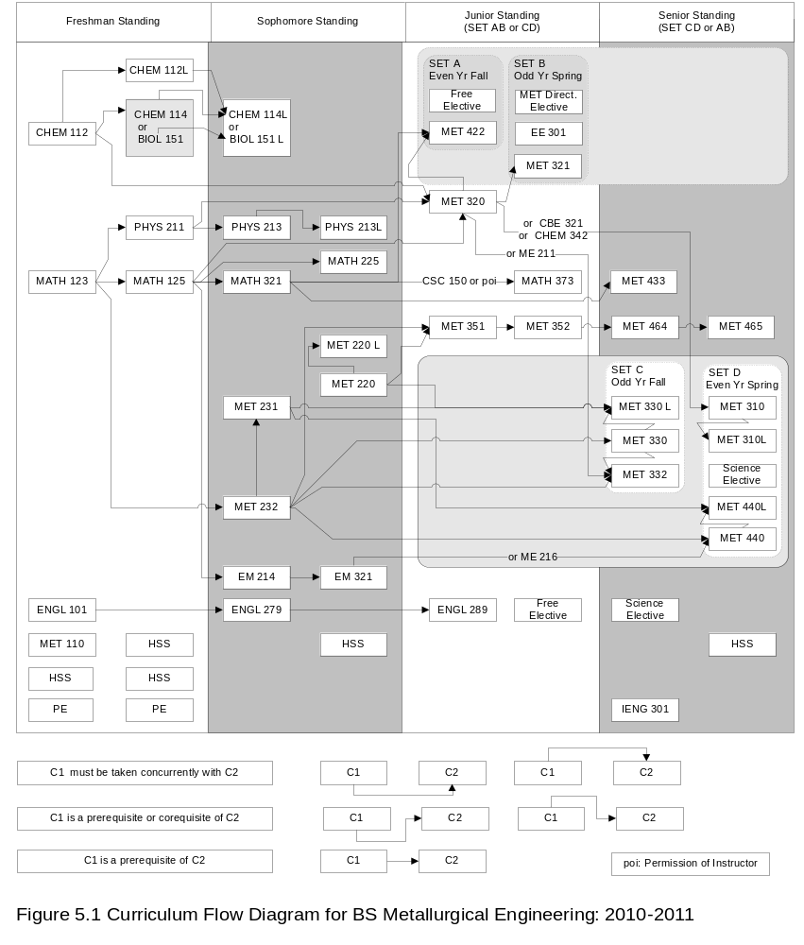

Table 1-1.6. B.S Metallurgical Engineering Approved Science Electives
Program | Course # | Course Name
ATM | 301 | Introduction To Atmospheric Sciences
ATM | 401/501 | Atmospheric Physics
ATM | 402/502 | The Global Carbon Cycle
ATM | 403/503 | Biogeochemistry
ATM | 404/504 | Atmospheric Thermodynamics
ATM | 405/505 | Air Quality
ATM | 406 | Global Environmental Change
ATM | 450/450L | Synoptic Meteorology I
ATM | 460/560 | Atmospheric Dynamics
BIOL | 121 | Basic Anatomy
BIOL | 123 | Basic Physiology
BIOL | 151 | General Biology I
BIOL | 153 | General Biology Ii
BIOL | 231 | General Microbiology
BIOL | 311 | Principles Of Ecology
BIOL | 341 | Microbial Processes In Engineering And Natural Sciences
BIOL | 371 | Genetics
BIOL | 403 | Global Environmental Change
BIOL | 423 | Pathogenesis
BIOL | 431 | Industrial Microbiology
CHEM | 230 | Analytical Chemistry For Engineers
CHEM | 252 | Systematic Inorganic Chemistry
CHEM | 316 | Fundamentals Of Organic Chemistry
CHEM | 326 | Organic Chemistry I
CHEM | 328 | Organic Chemistry Ii
CHEM | 332 | Analytical Chemistry
CHEM | 341 | Physical Chemistry For Engineers I
CHEM | 342 | Physical Chemistry I
CHEM | 343 | Physical Chemistry For Engineers Ii
CHEM | 344 | Physical Chemistry Ii
CHEM | 420/520 | Organic Chemistry Iii
CHEM | 421/521 | Spectroscopic Analysis
CHEM | 426/526 | Polymer Chemistry
CHEM | 434 | Instrumental Analysis
CHEM | 452/552 | Inorganic Chemistry
CHEM | 460/560 | Biochemistry
CHEM | 482/582 | Environmental Chemistry
GEOL | 201 | Physical Geology
GEOL | 212/212L | Mineralogy And Crystallography
GEOL | 331/331L | Stratigraphy And Sedimentation
GEOL | 341/341L | Elementary Petrology
GEOL | 351 | Geol Earth Resources And The Environment

Table 1.1.6. B.S Metallurgical Engineering Approved Science Electives, Continued
Program | Course # | Course Name
GEOL | 420/520 | Introduction To Remote Sensing
GEOL | 670 | Principles Of X-Ray Diffraction
PHYS | 275 | Relativity
PHYS | 312 | Experimental Physics Design I
PHYS | 314 | Experimental Physics Design Ii
PHYS | 341 | Thermodynamics
PHYS | 343 | Statistical Physics
PHYS | 361 | Optics
PHYS | 421/521 | Electromagnetism
PHYS | 433/533 | Nuclear And Elementary Particle Physics
PHYS | 439/539 | Solid State Physics
PHYS | 445/545 | Statistical Mechanics
PHYS | 451/551 | Classical Mechanics
PHYS | 471/571 | Quantum Mechanics
PHYS | 481/581 | Mathematical Physics I

In the BS Metallurgical Engineering program, a variety of career planning support is available to supplement the non-program specific efforts detailed previously. The program maintains contacts with as many program alumni as possible. These alumni often approach the department with their needs for summer interns and their companies open full-time positions. In addition, program faculty with on-going research often hire program undergraduates as part of the team to accomplish their research. The Advanced Materials Processing (AMP) Center and Back to the Future REU site are especially active in this regard. The program faculty also work closely with the Materials Advantage student chapter to help bring in speakers from various Metallurgical Engineering related companies and to help the students to improve their resumes. Currently, 6 students are working as summer interns in industry, while 6 students are performing research during the summer of 2010.

D. Transfer Students and Transfer Courses
“Transfer students” enter the School of Mines with previously earned post-secondary credits. An online checklist is created each semester to guide transfer-student transitions to the School of Mines. (See <http://www.gotomines.com/admissions/info-for/transfer> for an example.)

Upon admission, the registration officer in collaboration with the Associate Provost for Accountability and Assessment determine which credits meet the general education requirements, upper-division humanities or social sciences requirements (if applicable), and physical education requirements. The registration officer sends a check list showing the results of this credit-transfer analysis to the student’s advisor for review and inclusion in the student’s file.

Transfer-credit decisions for courses in the student’s major are made by the academic department. All academic programs have a designated “transfer advisor,” and the registration officer assigns this person to an incoming transfer student as his or her initial advisor. The universities in the SD State System share a common course numbering system and common course descriptions for many courses, and these commonalities ease the transfer of credit.

Transfer credits from other post-secondary schools (both domestic and foreign) are reviewed on a case-by-case and course-by-course basis. For mathematics, chemistry, physics, some of the sciences, general engineering, and some science courses the typical course of action is for the course catalog description and syllabus to be examined to determine sufficient similarity to a required course.

All transfer credit granted is fully documented on the Degree Check Sheet that is completed as part of applying for graduation. If the Degrees Committee could have any questions about the application of transfer credits, course syllabi and other documentation accompany the Degree Check Sheet when it is forwarded to the Degrees Committee for final approval.

For the BS Metallurgical Engineering program, the Department head reviews the student transcripts of any student who desires to transfer into the Metallurgical Engineering program from another SDSMT program. Specifically, the Department Head uses the online Datatel system to print out the student’s transcript and review that against the Graduation Progress Checklist for the Metallurgical Engineering program. Next, the Department Head schedules a meeting with the student to review the status of the student’s progress and outlines a semester-by-semester plan for the student to complete his/her degree. The student’s Graduation Progress Checklist (Table 1-1.3) is then updated routinely, and ultimately used for the Degree Audit the final semester prior to graduation. Table 1-2.1 shows the number of transfers into SDSM&T overall and into the BS Metallurgical Engineering program over the last 6 years.

Table 1-2.1. Transfer Students for Last Six Academic Years
Term | Number of Transfer Students Enrolled
 | SDSM&T | BS MET. ENG.
Fall 2009 | 92 | 0
Fall 2008 | 72 | 3
Fall 2007 | 100 | 1
Fall 2006 | 82 | 0
Fall 2005 | 110 | 0
Fall 2004 | 111 | 0

E. Graduation Requirements
Early in the semester prior to the semester in which the student plans to graduate, the major advisor completes a Degree Check for the office of the Registrar and Academic Services (RAS). A Degree Check involves retrieving the student’s record from WebAdvisor and performing an inventory of the student’s academic record in conjunction with both general education and program requirements.

The advisor annotates the Degree Check sheet whenever a substitute course has been allowed for one of the required or recommended courses in the program. If a course was taken on an “Independent Study” or “Special Topics” basis because of the SD State System requirements for minimum course enrollment, this will be noted. Before a student’s application for graduation will be processed by RAS, the advisor must sign and send to the registration officer a confirmation that a degree check has been performed and the student has met all requirements.

The Office of Enrollment Services maintains records of all student course records. These records are available via campus-wide digital systems: Datatel/Colleague and Webadvisor. Faculty members electing not to use the digital system can readily and promptly secure any student’s records from a variety of administrative personnel. These records are used by program faculty, in concert with each program’s student participation, to maintain the BS in Metallurgical Engineering Course Check List (Table 1-1.3), which shows progress towards graduation. The check list is typically reviewed every semester but at least annually. Students failing to make programmatically specified progress towards graduation are counseled by their advisor and, depending on the seriousness of the inadequacy, the program department head. The university also effectively maintains and enforces policies 1) requiring minimum overall and recent semester GPA performance, 2) specifying no more than three attempts in any one course, 3) requiring certain grade attainment in selected prerequisite (usually math) courses, and 4) assuring satisfaction of general education goals established by the Regents.

The Degrees Committee, with the help of Enrollment Management Services, makes a final check on all graduating students to determine that all graduation requirements have been met. Prior to the Degrees Committee degree check Dr. Kellar conducts a degree check using the attached form, Table 1-1.3. Dr. Kellar sends a completed Table 1-1.3 for each student considered for graduation to Enrollment Management Services for their consideration. The evaluation using Table 1-1.3 is completed at least 2 months prior to the student’s graduation.

Twelve of the credits listed in Table 1-1.3 as “Humanities/Social Sciences” must fulfill General Education requirements specified by the South Dakota Board of Regents. At the January 1999 meeting of the South Dakota Board of Regents a system-wide general education core for undergraduate education was established. This core is required for all students accepted to the university for the Fall 1999 semester or later. General education core requirements must be completed within the first 64 credits. Exceptions to this latter requirement for certain degree programs are currently under consideration. The BS Metallurgical Engineering program checklist of required goals of the General Education program is listed in Table 1-2.2. The goal requirements are listed in Table 1-2.3, and the detailed requirements are given below.
General Requirements

The following rules on graduation requirements apply for the bachelor of science degree in any curriculum offered by the university. Requirements that apply to many or all programs are described below. Please refer to the curriculum for an individual degree program for specific course requirements. Each candidate for a degree is personally responsible for meeting all requirements for graduation. No university official can relieve a candidate of this responsibility. The South Dakota School of Mines and Technology reserves the right to change any course of study or any part of a curriculum in keeping with accreditation, educational, and scientific developments. General Education Core Requirements General education core requirements must be completed within the first sixty-four (64) credits. Requests for exceptions to these general education requirements must be approved by the student‘s advisor and by the Vice President for Academic Affairs/Provost. The required core is listed below. Courses in bold are required for completion of the BS Metallurgical Engineering program.

Goal #1
Students will write effectively and responsibly and understand and interpret the written expression of others. Student Learning Outcomes: As a result of taking courses meeting this goal, a student will
- Write using standard American English, including correct punctuation, grammar, and sentence structure;
- Write logically;
- Write persuasively, with a variety of rhetorical strategies (e.g., expository, argumentative, descriptive);
- Incorporate formal research and documentation in their writing, including research obtained through modern, technology-based research tools.
Table 1-2.2. System-Wide General Education Requirements Checklist
Name:
Instructions: SDSM&T courses used to satisfy requirements must be selected from those listed on the back of this form. Enter the courses as you complete them and record the semester and year completed. Consult with your advisor on transfer courses.
Goal 1 Written communications (6 credits)
Date | Cr. Hrs. | Course | Title (if transferred, from where?)
Goal 2 Speech Communications (3 credits)
Date | Cr. Hrs. | Course | Title (if transferred, from where?)
Goal 3 Social Sciences (6 credits, in 2 disciplines or course prefixes)
Date | Cr. Hrs. | Course | Title (if transferred, from where?)
Goal 4 Arts/Humanities (6 credits; in 2 disciplines, course prefixes or a sequence of a foreign language)
Date | Cr. Hrs. | Course | Title (if transferred, from where?)
Goal 5 Mathematics (3 credits)
Date | Cr. Hrs. | Course | Title (if transferred, from where?)
Goal 6 Science (6 credits) Lecture and Lab are required.
Date | Cr. Hrs. | Course | Title (if transferred, from where?)
Goal 7 Information Usage (9 credits) Courses indicated by * and bold on back
Date | Cr. Hrs. | Course | Title (if transferred, from where?)

Table 1-2.3. General Education Requirement Goals
Goal Number | Goal Objective | Credit Hours Needed
1 | Effective Writing | 6
2 | Communicate Effectively | 3
3 | Social Sciences | 6
4 | Arts and Humanities | 6
5 | Mathematics | 3
6 | Natural Sciences | 6
7 | Information | 9
Globalization | Understand Global Issues | 0.5 (MET 310)
Writing Intensive | Improve Writing | 0.5 (MET 321)

Each course meeting this goal includes the following student outcomes:
Required: #1, #2, #3, and #4

Credit Hours: 6 hours

Courses:
ENGL 101 Composition I
ENGL 201 Composition II
ENGL 279/289 Technical Communications I and II¹

Goal #2
Students will communicate effectively and responsibly through speaking and listening. Student Learning Outcomes: Courses satisfying this goal will require students to
- Prepare and deliver speeches for a variety of audiences and settings;
- Demonstrate speaking competencies including choice and use of topic, supporting materials, organizational pattern, language usage, presentational aids, and delivery;
- Demonstrate listening competencies by summarizing, analyzing, and paraphrasing ideas, perspectives and emotional content.

Credit Hours: 3 hours

Courses:
ENGL 279/289 Technical Communications I and II²
SPCM 101 Fundamentals of Speech¹

Goal #3
Students will understand the organization, potential, and diversity of the human community through study of the social sciences. Student Learning Outcomes: As a result of taking courses meeting this goal, students will
- Identify and explain basic concepts, terminology and theories of the selected social science disciplines from different spatial, temporal, cultural, and/or institutional contents.
- Apply selected social science concepts and theories to contemporary issues;
- Identify and explain the social or aesthetic values of different cultures. In addition, as a result of taking course meeting this goal, students will be able to demonstrate a basic understanding of at least one of the following:
  - The origin and evolution of human institutions;
  - The allocation of human or natural resources within societies;
  - The impact of diverse philosophical, ethical or religious views.
Each course meeting this goal includes the following student learning outcomes: Required: #1, #2, and #3
At least one of the following: #4, #5, or #6

Credit Hours: 6 hours in two disciplines

Courses:

ANTH 210 Cultural Anthropology
ECON 201 Principles of Microeconomics
ECON 202 Principles of Macroeconomics
GEOG 101 Introduction to Geography
GEOG 212 Geography of North America
HIST 151/152 United States History I/II
POLS 100 American Government
POLS 210 State and Local Government
PSYC 101 General Psychology
SOC 100 Introduction to Sociology
SOC 150 Social Problems SOC 250 Courtship and Marriage

Goal #4
Students will understand the diversity and complexity of the human experience through study of the arts and humanities. Student Learning Outcomes: As a result of taking courses meeting this goal, students will
- Demonstrate knowledge of the diversity of values, beliefs, and ideas embodied in the human experience;
- Identify and explain basic concepts of the selected disciplines within the arts and humanities. In addition, as a result of taking courses meeting this goal, students will be able to do at least one of the following:
Identify and explain the contributions of other cultures from the perspective of the selected disciplines within the arts and humanities;
Demonstrate creative and aesthetic understanding;
Explain and interpret formal and stylistic elements of the literary or fine arts;
Demonstrate foundational competency in reading, writing, and speaking a non-English language.
Each course meeting this goal includes the following student learning outcomes: Required: #1, #2 At least one of the following: #3, #4, #5, or #6

Credit Hours: 6 hours in two disciplines or in a sequence of foreign language courses)

Courses:

ART 111/112 Drawing I and II
ARTH 211 History of World Art I
ENGL 221/222 British Literature I and II
ENGL 241/242 American Lit I and II
ENGL 250 Science Fiction
FREN 101/102 Introductory French I and II
GER 101/102 Introductory German I and II
HIST 121/122 Western Civilization I and II
HUM 100 Introduction to Humanities
HUM 200 Connections: Humanities and Technology
LAKL 101/102 Introductory Lakota I and II
MUS 100 Music Appreciation
PHIL 100 Introduction to Philosophy
PHIL 200 Introduction to Logic
PHIL 220 Introduction to Ethics
PHIL 233 Philosophy and Literature
SPAN 101/102 Introductory Spanish I and II

Goal #5
Students will understand and apply fundamental mathematical processes and reasoning. Student Learning Outcomes: As a result of taking courses meeting this goal, students will
- Use mathematical symbols and mathematical structure to model and solve real world problems;
- Demonstrate appropriate communication skills related to mathematical terms and concepts;
- Demonstrate the correct use of quantifiable measurements of real world situations.
Each course meeting this goal includes the following student learning outcomes: Required: #1, #2, and #3

Credit Hours: 3 hours

Courses:

MATH 102 College Algebra
MATH 115 Precalculus
MATH 120 Trigonometry
MATH 123 Calculus I
MATH 125 Calculus II
MATH 225 Calculus III
MATH 281 Statistics

Goal #6
Students will understand the fundamental principles of the natural sciences and apply scientific methods of inquiry to investigate the natural world. Student Learning Outcomes: As a result of taking courses meeting this goal, students will
- Demonstrate the scientific method in a laboratory experience;
- Gather and critically evaluate data using the scientific method;
- Identify and explain the basic concepts, terminology and theories of the selected natural sciences;
- Apply selected natural science concepts and theories to contemporary issues.
Each course meeting this goal includes the
following student learning outcomes: Required:
#1, #2, #3, and #4.

Credit Hours: 6 hours

Courses:

BIOL 151/151L General Biology I and Laboratory
BIOL 153/153L General Biology II and Laboratory
CHEM 106/106L Chemistry Survey/Laboratory
CHEM 108/108L Organic Chemistry/Laboratory
CHEM 112/112L General Chemistry I and Laboratory
CHEM 114/114L General Chemistry II and Laboratory
GEOL 201/201L Physical Geology/Laboratory
PHYS 111/111L Introduction to Physics I and Laboratory
PHYS 113/113L Introduction to Physics II and Laboratory
PHYS 211 University Physics I
PHYS 213/213L University Physics II and Laboratory

Goal #7
Students will recognize when information is needed and have the ability to locate, organize, critically evaluate, and effectively use information from a variety of sources with intellectual integrity. Student Learning Outcomes: As a result of taking courses meeting this goal, students will
1. Determine the extent of information needed;
2. Access the needed information effectively and efficiently;
3. Evaluate information and its sources critically;
4. Use information effectively to accomplish a specific purpose;
5. Use information in an ethical and legal manner.
Each course meeting this goal includes the
following student learning outcomes:
Required: #1, #2, #3, #4, and #5

Credit Hours: 9 hours

Courses:

ENGL 101 Composition I
SPCM 101 Fundamentals of Speech
ENGL 201 Composition II
ENGL 279/289 Technical Communications I and II¹

¹Engineering and sciences students at School of Mines take this six credit sequence in the sophomore and junior years. Both courses develop written and speech communications in an integrated fashion in the context of the major. Students must finish the entire sequence, as well as ENGL 101, to satisfy the requirements of Goal #1 and Goal #2.

²Technical Communications I and II develop written and speech communications in an integrated fashion in the context of the major. Students must finish the entire sequence, as well as ENGL 101, to satisfy the requirements of Goal #1 and Goal #2.

General Education Globalization/Global Issues and Writing Intensive Requirements
In addition to the seven system-wide general education requirements described above, all students will achieve learning outcomes focused on advancing their writing skills and their knowledge of global issues. Each academic program has designated one or more classes (the equivalent of one credit hour of study) as meeting each of these requirements. The syllabi of the courses designated state the requirement(s) met and explain how student achievement of the outcomes are assessed and factored into the course grade.

Globalization/Global Issues Goal Statement
Students will understand the implications of global issues for the human community and for the practice of their disciplines.
Student Learning Outcomes: As a result of taking courses meeting this goal, students will
- Identify and analyze global issues, including how multiple perspectives impact such issues; and
- Demonstrate a basic understanding of the impact of global issues on the practice of their discipline.

Writing Intensive Goal Statement
Students will write effectively and responsibly in accordance with the needs of their own disciplines.

Student Learning Outcomes: As a result of taking courses meeting this goal, students will
- Produce documents written for technical, professional, and general audiences within the context of their disciplines;
- Identify, evaluate, and use potential sources of information from within their disciplines for writing assignments that require research and study; and,
- Use instructor feedback throughout the semester to improve the quality of their writing.

F. Enrollment and Graduation Trends
The enrollment and graduation trends for SDSM&T and for the BS Metallurgical Engineering program over the last six years are shown for SDSM&T in Tables 1-3.1 and 1-3.2 and for the BS Metallurgical Engineering program in Table 1-3.3. The BS Metallurgical Engineering program graduates are listed in Table 1-4.

Outstanding Recent Graduate Awards

The Outstanding Recent Graduate Program honors graduates who have achieved exemplary career progress and recognition within ten years of their graduation. The program was originated and is sponsored by the SDSM&T Alumni Association and the SDSM&T Foundation. Candidates are reviewed based on nominations submitted by their undergraduate degree-granting department or program. The individuals selected for this award are considered excellent role models to show current students the importance of continued personal growth in a rapidly changing world. Typically, five awards are given yearly.

The BS Metallurgical Engineering program has a very strong record with respect to this award, and that has continued in the recent past with awards won yearly from 2005-2010. Table 1-5 lists the recent Outstanding Recent Graduate\ awards from BS Metallurgical Engineering program alumni

Table 1-3.1. Undergraduate Enrollment Trends for SDSM&T for the Past Six Academic Years: All Students
Category | Academic Year
Category | 2004-2005 | 2005-2006 | 2006-2007 | 2007-2008 | 2008-2009 | 2009-2010
Full-time Student Summer | 1 | 1 | 4 | 2 | 0 | 0
Full-time Student Fall | 1540 | 1545 | 1372 | 1396 | 1389 | 1490
Full-time Student Spring | 1405 | 1372 | 1264 | 1283 | 1255 | 1368
Part-time Student Summer | 374 | 417 | 427 | 315 | 313 | 351
Part-time Student Fall | 393 | 331 | 368 | 316 | 317 | 359
Part-time Student Spring | 367 | 393 | 347 | 333 | 38 | 424
Student FTE Summer² | 102 | 117 | 125 | 84 | 86 | 92
Student FTE Fall² | 1687 | 1678 | 1541 | 1550 | 1544 | 1663
Student FTE Spring² | 1540 | 1543 | 1427 | 1435 | 1438 | 1574
Total BS Degrees | 244 | 245 | 229 | 236 | 267 | 54¹
¹Total only includes 2009 Fall graduates; updated numbers will be available at the time of the visit
²FTE indicate Full-time Equivalents or 15 credits per term

Table 1-3.2. Undergraduate Enrollment Trends for SDSM&T for the Past Six Academic Years: Engineering Programs
Category | Academic Year
Category | 2004-2005 | 2005-2006 | 2006-2007 | 2007-2008 | 2008-2009 | 2009-2010
Full-time Student Summer | 0 | 1 | 2 | 0 | 0 | 0
Full-time Student Fall | 1196 | 1220 | 1141 | 1164 | 1158 | 1262
Full-time Student Spring | 1092 | 1093 | 1055 | 1070 | 1054 | 1137
Part-time Student Summer | 188 | 228 | 235 | 192 | 182 | 198
Part-time Student Fall | 126 | 113 | 124 | 122 | 132 | 102
Part-time Student Spring | 132 | 145 | 120 | 144 | 132 | 145
Student FTE Summer² | 53.9 | 65.5 | 70.7 | 54.3 | 51.9 | 59.5
Student FTE Fall² | 1253 | 1268 | 1210 | 1240 | 1236 | 1324
Student FTE Spring² | 1150 | 1169 | 1125 | 1145 | 1131 | 1218
Total BS Degrees | 185 | 194 | 182 | 177 | 205 | 49¹
¹Total only includes 2009 Fall graduates; updated numbers will be available at the time of the visit
²FTE indicate Full-time Equivalents or 15 credits per term
Table 1-3.3. Undergraduate Enrollment Trends for SDSM&T for the Past Six Academic Years: BS Metallurgical Engineering Program
Category | Academic Year
Category | 2004-2005 | 2005-2006 | 2006-2007 | 2007-2008 | 2008-2009 | 2009-2010
Full-time Student Summer | 0 | 0 | 0 | 0 | 0 | 0
Full-time Student Fall | 43 | 51 | 60 | 55 | 63 | 74
Full-time Student Spring | 37 | 42 | 56 | 58 | 61 | 0¹
Part-time Student Summer | 3 | 7 | 7 | 12 | 12 | 13
Part-time Student Fall | 3 | 2 | 1 | 3 | 5 | 4
Part-time Student Spring | 5 | 4 | 3 | 4 | 3 | 0¹
Student FTE Summer² | 0.7 | 1.2 | 1.6 | 3.7 | 3.9.3.1 | 92
Student FTE Fall² | 45.1 | 52.3 | 60.6 | 58.5 | 65.5 | 78.1
Student FTE Spring² | 38.3 | 45.2 | 57.9 | 62.0 | 61.9 | 0¹
Total BS Degrees | 0 | 6 | 16 | 8 | 4 | 12
¹Total only includes 2009 Fall graduates; updated numbers will be available at the time of the visit
²FTE indicate Full-time Equivalents or 15 credits per term

Table 1-4. Program Graduates (names removed for public posting)
ID | Year  Matr. | Year  Grad. | Placement | Last  Name | Middle  Name | First  Name
1649667 | 2005F | 2009F | Spirit Aerospace | Vayer-Jenkins | Ashley | Elizabeth
1589742 | 2005F | 2009F | Nucor Steel | Werning | Blake | Matthew
1533111 | 2005F | 2009F | Grad School – SDSM&T | Nelson | Austin | Christopher
1650660 | 2005F | 2009S | Grad School. – SDSM&T | Bergstrom | Casey | Scott
1272729 | 1999F | 2009S | Zyvex | Cook | Robert | Daniel
1064669 | 2004F | 2009S | Alcoa | Schmidt | Travis | James
1040413 | 2003F | 2008F | Radiance | Zelfer | Travis | John
1617233 | 2004F | 2008S | Chromalloy | Caldwell | Chandler | Russell
1271234 | 2004F | 2008S | Grad School– SDSM&T | Hansen | Dane | Christen
1073912 | 2003F | 2008S | Barrick Gold | Tlustos | Samuel | Edward
1065108 | 2004F | 2008S | Grad School– SDSM&T | Horton | Mark | Christopher
1045500 | 2003F | 2008S | Freeport-McMoran | Hahn | Robbie | Daniel
1013220 | 2003F | 2008S | Edison Welding Institute | Pramann | Zachary | Thomas
1035690 | 2003F | 2007F | Stork Materials Testing & Inspection | Johnson | Lucas | David
1057677 | 2002S | 2007M | Tinker AFB | Koch | Karl | John
1296552 | 2003F | 2007S | Micron | Carlson | Deborah | Marie
1292148 | 2002F | 2007S | Self Employed | Patzer | Ryan | Charles
1288301 | 2002F | 2007S | Caterpillar | Metzger | Christopher | Michael
1276470 | 2003F | 2007S | Self Employed | Beal | Jamie | LaRae
1274217 | 2002F | 2007S | Tinker AFB | Calvert | Christian | Joseph
1272561 | 2003S | 2007S | Grad School– SDSM&T | Roalstad | Jerrod | Andrew
1272553 | 1994F | 2007S | Strathmore Minerals | Bielstein | Nickolas | Karl
1272210 | 2002F | 2007S | Nucor Steel | Reisenweber | Kyle | Nicholas
1073939 | 2003F | 2007S | Fischer Controls | Lyndoe | Matthew | Paul
1068811 | 2003F | 2007S | RPM & Associates | Westendorf | Matthew | Paul
S-Spring; F-Fall; M-Summer;

Table 1-5. Program Outstanding Recent Graduates (names removed for public posting)
Name | Year Graduated | Year Awarded | Employer
Cale Groen | 1994 | 2005 | Caterpillar
Dustin Ellis | 1996 | 2006 | GE
Mike Connell | 1997 | 2007 | Micron
Chris Kinney | 1997 | 2008 | Caterpillar
Chris Misterek | 1998 | 2009 | John Deere
Jeff Major | 1999 | 2010 | Lincoln Electric

